Exercise set 01 (Deadline: X Feb, 2018)

Problem 1: Review the Hebron field PDO

Read the PDO document of the Hebron field (http://folk.ntnu.no/stanko/Courses/TPG4230/2018/Class_files/20180109/PDO_Hebron_project.pdf ) and:
- List all activities that were performed prior to the PDO. Group them in categories. Some recommended categories are: subsurface, environmental impact, offshore facilities, wells, drilling and completion, subsea system, project management, timeline, operations, personnel and supply logistics, processing facilities.
- Compare them with the activities listed in the PDO description document from the NPD here: http://www.npd.no/Global/Engelsk/5-Rules-and-regulations/Guidelines/PDO-PIO-guidelines_2010.
- Prepare a time-line in GANTT chart for the development and the production of the field. Indicate on the GANTT the main start and end of major events (landmarks), particularly those that have impact on the cash-flow calculations (production, injection and sales of Oil, Gas, Water, Development Drilling, platform modification and changes of major process arrangement). Please note that not all the development and production decision are well documented or explained in the PDO so you might have to add your own “educated” ideas on the missing information.

Problem 2: Early NPV calculations for the Goliat field.

The company ENI is conducting a study on feasible development scenarios as a pre-step to select the best case and prepare the Plan for Development and Operations.
The field will be produced in plateau mode with 100 000 stb/d of oil and a total recoverable reserve estimated of 180 E6 stb. The average producing GOR (gas-oil ratio) is 1600 scf/stb and WC (water cut) is 20%.
Your main task is to perform a simplified economical evaluation (NPV calculations) of the scenario currently under consideration to develop the field:

Subsea wells in templates and production to Sevan (circular) FPSO with risers

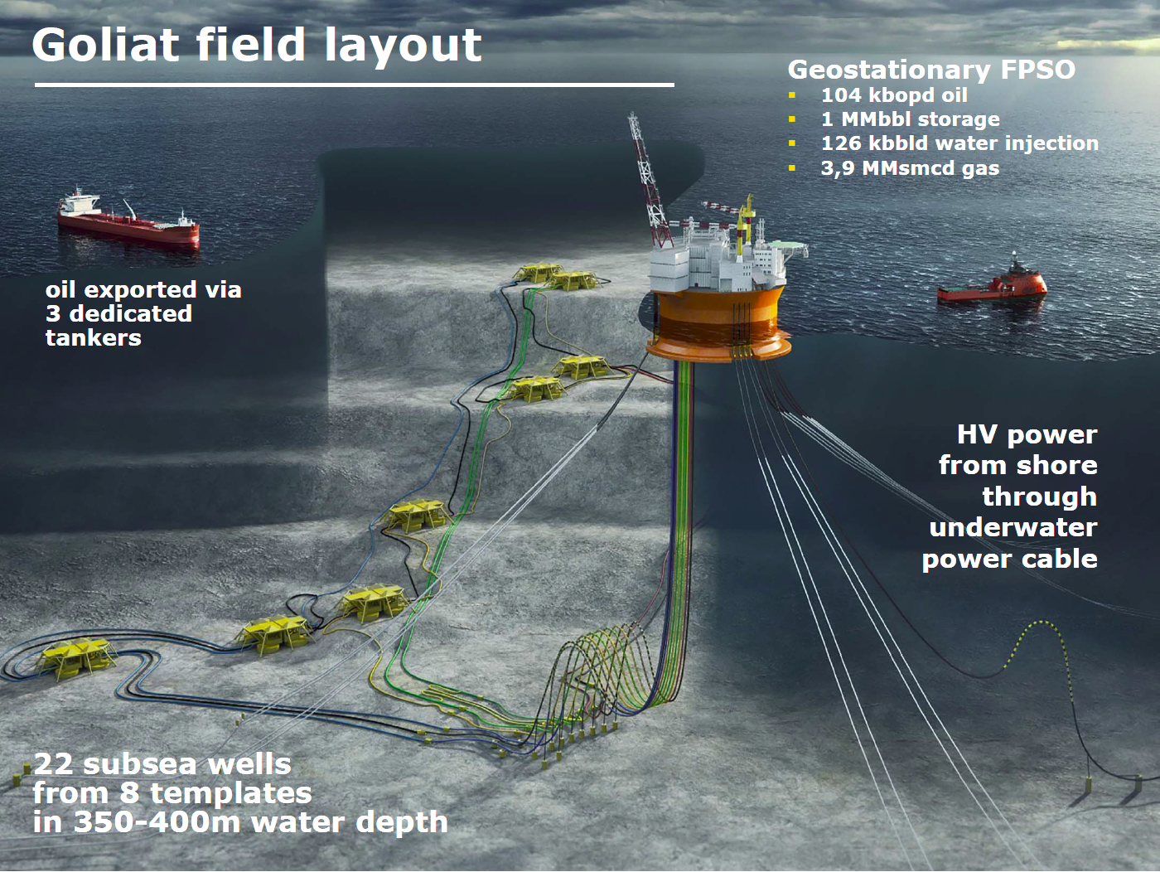

In this development alternative, the field will be produced for 15 years. The oil will be distributed to the market using tankers. All the produced water will be reinjected for pressure support. The gas will be reinjected into the Kobbe reservoir because, at the moment, there is no solution to distribute it to the market. The figure below shows the expected production profile for this field development strategy.

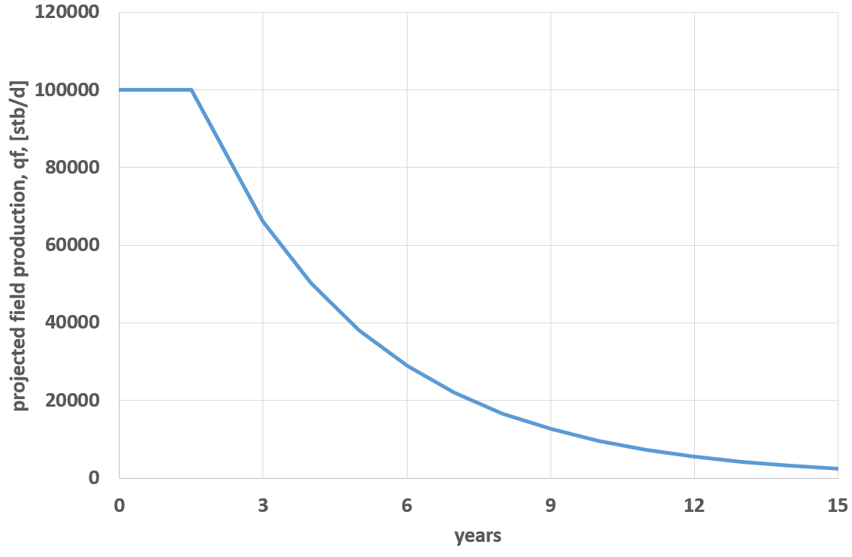
The field will be developed with 22 wells, 11 oil producers, 2 gas injectors and 9 water injectors. The well are subsea, perforated from 8 templates: 4 for production wells, 3 for water injection wells and 1 for gas injection.

All wells will be drilled in a period of 4 years (with an average duration of drilling and completing of 2 months). The average cost per well (including perforating, completing and well equipment) is 120 E6 USD. Usually there is a constant annual increase of 5% on this value.

The annual operating cost (OPEX) is 100 E6 USD.

The cost of the Sevan type FPSO is 1.1 E9 USD, it will be payed upfront during the first two years of the project and the total time until delivery on site is 4 years.

Other CAPEX costs like materials and installation of the risers, umbilicals and subsea manifolds can be neglected in this alternative.

All costs are given in 2018 dollars.

Your tasks are:

Calculate the annual revenues, DRILLEX, CAPEX, OPEX, total cost, cash flow, the discounted cash flow, and NPV of the proposed development for the Goliat field. Present your results on a table and plot discounted cash flow vs. time.

Perform a sensitivity analysis on the total NPV of the project considering the following variations
- ±40% variation in the oil price
- ±30% variation in the well cost price
- ±30% variation in the Sevan FPSO price
- ±30% variation in the OPEX
- Delay of the production startup in 1 and 2 years.

Plot your results in a Tornado chart.

General assumptions for your calculations

-Neglect the buildup period of the plateau (i.e. assume that all wells enter in production at the same time).
-Oil price: 60 USD/stb
-Assume that all CAPEX are executed during the first two years of the projects.
-Assume that the project starts in 2018.
-Employ a yearly discount rate of 7%

Suggestions and recommendations:
-Calculate the cumulative production of each year using the trapezoidal rule (https://en.wikipedia.org/wiki/Trapezoidal_rule)
-The cost values given are purely referential and should be used cautiously. If an inconsistency is detected or you have obtained information from a trustworthy source, feel free to modify the input.
Problem 3: Probabilistic estimation of Original oil in place and Total Recoverable Reserves of the Kobbe Formation

The company ENI has found a reservoir in the Barents sea, Kobbe, 50 km south of the Snøhvit field and 80 km from the LNG plant of Snøhvit in Hammerfest (Melkøya). The water depth in the area is 360 – 420 metres and, luckily, is an “ice-free” area. The company is evaluating to produce it and baptized the field: “Goliat”.
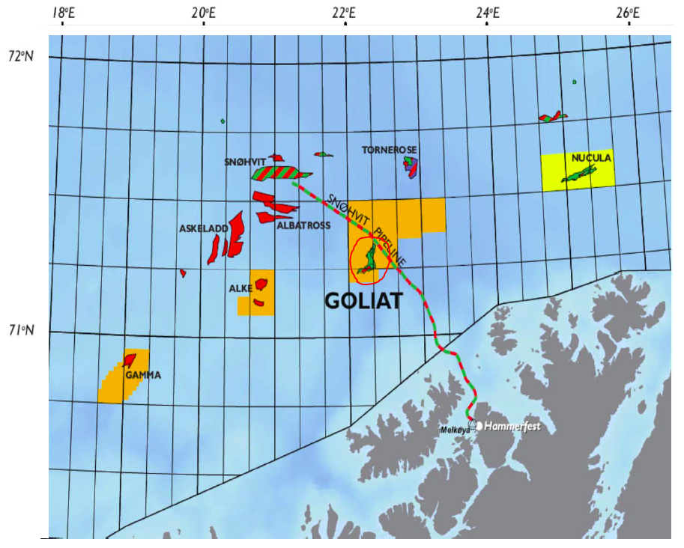
The reservoir contains oil with a thin overlying gas cap and it lies approximately 1800 meters beneath the seabed. The static reservoir pressure is 190 bar.

As part of the early development studies and as required by the Norwegian authorities, your first task is to perform a probabilistic estimation of the total recoverable reserves and the original oil in place of the Kobbe reservoir. The subsurface group has provided (in the excel sheet attached) information on the factors needed to calculate hydrocarbon pore volume (rock volume, net to gross, oil saturation, and the reservoir engineering group the formation volume factor (all based on a uniform probability distribution). The ultimate recovery factor is represented by a triangle distribution with a min value of 0.18, a max value of 0.35 and a mode of 0.25

There is disagreement within the company with respect to which porosity values to employ. A senior petrophysicist A says that a uniform porosity distribution should be employed with a min value of 0.18 and a max value of 0.30. Another senior petrophysicist B says that a skewed triangle distribution should be used with a min value of 0.18, a max value of 0.30 and a mode of 0.25.

Assumptions and extra information:

Use the following equation to calculate total recoverable reserves (TRR):
$$\text{TRR}=N_{\text{PU}}=N⋅F_{\text{RU}}=\frac{V_{R}⋅φ⋅S_{o}⋅\left(N_{\text{TG}}\right)}{B_{o}}⋅F_{\text{RU}}$$
And the following equation to calculate Original oil in place (N):
$$N=\frac{V_{R}⋅φ⋅S_{o}⋅\left(N_{\text{TG}}\right)}{B_{o}}$$
All the input information given is uncertain and reported as a uniform or triangular distribution (min, max or Min, Mode, Max). The details of the distributions have been given in class.

Tasks:
-Perform a Monte Carlo Simulation Study (using 1000 simulations) to obtain the expected value of the Total Recoverable Oil Reserves and the initial oil in place. Report the outcome as:
- Expected value (Mean or Average)
- Most probable value (mode)
- Median (P50), P10, P90
- Expectation curve for the Total Recoverable Oil Reserves (Plot of Cumulative Probability) and the initial oil in place
-Estimate the required number of iterations for the Monte Carlo method using the values calculated above. Assume that the desired error is 2% of the average, and the desired confidence level is 98%. Do you have to run more iterations?

Problem 4: Estimation of Original oil in place of the Kobbe Formation using a probability tree

- How would you solve problem 3 using a probability tree? Please explain the procedure and make a sketch of one branch of the tree.
- Will a probability tree give the same result as the Monte Carlo simulation? Explain your answer.
- Discretize the probability distributions of: porosity (with the distribution recommended by Petrophysicist A), oil saturation, oil volume factor, net to gross, rock volume and Original oil in place (found in problem 3 with the porosity distribution recommended by Petrophysicist A). To represent each parameter use 3 values with their associated probabilities. The following probabilities are suggested: 0.3, 0.4 and 0.3.

Suggestions:

For your study, you will have to discretize the probability distributions provided for each parameter in problem 3. See some guidelines to do this below.

