Explore Zirkon area, and look for slumping geometry and possible reservoirs.

Håvard K. N., Åsmund V. F., Paul G., Vivien H. V.

Introduction

In exploration the contribution from seismic interpretation is fundamental. Seismic images provide the geophysicist and geologist with answers together with some unanswered questions. It is these questions we try to search a solution for search for hydrocarbons. We try to interpret our data, look for faults, traps and possible reservoirs. Our data has already been processed and interpreted by Statoil. We must see if we agree with this interpretation and look for traps and a possible slumping area.
We will use partial stacks; near, mid and far stack from the base survey 85.The interpretation will be done in tools like Seisworks, Promax and well data.
We are in this report going to look closer at a search model at Gullfaks area in the North Sea. Its called Prospect Zirkon. Zirkon is located near a producing area, in segment G6, it is divided into three parts, called from north to south; Alfa, Beta and Gamma. In this report we will explore the Zirkon area and look for a possible reservoir and slumping geometry. Zirkon is located at greater depth than the rest of the Gullfaks field. The area looks very complex. There is a possibility that there is a slumping geometry, this is something we will look closer to.

Theory

The amplitude in the seismic data will give us valuable information about the geological formation in the prospect. When amplitudes vary as a function of offset (or angle) the particular way the amplitude changes take place may be an indication of hydrocarbons. Normally we expect the amplitude to be more attenuated and absorbed further away from the source. When we have interfaces between cap rock and a reservoir we normally expect the amplitudes to increase with offset for the interfaces between the cap rock and the gas (or oil) filled reservoir. The same will occur for the gas/oil, gas/water or oil/water contact, but then with opposite polarity to the cap rock/gas interface. AVO is performed on prestack data, however it may be possible to do a partial stack (near stack, mid stack and far stack) to increase the signal to noise ratio. The same time preserve the amplitude characteristic for the various offsets.

We have done a simple AVO analysis, looked at Vp/Vs and tried to get something out of this, and see if we observe the same thing on the AVO and Vp/Vs ratio. In real life this is far from enough to come to a conclusion, but we have received a cross plot from Statoil to help us to get a better understanding and hopefully a better conclusion.

Interpretation

Zircon is divided into three zones, we have interpreted it separately. We begin with Gamma.

Gamma is stretched from L2721 – 2801, T2620 – 2635, depth 1930 - 2000 ms. Gamma changes a bit as we move through it. It gets more complex, smaller and shallower in the south. Compare the near, mid and far stack from the 96 survey is interesting. The amplitude increases with offset. This is an AVO feature. Gamma is located very close to a producing area, and here is expected less chance of discovery, but if there is one there will probably be oil present.

The image, see Figure 1, is from inline 2741. The three horizons from the top are, Kritt, Brent and Ness. Our target lies in Brent formation, which is between the yellow and the lowest red horizon

The Vp/Vs ratio at Gamma has ratio at 2.2, the producing area, from T2535 – 2680, has a ratio at 1.7 – 2.0. Here there is a variety in bright colours. The strongest here is the one we see in Gamma. Vp gets smaller in gas, while Vs is not effected that much. The brighter red colour represent higher ratio. Vp is higher in oil and water than gas, but usually slower than in grains. This may be an indication of little gas since the ratio is higher. See figure 2

In seismic interpretation one way to look at the data is from above, where you get an overview of the amplitudes from above in different times. This is an efficient way to look for amplitude behaviour. Zirkon is located deeper than the producing area, it is from 1948 ms south, to 2060 ms in north. The time slices are an efficient way to look for AVO anomalies. Figure 3 represent time slices from Gamma area, near 85 is to the left, far 85 to the right. This type of time slices we looked in Beta and Alfa area. You can see how the reflections vary. The reflectors that gets weaker and thinner to the left. This is an AVO anomaly.

Beta is located further north and deeper. From inline 2800 – 2860, T2610 – 2660, depth is from 1970 – 2040 ms. Beta looks more flat and are bigger area than Gamma. The seismic image show us the depth in time and how continuous the reflections are. This tells us something about how the complex and if it’s a dipping interface. If there should be a possible for slumping geometry there might be an advantage that is dipping, like Gamma does a little bit

Alfa is the area which lay close to the gas field in the north of Gullfaks. Here it is expected to discover more gas than oil, if there is a discovery. Alfa is located from inline 2860 to 2901, T2620 – 2665, at depth 1980-2060 ms.

The seismic image of Alfa is very complex.

Alfa, inline 2871, T2620 – 2660, depth: 1990-2020 ms, looks very complex. Here is no continuous reflection. We see a low ratio 1.9 – 2.0 from T2600 – 2640, and a higher ratio 2.1 – 2.2 from T2640 – 2660. This changes when we move north. Then we see a more clearly continuous reflection and a better Vp/Vs ratio. See figure 4, which show that the colours in the ratio is a reasonable ratio.

Discussion

With regard to the interpretation done by Statoil there are relatively good chances to discover hydrocarbons in Zirkon area. Zirkon is divided into three zones, Alfa, Beta and Gamma. These three zones are representing different chances of discovering oil and gas. Alfa is located near the big gas field north of Gullfaks. Chance of making a discovery is higher in Alfa, but here there is probably much more gas than oil. Beta is located between Alfa and Gamma and the chance of making a discovery in Beta is a bit lower than Alfa. Statoil’s interpretation says there is in Beta equal chance of discovering oil as gas. Then there is Gamma, which is located most south in Zirkon area. Chance of discovery is lower here, but if there is a discovery, the chance for oil present is higher than gas present. The task was to explore Zirkon prospect to see if the is possible slumping geometry and possible discovery of hydrocarbons. We took basis of Statoils interpretation to locate and explore Zirkon to see if we get a similar conclusion or not.

To interpret the seismic data we used Landmarks Seisworks, mostly from the base survey 85. If the interpretation should be good and reliable, the interpreter needs experience and work next to a geologist to get a good interpretation. This we don’t have. Still we think we got some answers from the seismic data through an AVO analyses, Vp/Vs ratio and geology knowledge. What makes Zirkon a little unusual is the geology geometry. Statoil have interpreted a possible slumping geometry in Zirkon area. This was something we looked for.

Gamma has a god AVO feature, but the Vp/Vs ratio is different from Gamma south to the producing area to the east. The colours area similar and the ratios can overlap a bit. In regard to AVO analysis, Vp/Vs ratio and time slice we see that Gamma north is an area to look closer to. If we take the Vp/Vs ratio, which is a good lithology indicator, we compared our located area with a producing area to see if there were any similar colours. Gamma south, inline 2741, we get a different Vp/Vs ratio than the producing area. But this difference gets smaller as we move north and we get deeper. On the seismic data we saw an AVO feature, both on traditionally and on the time slices. This was confirmed with the analysis we did. The seismic reflection increases with offset. This is much clearer in Gamma than Alfa or Beta. The cross plot confirmed what we observed in our interpretation.

When it comes to Beta, this is a much bigger area than Gamma. The image changes a bit from north to south. This might not be a good sign since we want clear good reflections and a favourable AVO feature. This we don’t see in the vertical seismic image, but we see in the time slice a clear big area with strong reflections, but only for a little depth interval. The Vp/Vs ratio shows that there are similar colours as the producing area, especially in the north. To see a slumping geometry is difficult on the inverted data or any data for that matter. The AVO analyses support the fact of less chance for discover. In the analyses Beta showed lowest amplitude, which we think is the area where there is less chance of discover. The cross plot show in the Beta area is not much warm colour, which we predicted.
Alfa is a more complex area regard to the seismic and Vp/Vs ratio. Comparing the near and far images, both on vertical and time slices we see stronger amplitude with far offset or wider angle if preferred. Alfa we expect more gas than Gamma, because it is more north, closer to gas field and deeper. But reflections on both these images, seismic and the ratio don’t show a typical high change in impedance, like there should the crossing over to top reservoir, from (probably) shale to gas. The AVO analyses show a bit high amplitude, but nothing compared to the gas field which lay next to Alfa.
We have to be careful to spit out conclusions of discover hydrocarbons. Because that type of conclusion need a lot of work, many different analysis and interpretations to look into. We are a group of student who tried the best to look into this type of data, and with our knowledge to come with conclusions. All together we will try to conclude that our interpretation support some of Statoil’s interpretation. We believe that there is higher chance for discovery in Gamma, and then Alfa comes as number two. Beta we think are less chance of discovery. Unfortunately we could not manage to calculate a curtain percent of how much the discovery chance were.

AVO – Analysis
The AVO analysis is based on the AVO anomalies. We done an empirical AVO analysis over prospect Zirkon with oil reservoirs close by as empirical references.

The ratios from Zirkon gamma is shown in figure 7 together with the reservoirs used as references. The two references shown on the left of each ratio from gamma is found from the same line as the ratio found from gamma.
That is, three and three ratios are found from the same line. The references have been moved to the left to better see them. From Figure 7 we can see that the ratio for Zircon gamma has somewhat greater uncertainty than the reference ratios. We can also see that the oil ref 2 ratios are mostly within the range found on gamma, while the oil ref 1 ratios are partly within the range of the gamma ratios, but only the lower part of the gamma range and the upper part of the oil ref 1 range overlaps. The ratios from the field containing gas is in the area of 1 with a standard deviation of approximately 0.3-0.4, see figure 10. This is within the lower range of the ratios found from gamma. From figure 11 it is seen that the ratio from the water filled sandstone has approximately an average of 0.5 and a standard deviation of about +-0.2-0.3. This means that some of the ratios found on gamma is slightly within the range of the range of the ratios from the water filed sandstone. By comparing the figures 7 and 11 one can see that gamma has an approximate average of 1.75, while the hydrocarbon references have an approximate average of 1-1.2, and the water filled sandstone reference has an approximate average of 0.5. The ratios from Zirkon beta is shown in figure 8, again the references are shown in the same figure, and again they are displaced to better be seen. The uncertainty in the ratios gathered on beta is smaller than for gamma. This is seen in figure 8 as a smaller range around each ratio. From the figure, it can also be seen that the ratio gathered on beta overlaps much of the ranges of the hydrocarbon references. The leftmost ratio from beta is almost not seen since it is on the very edge of the figure, the same goes for the rightmost ratio of oil reference 2. If one compares figures 8 and 11 it is seen that the lower range of the ratios from beta contains the upper range of the ratios found from the sandstone containing water. The beta values have an approximate average of 1, while the hydrocarbon references have an approximate average of 1-1.5 and the water filled sandstone 0.5.

The ratios from Zirkon alpha is shown in figure 9. Since we had limited time, we chose to not gather more data for references than we already had. This was maybe not to smart, since we then can not plot the references in the same figure as the ratios from alpha. But one can still see from figure 9 that the ratios with uncertainties are in the same range as the references in figures 7 and 8. From figure 11 it is seen that the lower part of the ratio ranges from alpha overlap the upper ratio ranges of the water filled sandstone ratios. The uncertainties for the ratio from alpha are slightly greater than for beta, and smaller than for gamma. The approximate average of the ratios from alpha is 1.3 while, as before mentioned, the hydrocarbon references
21 have an average somewhere around 1-1.5 and the water filled sandstone 0.5.

If one looks at the trend in the gathered data, it is seen that the ratios found on the different prospects on Zirkon has similarities with the ratios from the oil and gas fields. That is, the ratio is greater than one. At the same time the gathered data also have similarities with the ratios found from the water filled sandstones, though these ratio ranges never exceeds one. It seems that the actual values of the ratios from prospect Zirkon is somewhere around the ratio from the hydrocarbon references and above the water filled sandstone. The ratios from the water filled sandstone have the biggest standard deviations out of the calculated ratios. It is approximately +-60%. The biggest standard deviations from the hydrocarbon references is found in figure 8 and is approximately +-50%, while the biggest standard deviation found on Zirkon gamma is found in figure 7 and is approximately +-57%.

It should be noted that all ratios have been calculated based on readings from far stacked data scaled differently than the near stacked data. This results in lower ratios than expected. But since all the samples have been taken without changing the scales, the information from the ratios is still valid. The deviations, however, might be effected by the skew scaling. Since the far stacked data was scaled to low, the amplitudes were weaker than they should have been. This has made the detection of the exact boundaries of given amplitudes harder to detect, and thus the data gathered has greater uncertainty.

As the theory says, in the case of hydrocarbons we should see greater amplitude the larger the offset is. Our results for prospect Zircon indicate a trend like this, and are therefore a hydrocarbon indicator. But, as discussed above, there is a lot of uncertainty in these analyzes. We can easily see the large deviation in the far over near plots. Especially the lines at same height as Zircon Beta from the G5 segment, where there is known oil reserves, shows
a ratio less than one and weakens the AVO-Analyzes. But looking at the big picture we get in general a ratio larger than one in the known oil columns and in prospect Zircon, while the water filled sandstone gives a ratio of 0.5. This was a motivating result for us, knowing from the start that this is already an interesting prospect from Statoil’s point of view. We also registered a statistic from the field above Zircon Alfa. This field contains known gas reserves which we used to compare with our far over near ratio from Zircon. The ratio came pretty close to one over the lines we analyzed. This fitted good with our results from the Zircon Beta area indicating gas reserves there. However, the individual amplitudes were both much higher in the gas field compared with the Zircon Beta prospect. The high amplitude is intuitively understood because of the large difference in mass density going from rocks to gas. This therefore weakens our statistical hint there being gas in this prospect. This argument is also strengthen by the fact that the B-35 well lies pretty close to the Zircon area and we can easily trace the upper formation 22 of the gas-field going south to Zircon. However our statistic has shown that the amplitudes can vary much from two different known oil segments and is therefore, of course, not to be trusted completely. For example we have seen very high amplitudes in oil segments too, not only in the gas-field penetrated by the B-35 well.

Another thing to comment is that the amplitudes collected in prospect Zircon is in general lower compared to the G5 and H7 segments. It is, for us, not easy to conclude with anything concerning this trend, but that fact that the prospect is at a greater depth may have something to do with it. However, the shape of the reflecting layer on prospect Zirkon has a almost parabolic shape and should therefore concentrate the reflections and make them stronger. May it be that this is why the amplitude is somewhat stronger on prospect Zirkon than from the surrounding non hydrocarbon filled structures? Might it be that it is not the presence of hydrocarbons that has caused the AVO anomaly? We don not know. But we do need to do some further analysis to see if we can find out.

Geology:

As seen in Figure 5 the Tarbert formation consists of two separated layers of sandstone with high permeability values. They also have a weak sand strength and very good lateral continuity. These qualities make for a very good reservoir. An impermeable siltstone layer drapes the bottom of the formation. The formation consists of material deposited from a retracting delta.

Mass wasting is a phenomenon where soil move downslope due to the forces of gravity. Slumping is a type of mass wasting where (loosely) consolidated materials slide downwards a typically listric-shaped slip-plane while rotating backwards. It was first defined by
Coates in 1977 as "rotational motion on a concave upwards shear plane".

Generally slope failures occur as a result of increasing shear stress and/or decreasing shear strength followed by a triggering event. Where the shear-stress is greater than the shear-strength a rupture point will follow. The decreased shear-strength due to the initial rupture points may then lead to the development of an continuing detachment surface called the slip-plane or fault-plane (slip-line, fault-line in the two dimensional case) which the mass slides on. The slip-line can be permeable or impermeable.

When slumping occurs, all overlying layers are affected and move as well, but the underlying layers are mostly unaffected. At most they are influenced afterwards due to change in the overlying weights. \cite{delta-pressure} discusses that the listric shape of the slip-plane can be formed by a gradual change in pore-pressure. Also, "there is abundant seismic and well evidence for 'listric' fault shapes associated with overpressured slopes."

When examining the seismic, see Figure 1, we see that the underlying layers are unaffected by what has happened in Tarbert and base Cretaceous showing no signs as well. This implies that the slumping have occurred while Tarbert was the top layer, or while Heather was being deposited. Since it obviously occurred in the Jurassic, diagenetic processes are not likely to have started by then, and are not contributing to
weakening the fault-line. When examining the geometry of Zirkon, we find that the slope angle is not steep enough to be an important factor.

Excess pore pressure can develop in a number of ways, including rapid sedimentation, land-elevation relatively to water, and several forms of diagenesis. As previously mentioned, Zirkon consists of mass deposited from a retracting delta-front. This makes the rapid sedimentation explanation highly probable.

Rapid sedimentation can can intuitively be understood as if the sedimentation clogs the pores such that "incomplete drainage prevents normal compaction and allows excess pressure to build up".

Slumping structures form a very complex geological structure. Combine this with small size of the separate slump blocks, and you have a structure which is difficult to identify using the conventional methods and tools for analysis in hydrocarbon searching.

Slumping is a probable geological phenomen in Zirkon. Slumping is known to be the geological structure containing hydrocarbons on the East Flank of Statfjord. If the internal deformation of the slump blocks are low then there are very good possibilities of having good quality reservoirs in the reservoirs and with impermeable fault-planes combined with the Heather clay on top there also is a proper trap geometry. The slumping has occured the Tarbert formation in upper Brent in middle to late Jurassic time but prior to Cretaceus, this can be seen due to the clearly defined base Cretaceous. The important weakening mechanism was probably excess pore pressure developed from rapid sedimentation. Diagenetic processes are unlikely to have contributing to the dispatch of slumping. As well as slumping being uncertain, the impermeability of the seals, and the viability of the prospect with them, are uncertain. We have not been able to conclude about a probable sealing effect, but clay smear and diagenetic processes as precipitationa of minerals has been mentioned.

Figures

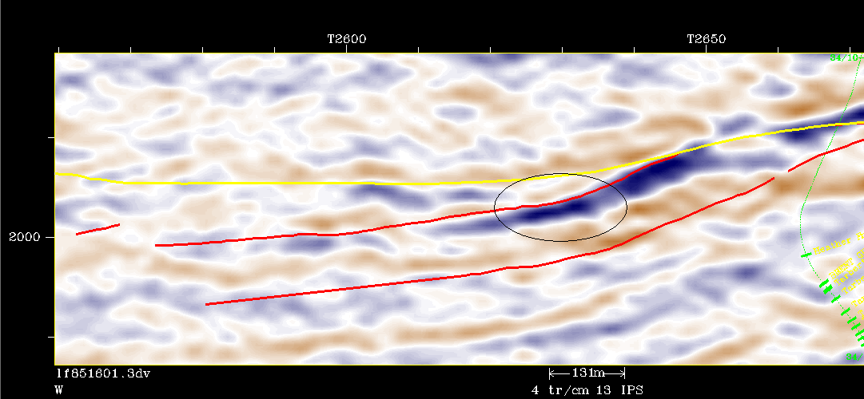

Figure 1: Inline 2741, where the horizons from Kritt, Brent and Ness are displayed. Gamma is denoted with a circle. This is mid 85 data.

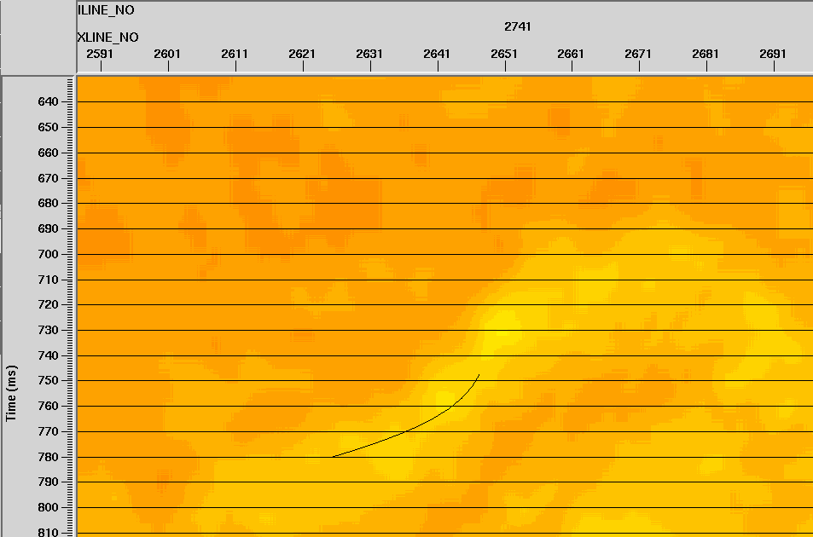

Figure 2: Show Vp/Vs ratio for inline 2741. The black line shows where Gamma is located.

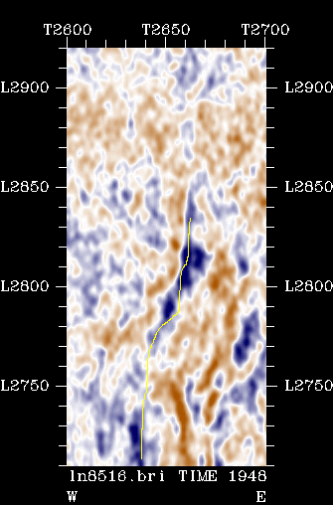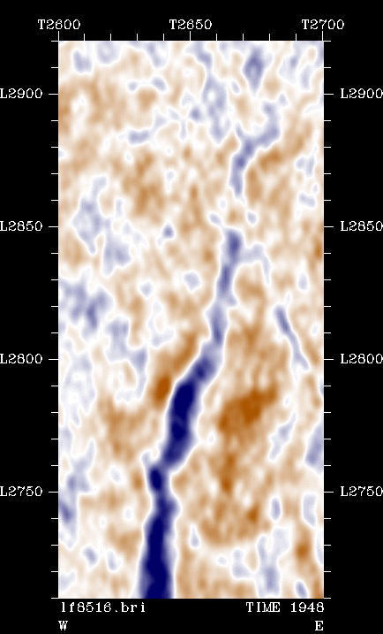
Figure 3:This two images show the near and far 85 data at depth 1948 ms. Far is to the right, you can see the amplitudes area stronger here. Gamma is the strong blue vertical reflector up to inline 2800.

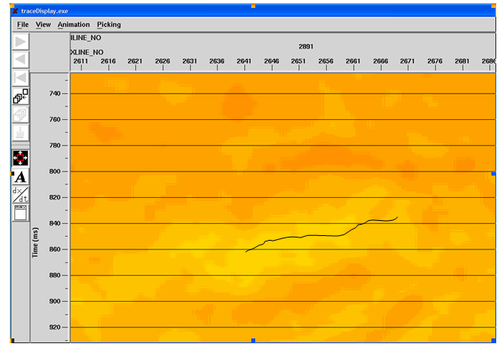
Figure 4: Show Vp/Vs ratio from inline 2891 Alfa north. The black line represents Alfa.

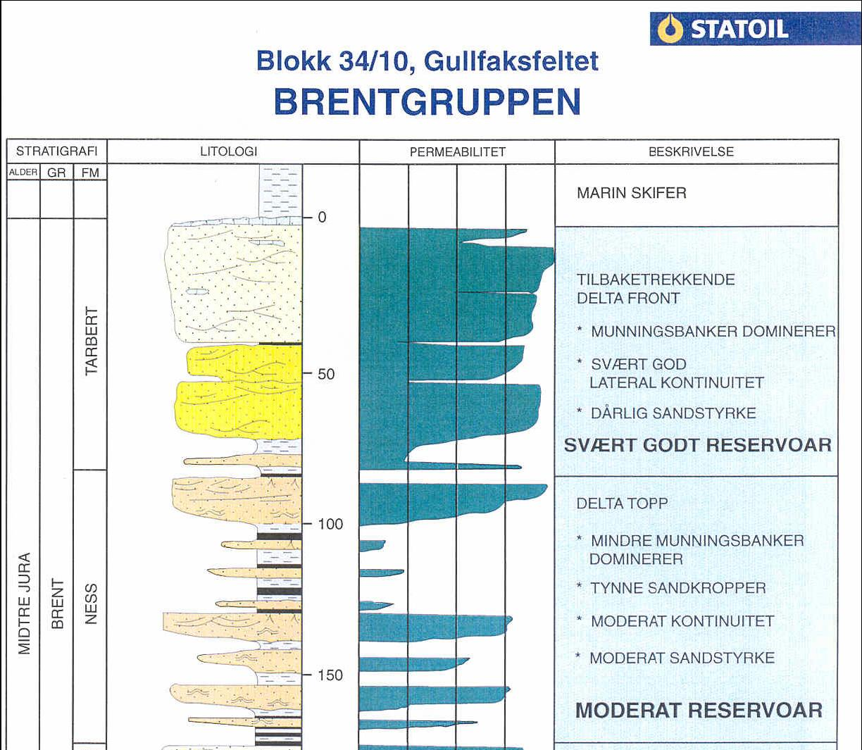
Figure 5

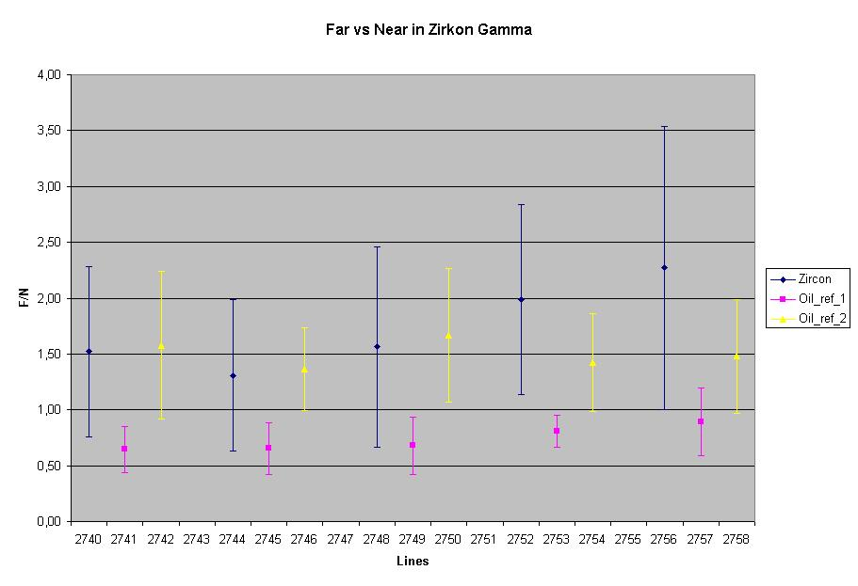
Figure 7.

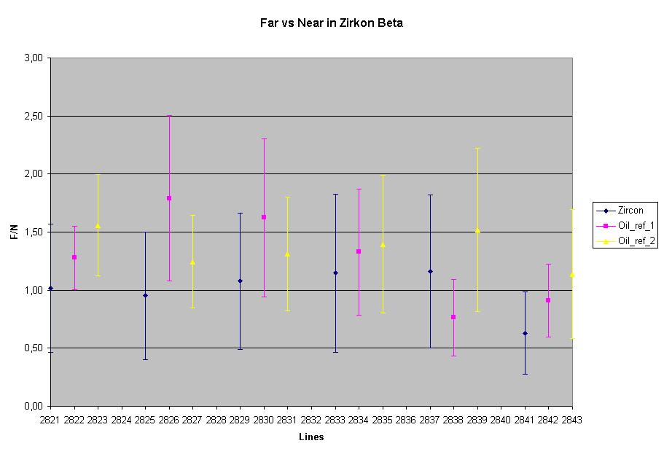
Figure 8
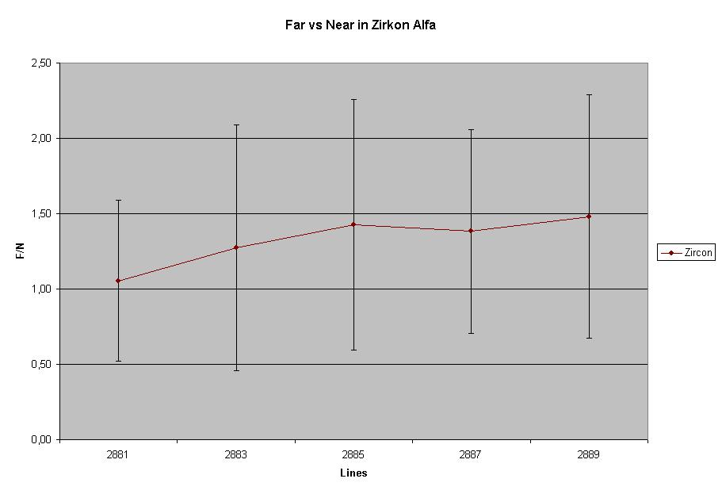
Figure 9

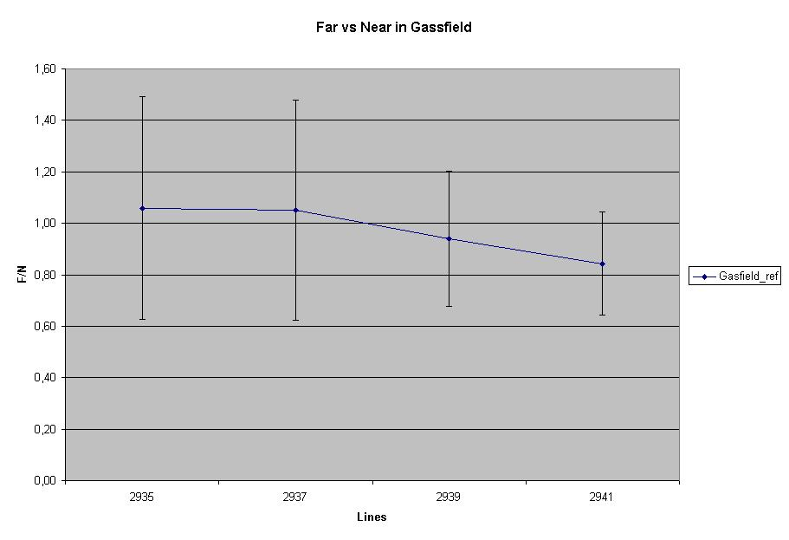
Figure 10

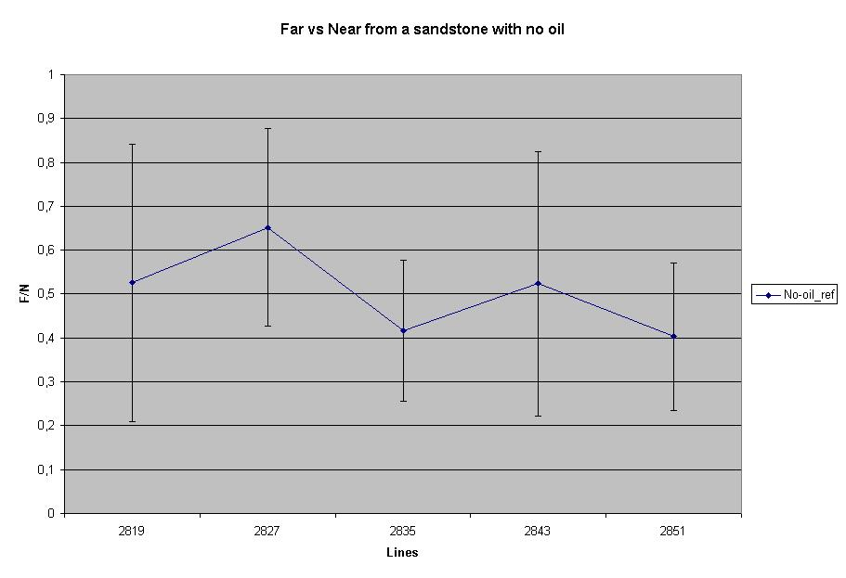
Figure 11

