EXPERT IN TEAM
GULLFAKS VILLAGE 2010

2/22/2010

GROUP 3

Content
1 Introduction 1
2 Stractural Geology of Gullfaks Area 2
2.1 Gullfaks Main Field 2
2.2 Gullfaks South 3
3 Source rocks and migration in Gullfaks South 4
4 Reservoir Quality, Statfjord Formation, Gullfaks South 5
5 Seismic data in Gullfaks 7
6 The wells in Gullfaks Sør 8
7 Simulation Results 14
7.1 Reference Case 14
7.1.1 Field 14
7.2 Extended Case 15
7.2.1 Field 15
7.2.2 Wells 15
7.3 Comparison 22
7.3.1 Field 22
8 Economic Evaluation 26
8.1 Assumption - General 26
8.2 Assumption - Alternative 1 – Drilling Platform 27
8.3 Assumption - Alternative 2 – Subsea Solution 27
8.4 Economic Results 28

Management Summary

Introduction
Fields, discoveries and prospects in the Gullfaks area are shown in Figure 1. The area comprises nine production licences. The red line in the figure divides the area into two parts: the Gullfaks field (Gullfaks/GF) and the Gullfaks satellites (Gullfaks SAT/GF SAT). Gullfaks SAT consist of Gullfaks South, Rimfaks, Gullveig, Skinfaks and Gulltopp. The Gullfaks Satellite Fields all lay on separate, westward rotated fault blocks in the southern part of the Tampen area to the west and south of the Gullfaks Field. The pre-Cretaceous structure is the result of two different rift phases – one Permian-Triassic and one late Jurassic-early Cretaceous. The structuring during the first phase partly controlled the development of the structural pattern during the latter phase. The area is dominated by late Jurassic–early Cretaceous rift-phase developments.

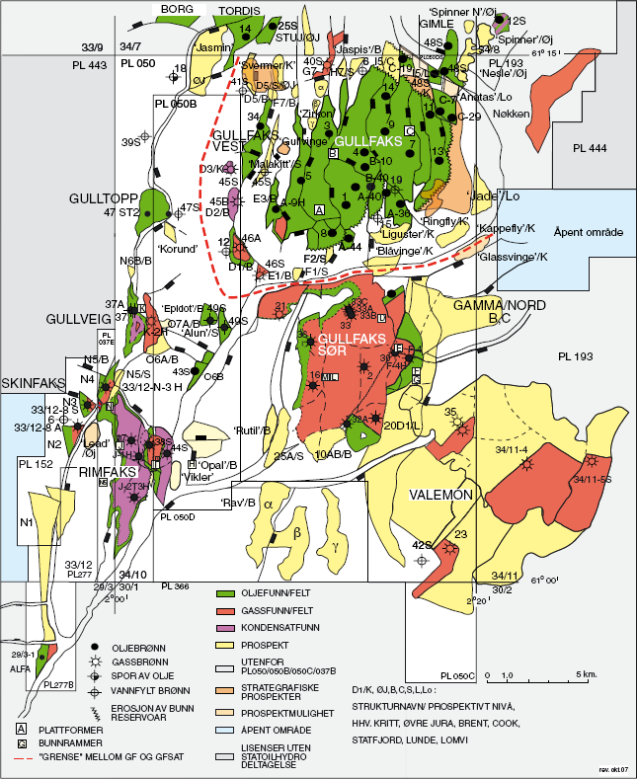

Figure 1: Field, discoveries and prospects

Stractural Geology of Gullfaks Area

Gullfaks Main Field
The Gullfaks Field lies to the west of the Viking Graben, and constitutes a structural high point in the Tampen area. The field comprises a number of rotated fault blocks, containing mainly pre-, but also syn-rift sediments as young as late Jurassic to early Cretaceous in age and is divided into three main structural domains (Figs. 2 ). The central and western areas of the field consist of a domino system of westerly dipping rotated fault blocks. A nonrotated horst complex lies farthest to the east. Between these two areas lies a complex accommodation area, characterised by a fragmented antiformal fold structure. The structural architecture of Gullfaks is mainly the result of late Jurassic-early Cretaceous rifting, although earlier rift structures of Permian-Triassic age probably influenced the later structural development to some degree (for more detailed description Ref.1.).
The field is dissected by a set of main faults which form an anatomising pattern, with a dominant north-south orientation in map view (Figure 2). These faults typically have offsets of between 50 and 250 metres, although throws of almost 500 metres are recorded. The main faults in the domino system have an eastward dip of approximately 30°. In the horst complex, the faults have a westward dip of approximately 60-65°.

Figure 2: General Average of Gullfaks main field

Gullfaks South
Gullfaks South represents the deepest structural level in Gullfaks SAT, with top reservoir at
2,860 m TVD MSL. In terms of both area and total resources in place, it is clearly the largest of the four fields. The faults in Gullfaks South have dominant N-S trends, and are associated with NE-SW and E-W trending faults. The fault density tends to increase at shallower stratigraphic depths (Brent Group), containing sediments that were less consolidated at the time of deformation. The Gullfaks South structure has traditionally been divided into three structural domains from west to east: the domino system, the transitional area and the horst complex (Figure 3).

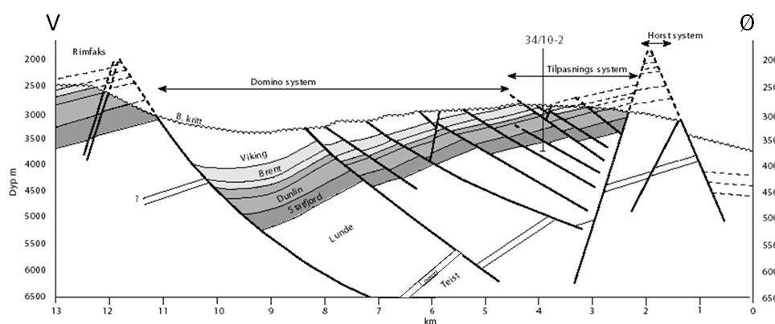
Figure 3: General cross-section of Gullfaks South
The domino system
The domino system is represented by recurring easterly dipping faults and westerly dipping layers. This is the dominating structural domain and constitutes the western and central parts of Gullfaks South.
The accommodation area
Between the domino system and the horst complex lays a transitional area which makes up the third structural domain on Gullfaks South. The transitional area (also referred to as the accommodation area) has a NNE-SSW orientation and is the most complex structural area.
During the fault development phase, this area must have acted as a buffer zone between the eastward-facing faults in the domino area and the westward-facing faults in the horst complex.
The horst complex
The horst complex makes up the eastern most part of Gullfaks South, and defines a structural crest with a NNE-SSW orientation and is delineated by easterly and westerly dipping faults.
This is also the most eroded area, mostly with Cretaceous sediments lying directly on the Triassic sediments of the Lunde Formation. Locally, up to 30 m of upper Jurassic with traces of unclean sands (34/10-F-4 H, -G-3 H) has been preserved beneath the Base Cretaceous Unconformity. The horst structure may be less deformed than the other parts of the field to the East, although the lack of good continuous seismic reflections makes this interpretation uncertain. In the east, the horst is bounded by a fault offset of more than 1,000 m. Fault seal analyses, including measurement of micro-faults in core samples, show significant reduction of fault rock permeabilities relative to the undeformed rock (Ref.2, 3).The fault rock permeability decreases with increasing amount of phyllosilicate minerals in the reservoir. This reduction is especially pronounced for faults in the Ness and Etive Formations, due to relatively low sand thicknesses in these layers and the consequent high probability for fault offset, and restricted fluid flow can be expected. Faults in the Tarbert Formation and Rannoch Formation have higher permeabilities, as the sand layer thickness is greatest for these intervals, and the communication in these zones is expected to be less restricted for a given fault offset. Faults in the Statfjord Formation are generally dominated by low permeability fault rocks that are likely to restrict fluid flow. Good communication across faults in the Eirikson Member, where cataclasite is locally distributed, was indicated in a fault seal analysis study. Production history, however, shows that this analysis was overly optimistic: this was later confirmed by a comprehensive micro structural study of cores from Wells 34/10-2 and 34/10-30 (Ref.4) .This study revealed the presence of deformation bands (containing cataclasite and framework phyllosilicate) leading to a reduction of the fault rock permeability by a factor of four relative to the undeformed rock. Obviously, this would contribute to the general poor flow characteristics of this reservoir.

Source rocks and migration in Gullfaks South
The conclusions from geochemical data and migration modelling studies are summarised below:

The fluids in Gullfaks South have been generated from a moderately mature marine Draupne Formation source rock.
- The field has primarily been filled from the east via the Lunde Formation through the Statfjord Formation to the Brent Group. The Brent Group in the Gamma structure to the East is juxtaposed against the Lunde Formation on the Gullfaks South Field across the main eastern boundary fault.
- The geochemical signature of the fluids in the western parts of Gullfaks South (Wells 34/10- 36 and 34/10-21) has a greater terrestrial kerogen source signature indicating that the fluids have received some contribution from a local kitchen area, probably in the west, which is oil- mature today.
- This kitchen also has the possibility of contributing oil to the 15AB/B and H/B prospects. The contribution from this basin will, however, be extremely limited.. The Draupne Formation in the southern part of the Viking Graben has passed beyond hydrocarbon generation today, but was oil-mature in the Palaeocene.
- The geochemical signature of the Statfjord Formation oil in Well 34/10-32R in the south of Gullfaks South indicates contribution from a local source. According to the local migration model, a local basin in the south contributes to this area – something that is positive for the prospects in Segments 10AB/B.

Reservoir Quality, Statfjord Formation, Gullfaks South
The upper Statfjord Formation interval, consisting of the Nansen Member and Eiriksson-2 unit, is approximately 70-80 m thick, while the lower Statfjord Formation interval, consisting of the Eiriksson1 unit and Raude Member, has a thickness of around 160-175 m. In a number of wells and observation boreholes, there have been clear indications of several hydrocarbon systems internally in the Statfjord Formation (Ref.2.). Empirical production data from Wells G-2 HT3 and F-4 AHT3 show that the reservoir pressure has decreased quite quickly and are indicative of limited communication laterally within the reservoir. This was the background to a geological study of the structure based on core material from exploration Wells 34/10-2 and 34/10-30 in the summer of 1999.The study found a number of deformation bands linked to faults and these were interpreted as the most important reason for reduced communication. The throw across the micro-faults/deformation bands is on a millimetre to centimetre scale, but dissolution and recrystalization of quartz has caused much reduced permeability across the deformation zones. In Well L-4 H (drilled during winter 1999/2000) the Statfjord Formation was found to be dry approximately 60 m above the OWC in the existing fluid model (3,362 m TVD MSL). This indicates that there are sealing faults within the Statfjord Formation and that the reservoir is significantly more complex than was originally assumed.
The assumed contacts for the Statfjord Formation at Gullfaks South are based on pressure measurements and log evaluations in Exploration Wells 34/10-2 and 34/10-30. The resistivity log in Exploration Well 34/10-32 is consistent with the same OWC. For volume calculations, we therefore assume a common GOC and OWC for most segments, even though we know that the detailed pressure picture is very complex, so that the contacts may vary locally.
In addition to the exploration wells, the Statfjord Formation has been logged in Wells F-4
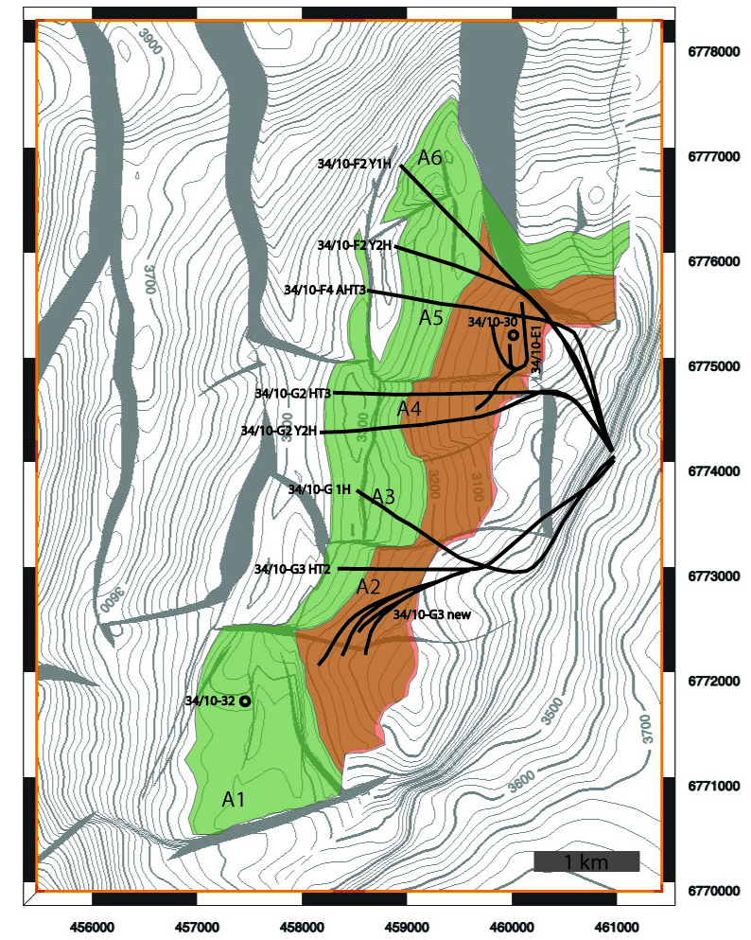
AHT3, G-2 H, G-2 T3H, G-3 HT2, G-1 H, G-2 Y2H, F-2 Y1H and F-2 Y2H (Figure 4).
Figure 4: Distribution of the Exploration and Production Wells

Seismic data in Gullfaks
Gullfaks is covered by a number of seismic volumes, both surface streamer seismic surveys and ocean bottom cable seismic data. The quality of the seismic data varies across the Gullfaks Field. Problems with imaging are often related to carbonate-cemented sands in the Hordaland Group and gas leakages. There are also areas of significantly reduced reflectivity associated with the near surface sediments deposited along the Norwegian Trench. A map showing the extent of these deposits, and a seismic cross-section illustrating the problems with data described above is shown in Figure 5.

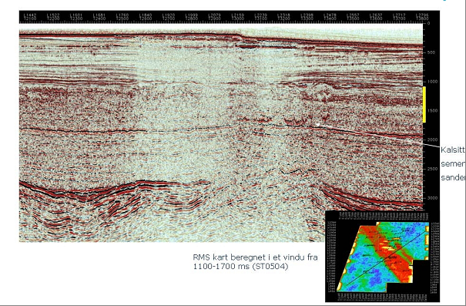
Figure 5: Seismic data quality.Gullfaks HF

The wells in Gullfaks Sør
The Gullfaks Sør field is located in the Statfjord formation, and consists of three zones. These are Nansen, Eiriksson and Raude. The reservoir model is divided into 15 layers(layer 15 inactive):
Formation |  | Layer
Nansen |  | 1, 2, 3, 4, 5, 6, 7, 8
Eiriksson |  | 9, 10, 11, 12, 13
Raude |  | 14, 15
Well | Comments |  | Prod. /Inj. from 2010 | Perforations in Nansen/Eiriksson/Raude | Perf. top | Perf. btm
G-2T3H | Prod. start 1999 |  | - | N, E, R | 3706 | 4930
G-2ML | Prod.start 2004 |  | P
F-4AT3H | Prod.start 1999 |  | P
G-3T2H | Prod.start 2001 |  | - | N | 4457 | 4955
G-1H | Prod.start 2003 |  | - | N, E, R | 4526 | 5253
F-2ML | Prod.start 2004 |  | P
F-1H | Future well (but included in basecase) |  | P
E-3H | Future injection well (but included in basecase), shut in 5 y before end simulation |  | I
G-4H | Future well (but included in basecase) |  | P
E-2BH | Future injection well (but included in basecase), shut in 5 y before end simulation |  | I
G-3Y3HT4 | Prod. start 2005 Lost? |  | -
E-1Y3H | Start 2006  Gas injector |  | - | N, E, R
Tabell 1: Old Wells
Well | Total perforated length [m] | k_{h}/k_{v} | High permeable layers
W1 | 997,6802 | 10 | 4, (7), 9, (10), 12, 13
W2W3 | 1095,714 | 10 | 4, (7), 9, (10), 12, 13
W4W5 | 1249,737 | 10 | 4, (7), (9), (10), 12, 13
W6W7 | 963,3361 | 10 | ((3)), 4, (10), 12, 13
GI-2 | 238,48 | 10 | ((3)), ¤, 7, (8), 9, (10), 12, 13
GI-4 | 231,3422 | 10 | ((1)), (3), 4, 7, ((8)), 9, (10), 12, 13
Tabell 2: New Wells
The data is found in the ‘Statfjord_(landsby_2010)’ directory in the Gullfaks database. We can see that layer 4 is the most permeable layer in the formation. Other high permeable layers are 9, 12 and 13. The parenthesis in Tabell 2 indicates the degree of high permeability.

There is assumed zero skin in the model. The wells are completed with 6 5/8” screens, 8.5” wellbore. In the base-case, five wells are producing from 2010 and two wells are injecting (Tabell 1). In addition, 6 more wells are added in the extended case, four producers and two injectors. The well trajectories are shon in Figure 6.
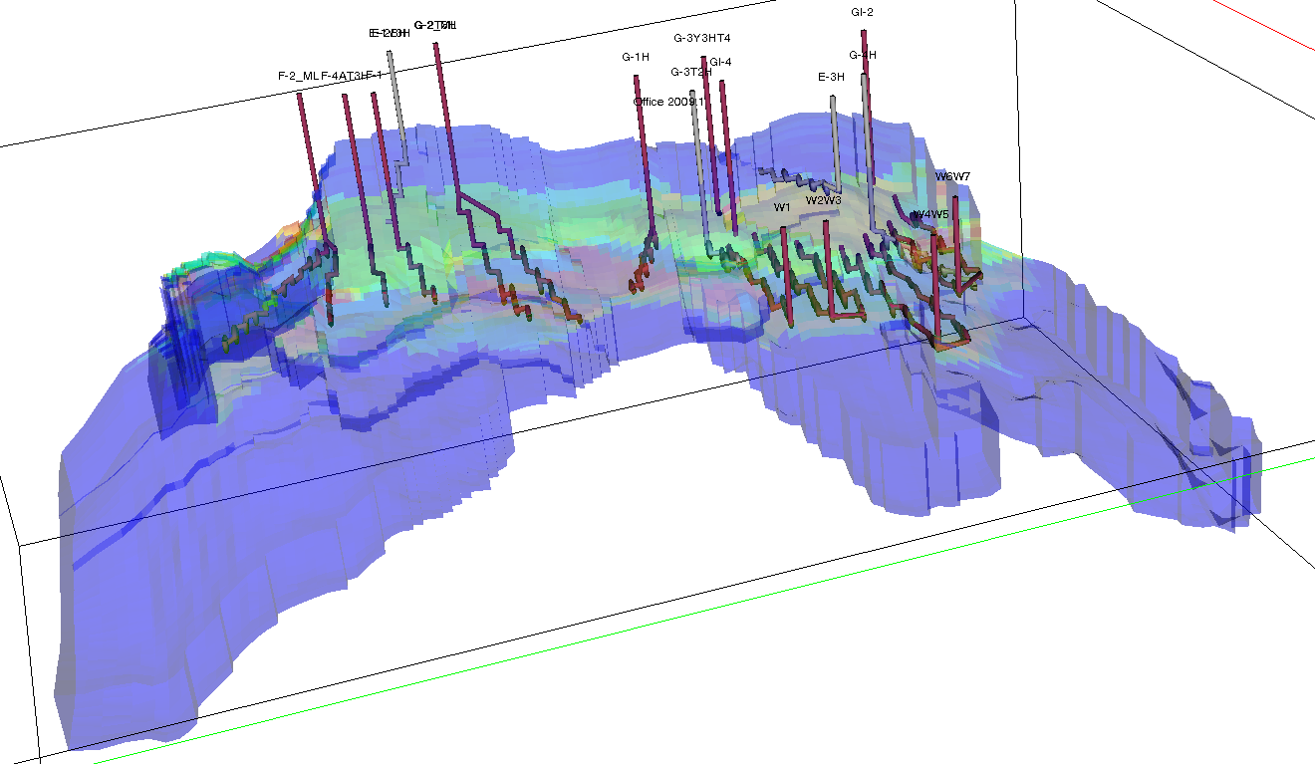
Figure 6 The reservoir with well trajectories, extended case
Permeability in the different layers in the Gullfaks Sør model:
At “GRAF” we can see the different permeabilities in the 14 different layers, by choosing horizontal section for each layer. The results from the figures matches with the observations from the wells. Examples shown from typical layers, high permeability layer 4, low permeability layer 6, mixed/medium permeability layer 3:

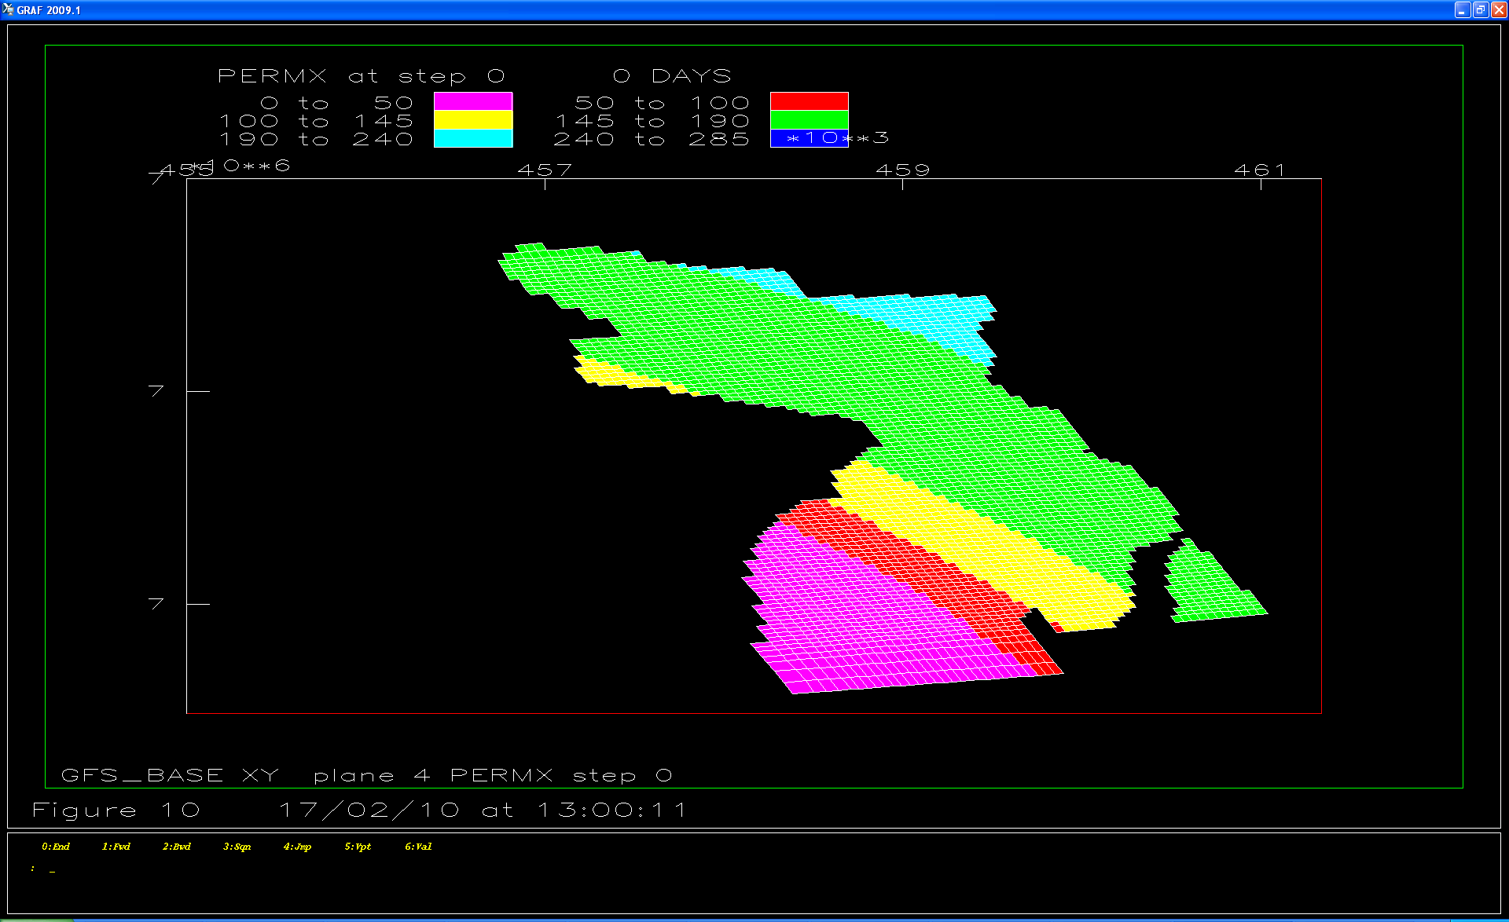
Figure 7 Layer 4
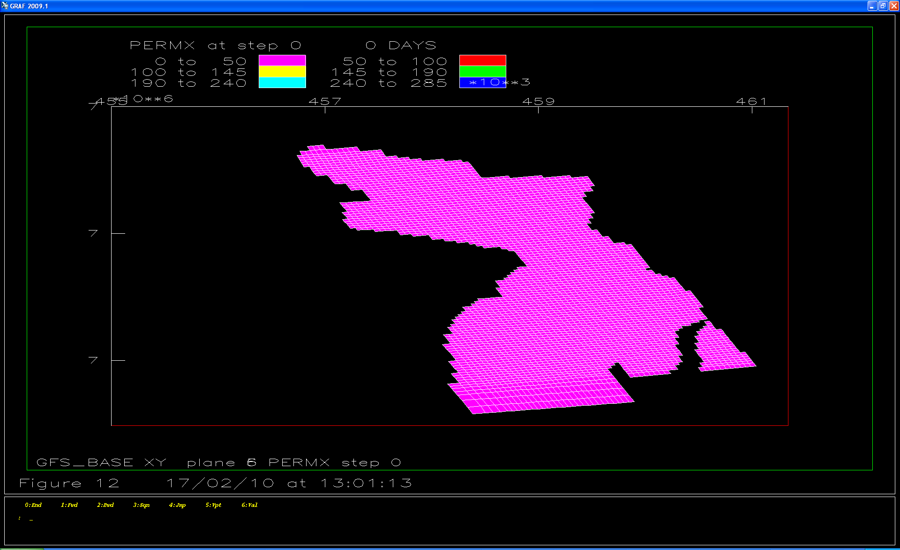
Figure 8 Layer 6

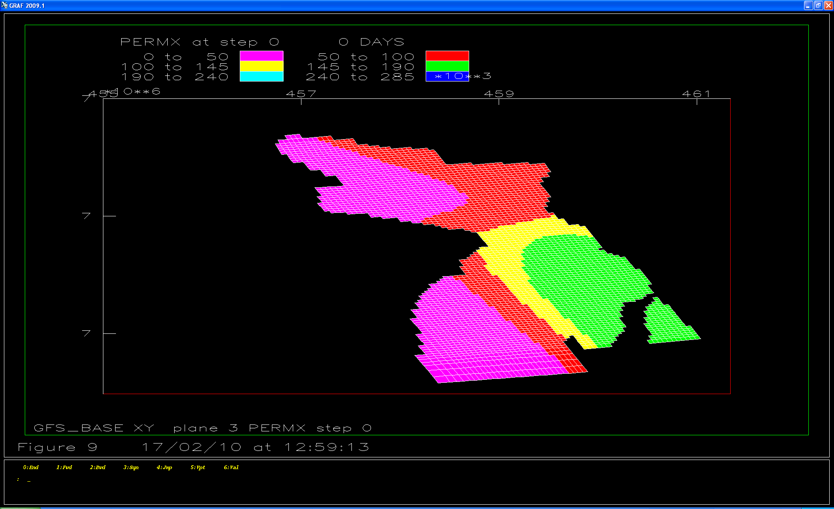
Figure 9 Layer 3

Simulation Results

Reference Case

Field
The reference case consists of 9 producers and 3 injectors. The total field production rates of oil and gas, and the water cut are displayed in Figure 10.

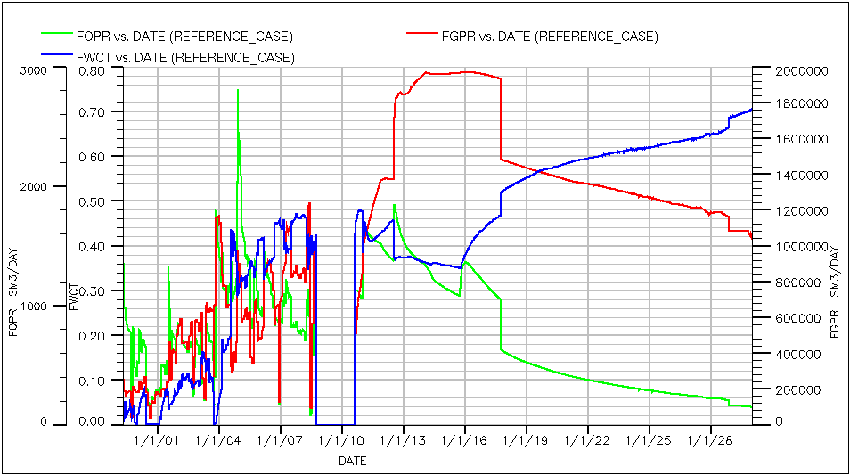
Figure 10: Field Oil Production Rate, Field Gas Production Rate and Field Water-Cut

Extended Case

Field
The extended case will, in addition to the wells and injectors from the reference case, also include 2 Gas Injectors on the existing E-template and 3 branched and 1 single oil producers on a new template. New total field production rates of oil and gas, and the water cut are displayed in Figure 11.

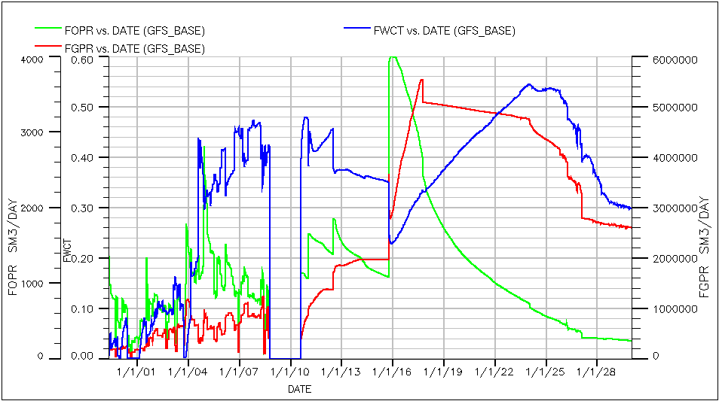
Figure 11: Field Oil Production Rate, Field Gas Production Rate and Field Water-Cut

Wells
The new single oil producing well is called W1 and the three branched oil producers are called W2W3, W4W5 and W6W7 respectively. The well oil production rates of the new wells are displayed in Figure 12. As seen W1 has a production rate plateau at 500 Sm³/day, while W2W3, W4W5 and W6W7 have production rate plateaus at 800 Sm³/day. But the plateau production rates lasts only for approximately 1 to 2 years, and the production rates start to fall. W4W5 is shut down 1/1/2027.
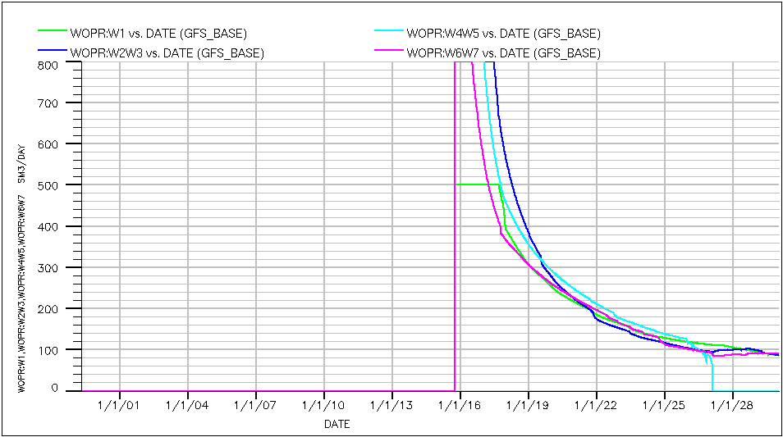
Figure 12: Well Oil Production Rates W1, W2W3, W4W5 and W6W7
The well gas production rates of the new wells are displayed in Figure 13. The gas production rates rise up to production rate plateaus of 1 000 000 Sm³ over a period of approx. 1 to 2 years. The gas production rate of W4W5 starts to fall about 1/1/2026 and is shut down 1/1/2027.

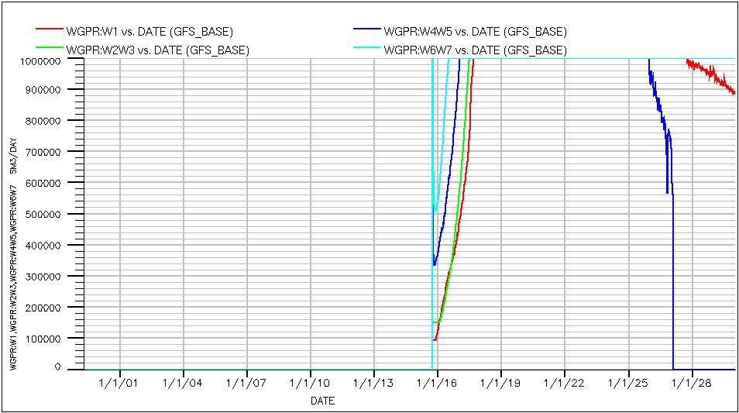
Figure 13: Well Gas Production Rates W1, W2W3, W4W5 and W6W7

The well gas-oil ratios for the new wells are displayed in Figure 14.
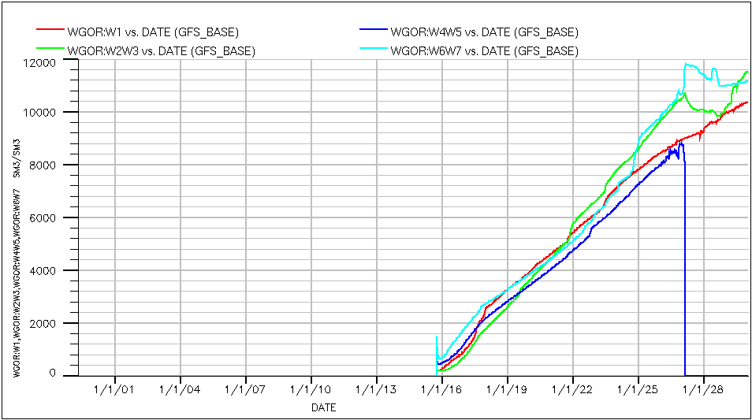
Figure 14: Well Gas Oil Ratio W1, W2W3, W4W5 and W6W7

The well water cuts for the new wells are displayed in Figure 15. The variations in water cut in the wells are considerable, as well W4W5 produce over 60% water at its maximum in 2026, while well W6W7 produce approx. 5% water at the same time, and has its maximum at 12% at the start of production. W1 and W2W3 both have their maximum water cut at approx. 40% in the beginning of 2028.

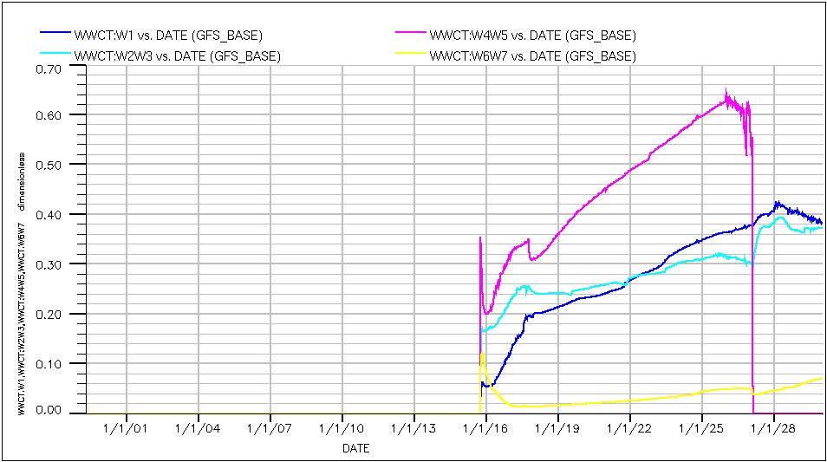
Figure 15: Well Water Cut W1,W2W3, W4W5 and W6W7

The bottom hole pressures of the wells start at approx. 400 bara at the start of production, and falls steadily to approx. 100 bara at the end of production. This is displayed in Figure 16: Well Bottom Hole Pressure W1, W2W3, W4W5 and W6W7

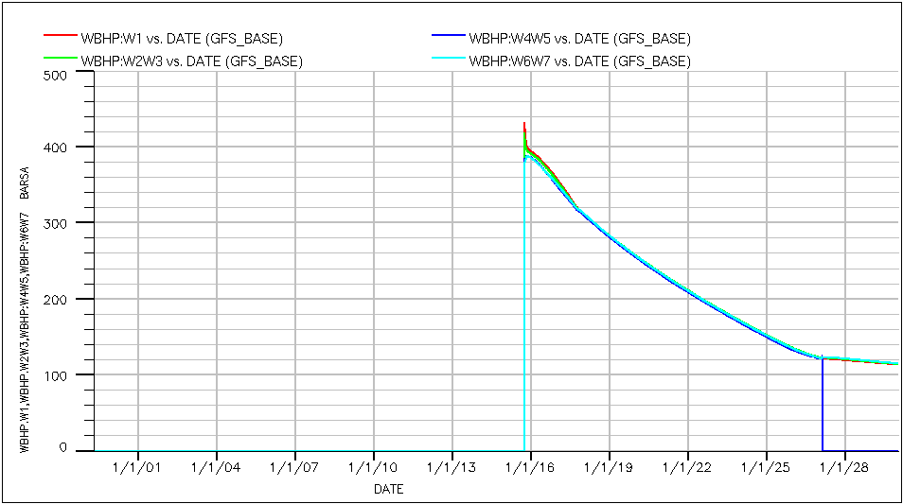
Figure 16: Well Bottom Hole Pressure W1, W2W3, W4W5 and W6W7

W1:
Oil production rate plateau of 500 Sm³/day from start of production to late 2017, where the production rate starts to fall. At the same time the gas production rate plateaus at 1 000 000 Sm³/day. The gas production rate plateau lasts to late 2027, when the production rate starts to fall. At this time the oil production rate and water cut also has a visible fall. The water cut rise from approx. 6% at the start of production to approx. 20% in late 2017, and continues to rise at a lower rate to approx. 42% in early 2028 and then drops (Figure 17).

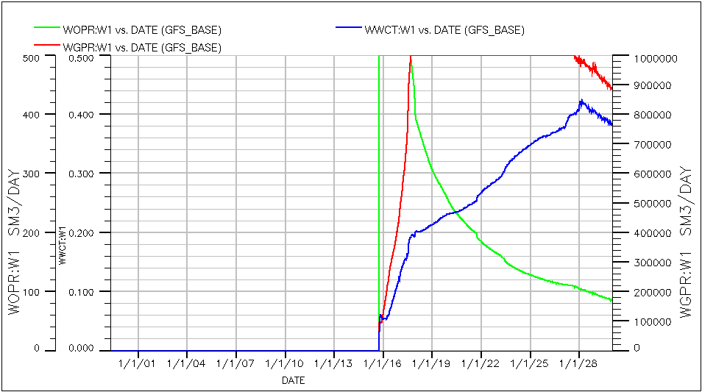
Figure 17: Well Oil Production Rate, Well Gas Production Rate and Well Water Cut for well W1.

W2W3:
Oil production rate plateau of 800 Sm³/day from start of production to midway in 2017, where the production rate starts to fall. At the same time the gas production rate plateaus at 1 000 000 Sm³/day. The water cut rise from approx. 14% at the start of production to approx. 25% midway in 2017, and continues to rise at a lower rate to nearly 40% in the beginning of 2028 (Figure 18).

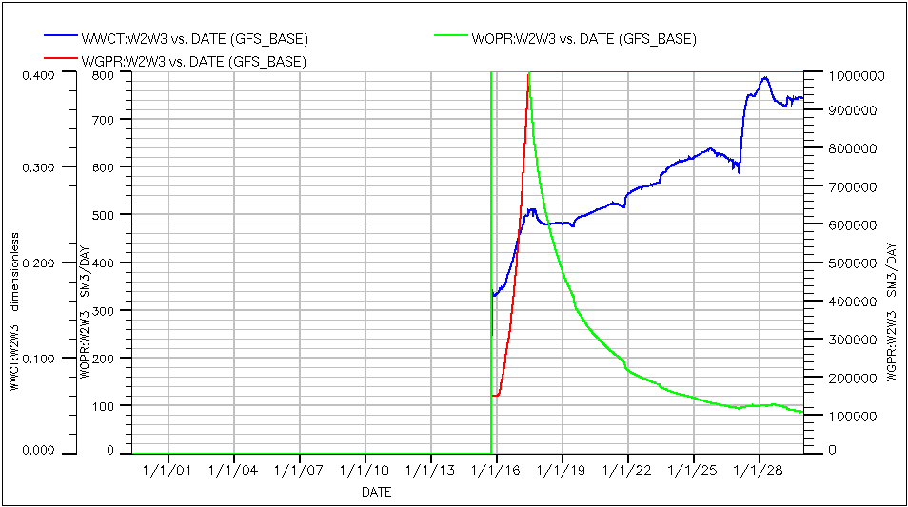
Figure 18: Well Oil Production Rate, Well Gas Production Rate and Well Water Cut for well W2W3.

W4W5:
Oil production rate plateau of 800 Sm³/day from start of production to the beginning of 2017, where the production rate starts to fall. At the same time the gas production rate plateaus at 1 000 000 Sm³/day. The gas production rate plateau lasts to late 2025, when the production rate starts to fall. At this time the oil production rate and water cut also has a visible fall. The water cut rise from approx. 20% at the start of production to approx. 35% in early 2017, and continues to rise at a lower rate to approx. 64% in late 2025. The well is shut down 1/1/2027 (Figure 19).

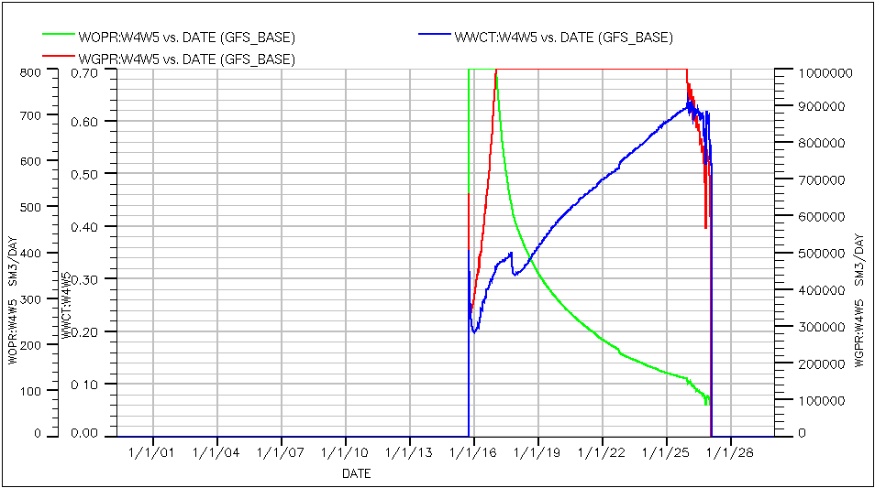
Figure 19: Well Oil Production Rate, Well Gas Production Rate and Well Water Cut for well W4W5.

W6W7
Oil production rate plateau of 800 Sm³/day from start of production to late 2016, where the production rate starts to fall. At the same time the gas production rate plateaus at 1 000 000 Sm³/day. The oil production rate hits a second plateau in early 2027 at approx. 90 Sm3/day, and lasts until end of production. The water cut falls from approx. 12% at the start of production to approx. 1.5% in late 2016. From here it starts to rise to approx. 5% in early 2027, where it suddenly drops to approx. 4%, and starts to rise until it reaches a water cut of approx. 7% at the end of production (Figure 20).
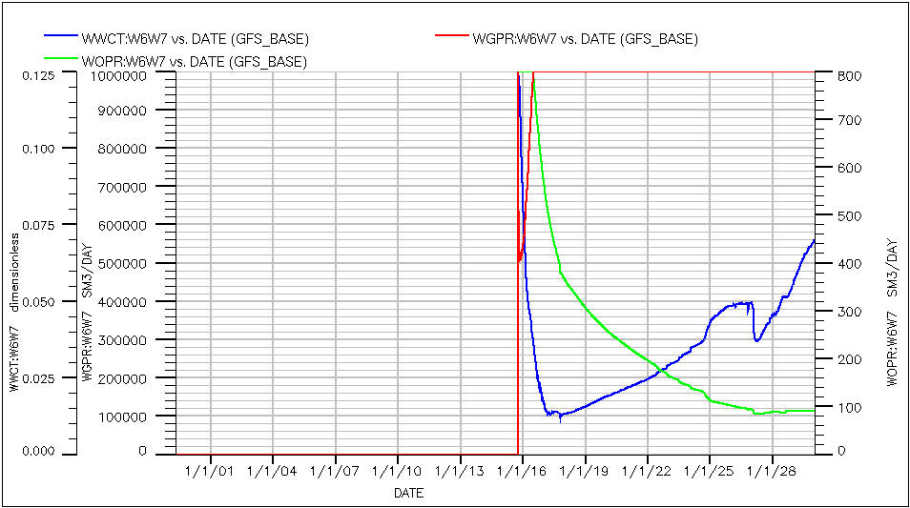
Figure 20: Well Oil Production Rate, Well Gas Production Rate and Well Water Cut for well W6W7.

Comparison

Field
The field oil production rate of the reference case and the extended case is displayed in Figure 21. When the new wells start producing there is a sudden rise of the field production rate from approx. 1 200 Sm³/day to approx. 4 000 Sm³/day in the extended case. But after a short period of time it starts to fall rapidly until late 2017, where the fall decreases. This increase in field production rate will increase the total field production of oil as displayed in Figure 22. The field oil efficiency (the recovery factor) is displayed in Figure 22.
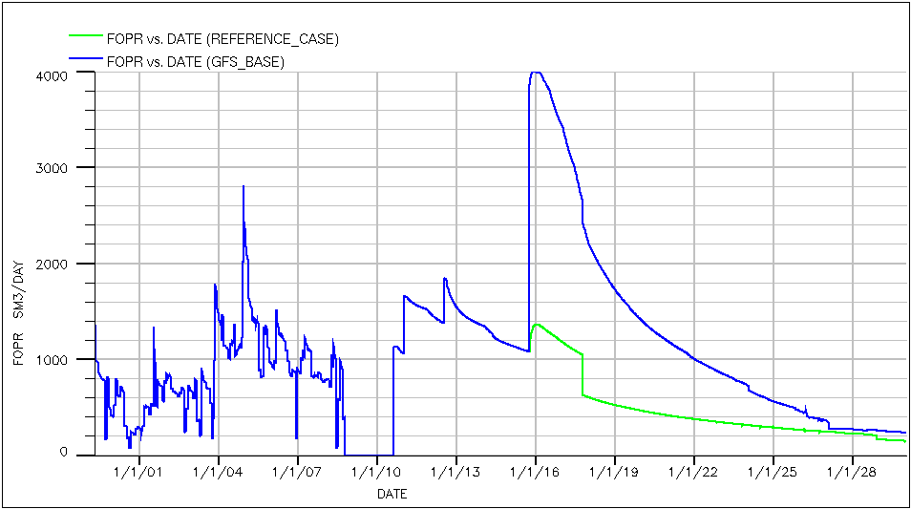
Figure 21: Field Oil Production Rate for the Reference Case and the Extended Case.

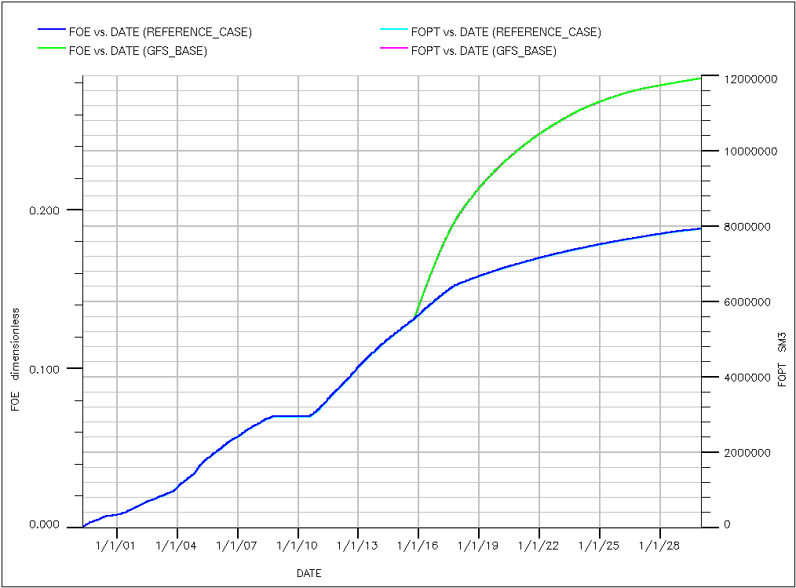
Figure 22: Field Oil Production Total for Reference Case and the Extended Case.

In 1/10/2015 in the extended case two new gas injectors are introduced to the field. The field gas production rates for the reference case and the extended case are displayed in Figure 23. The field gas production rate rise from approx. 2 000 000 Sm³/day to approx. 5 000 000 Sm³/day in about 2 years in the extended case. This increase in field production rate will increase the total field production of gas as displayed in Figure 24.

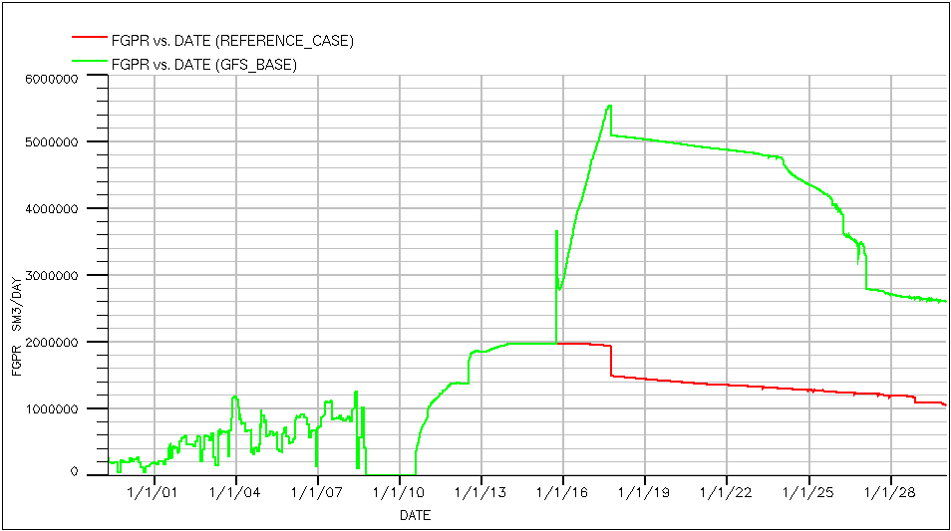
Figure 23: Field Gas Production Rate for the Reference Case and the Extended Case.
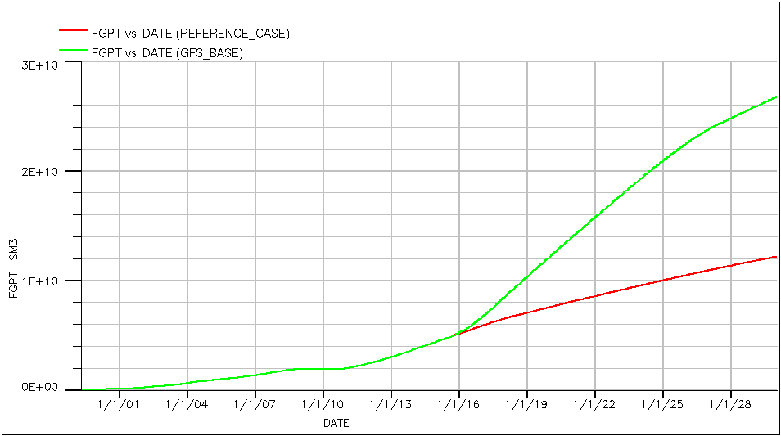
Figure 24: Field Gas Production Total for the Reference Case and the Extended Case.

The increase in field produced gas compared to oil will increase the gas-oil ratio in the extended case, compared to the reference case. This is displayed in Figure 25.

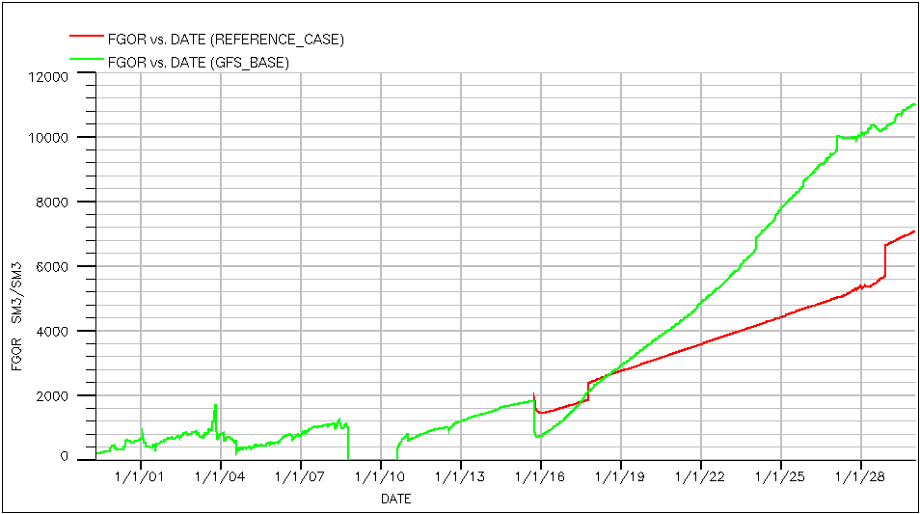
Figure 25: Field Gas-Oil Ratio for the Reference Case and the Extended Case.
Due to the increased gas production rate the field water cut decrease when the new wells start producing. This is displayed in Figure 26.
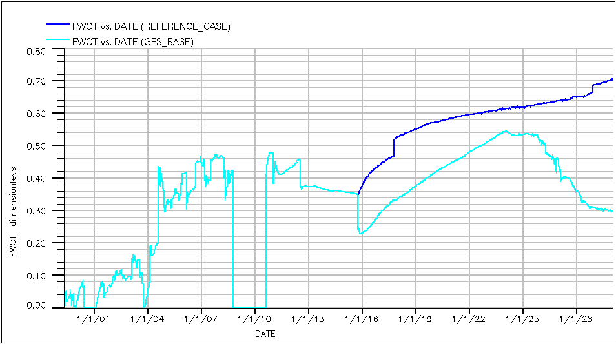
Figure 26: Field Water Cut for the Reference Case and the Extended Case.
The field pressure in the Extended Case falls at a higher rate than in the Reference Case. This is due to increased oil production. The gas injectors are supposed to keep the pressure at a higher level, but fail to do so.
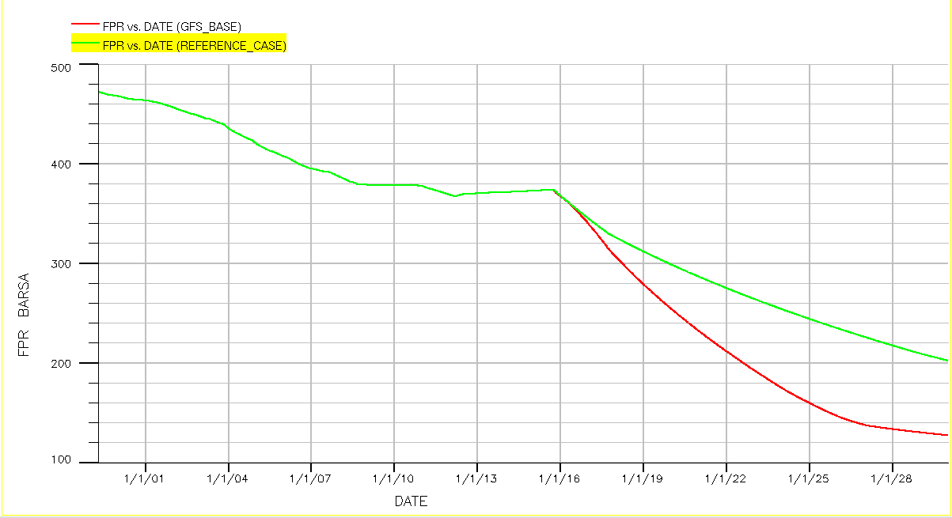

Figure 27: Field Pressure Rate for the Reference Case and the Extended Case.

Conclusion
When the field is extended with 4 producers and 2 gas injectors the recovery factor is increased from 19% to 28%, that leads to an increase in the total field production of 4 000 000 Sm³, to a total of 12 000 000 Sm³. But by injecting gas into the field the gas production rate rises. This increase in gas production results in a higher gas-oil ratio. When the injected gas reaches the new wells the oil production rates suddenly drops. Another observation is that the injectors do not seem to keep the pressure in the field up at a satisfying level.

Economic Evaluation
For the Economic Evaluation the Net Present Value model is used. The evaluation compares two different alternatives with each other. In the following pages the two alternatives are introduced, the assumptions are stated and the result of the analysis is shown.

Assumption - General
- Oil
  - Price - Increasing with 4%/a
  - Price - Start 2015 - 450 NOK/bbl
  - Oil for calculation = FOPTEXTEND - FOPTREFERENCE
  - All produced oil is soled
- Gas
  - Price - Increasing with 2%/a
  - Price - Start 2015 - 2 NOK/Sm^3
  - Gas for calculation = FGPTEXTEND - FGPTREFERENCE
  - Sold Gas = Produced Gas – Injected Gas
- Interest Rate - 5 %
- Exchange Rate - 6 NOK/USD
- Three cases for each alternative
  - Base NPV
    - Normal Oil Price
    - Normal Opex
    - Normal Capex
  - Best NPV
    - +40% Oil Price
    - -40% Opex
    - -40% Capex
  - Worst NPV
    - -40% Oil Price
    - +40% Opex
    - +40% Capex

Assumption - Alternative 1 – Drilling Platform
- Capex
  - Investment for a Plattform – 1.00*10^9 NOK
  - Drilling Cost – 6*10^8 NOK
  - Capex is invested in 2015

- Opex is 2.5% of Capex + Oil Income

Assumption - Alternative 2 – Subsea Solution
- Capex
  - Floater Cost for 6 Month – 3.24 * 10^8 NOK
  - Drilling + Subsea Plattform – 1.75*10^9 NOK
  - Capex is invested in 2015
- Opex is 2.5% of Capex + Oil Income

Economic Results

Net Present Value

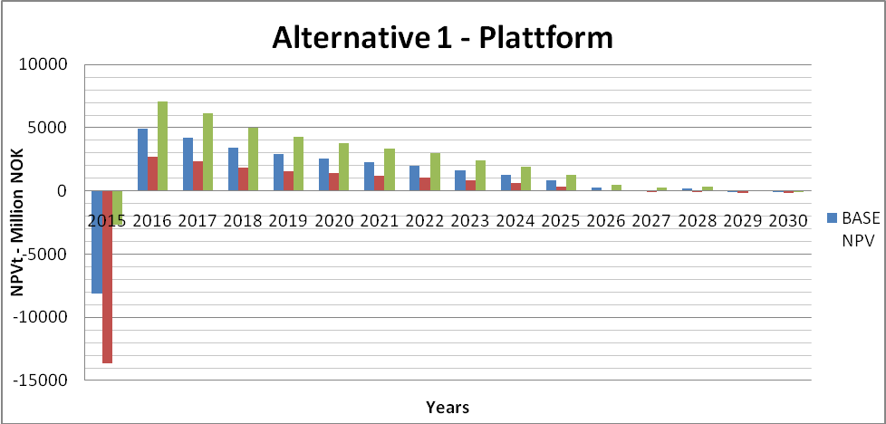
Figure 28: NPV Alternative 1
The NPV of alternative 1 (Figure 28), shows a negative cash flow in the first year this is related to the high investmen costs. After the year 2028 it isn’t economical do run the project, because of the high opex cost and the reduced oil production.

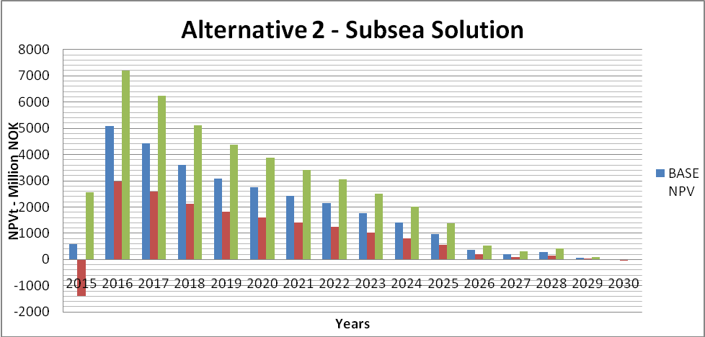
Figure 29: NPV Alternative 2

The net present value as shown in Figure 29 is a high economic one, even with the investment in the first year the base and best case are still profitable. The profability decreases from year 2016 until the end because of the reduced oil production.

Cumulative Net Present Values
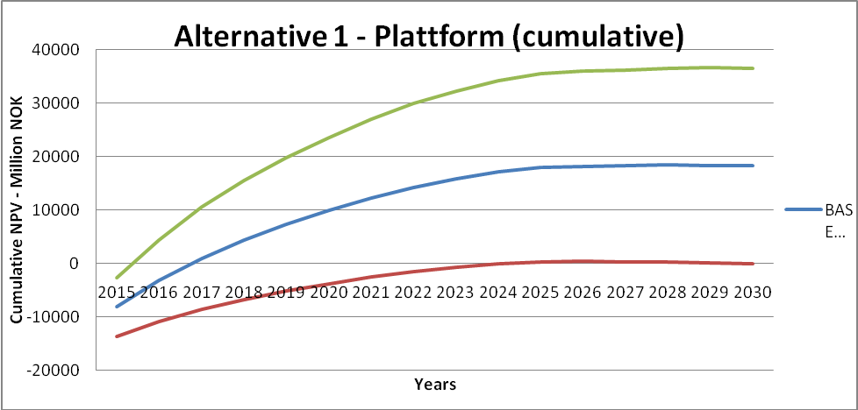
Figure 30: Cumulativ NPV
Figure 30 shows the cumulative NPV of the Platform. In the best case the BEP is reached after the first year of production. In the base case it takes two whole years. In the worst case the BEP is reached after 10 years. The worst case shows a non-profitable project in contrast to the best and base scenario.

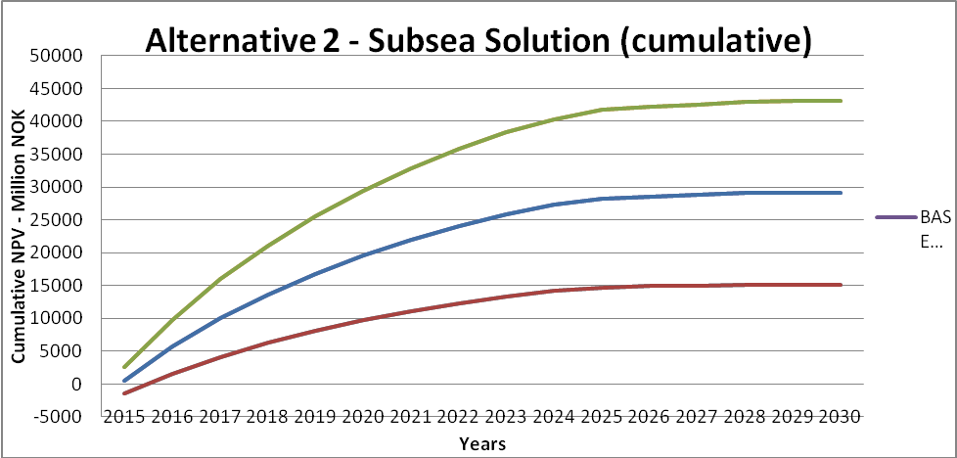
Figure 31: Cumulativ NPV Alternative 2
Figure 31 shows the cumulative NPV of the subsea solution. In the best and base case the BEP is reached in the first year of production. In the worst case it takes up to one year. All three scenarios are highly profitable .

Sensitive Analysis
The Sensitive Analyses shows the sensitivty to the different parameters which are included into the model. Figure 32 and Figure 33 are showing that the factor which has most influence on the NPV is the Gas price followed by the oil, capex and opex.

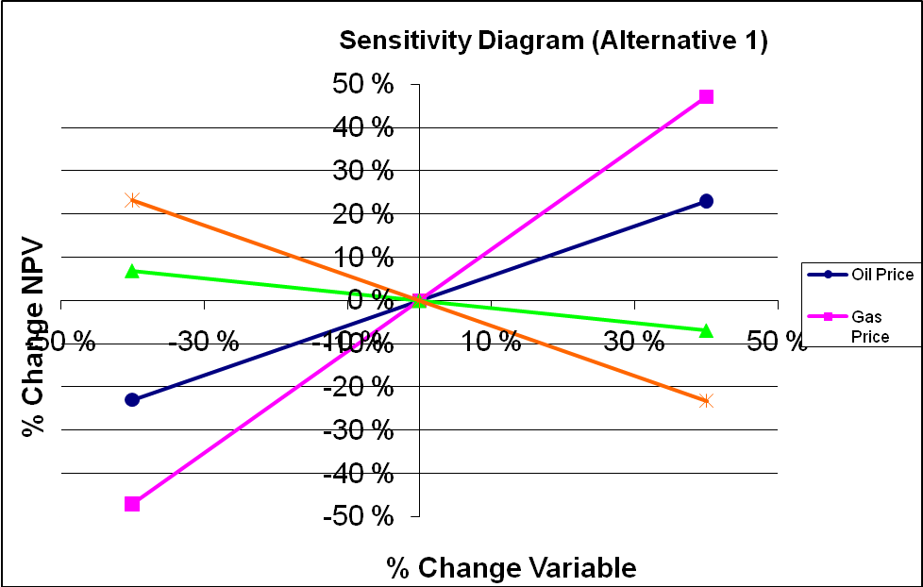
Figure 32: Sensitive Analyses Alternative 1
The alternative one shows a high sensity to changing oil and gas price. If the gas price increases with 10 % the NPV increases with 15 %. This relation leeds to a higher risk factor for the project.
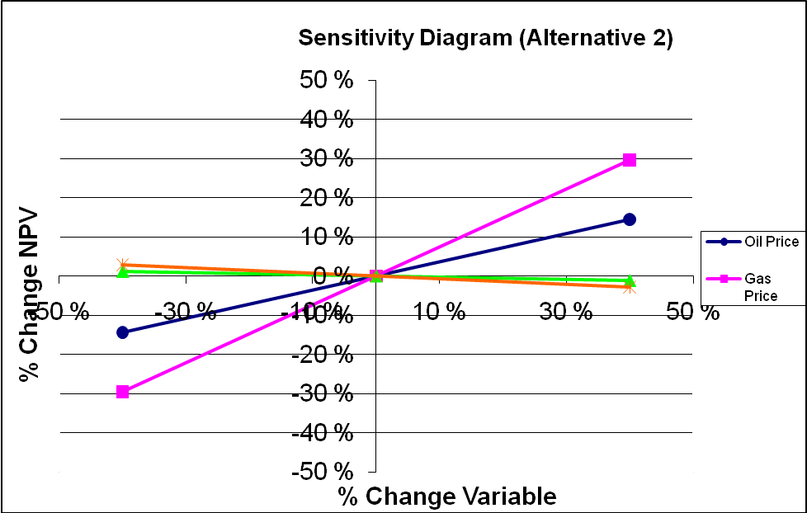
Figure 33: Sensitive Analyses Alternative 2
The alternative two shows the same sensity to a changing oil and gas price. If the gas price increases with 10 % the NPV increases with 10 %. In comparison to Alternative1 the factor of risk is reduced. .

The higher Investment of alternative one makes it less profitable and more dangerous, as we can see in the worst case scenario. From the economical analysis the second alternative is the clear favourite, because all scenarios are high profitable and the sensitivity to a change in the oil or gas price is lower. However before taking a final decision non-economical aspects should be taken into consideration which show the advantages or disadvantages between the two possible solutions..

Figure 1: Field, discoveries and prospects 1
Figure 2: General Average of Gullfaks main field 2
Figure 3: General cross-section of Gullfaks South 3
Figure 4: Distribution of the Exploration and Production Wells 6
Figure 5: Seismic data quality.Gullfaks HF 7
Figure 6 The reservoir, extended case 10
Figure 7 Layer 4 10
Figure 8 Layer 6 11
Figure 9 Layer 3 11
Figure 10: Field Oil Production Rate, Field Gas Production Rate and Field Water-Cut 14
Figure 11: Field Oil Production Rate, Field Gas Production Rate and Field Water-Cut 15
Figure 12: Well Oil Production Rates W1, W2W3, W4W5 and W6W7 16
Figure 13: Well Gas Production Rates W1, W2W3, W4W5 and W6W7 16
Figure 14: Well Gas Oil Ratio W1, W2W3, W4W5 and W6W7 17
Figure 15: Well Water Cut W1,W2W3, W4W5 and W6W7 18
Figure 16: Well Bottom Hole Pressure W1, W2W3, W4W5 and W6W7 18
Figure 17: WOPR, WGPR and WWCT W1 19
Figure 18: WOPR, WGPR, WWCT W2W3 20
Figure 19: WOPR, WGPR, WWCT W4W5 21
Figure 20: WOPR, WGPR, WWCT W6W7 22
Figure 21: FOPR, Reference and Extended Case 23
Figure 22: FOPT Reference an Extended Case 23
Figure 23: FGPR Reference and Extended Case 24
Figure 24: FGPT Reference and Extended Case 24
Figure 25: FGOR Extended and Refernce Case 25
Figure 26: FWCT Reference and Extended Case 25
Figure 27: FPR Reference and Extended Case 26
Figure 28: NPV Alternative 1 28
Figure 29: NPV Alternative 2 29
Figure 30: Cumulativ NPV 29
Figure 31: Cumulativ NPV Alternative 2 30
Figure 32: Sensitive Analyses Alternative 1 31
Figure 33: Sensitive Analyses Alternative 2 31

References:

(Geology-Part)
1. Structural geology of the Gullfaks Field, 1995 GF/PETEK 945145R
2. Faulting and Fault Sealing in the Gullfaks Sør Field. Statoil rapport 9802. 98S00004479(1).
3. Kartlegging av forkastningsbergarter og beregning av transmissibilitetsfaktorer på Gullfaks
4. Orientation, distribution and microstructure of deformation bands within Wells 34/10-2 &
34/10-30. Rapport GF-PETEK-99, 714, av14.07.99.
5. Reservoarstyringsplan for Gullfaks Satellitter, oktober 2003.

