GullfaksVillage 2010
NTNU - Experts in Team (EiT)
Improved Oil Recovery from Gullfaks Sør Statfjord
Presented at IPT, NTNU on January 20, 2010

- Introduction

An important goal for Statoil is to increase the recoverable oil reserves from the Gullfaks license through launched technology programmes and improved reservoir management. The term IOR is widely used for Improved Oil Recovery and this term is also used for the GullfaksVillage. IOR-projects draw upon expertise from across the whole Statoil organization and different experts are working together in teams. The GullfaksVillage will use a similar work process with a goal to develop innovative recommendations that could increase the oil recovery by 10 % from one of the fields in the Gullfaks area.

As a part of the Experts in Team concept, Statoil has installed a large Gullfaks database at NTNU, and will present new data with main focus on the assignment for 2010. Furthermore, the students will be invited to one day at Statoil’s offices at Sandsli, Bergen where all required information will be provided plus that the students will be able to discuss the challenges with personnel that work with these issues in Statoil.

Figure 1 shows the Gullfaks area where the main field came on production in 1986. It has had pressure maintenance, mostly through water injection, from the start. Gas injection has been used to drain attic oil and Water-Alternating-Gas (WAG) injection has also been employed to improve vertical sweep. As of yearend 2009, the Gullfaks main field has produced 345 MSm³ which is 56 % of the in-place volumes. The ambition for Estimated Ultimate Recovery (EUR) is 400 MSm³ which represents 70 % recovery.

The Norwegian Petroleum Directorate (NPD) has an IOR-award in order to recognize licenses, companies, projects or individuals that have created additional value on the Norwegian continental shelf through brave IOR-actions and plans. For the year 2004, the Gullfaks licence won this prestigious award

In addition to Gullfaks main field there are six satellite fields: Gullfaks Sør, Rimfaks, Gullveig, Gimle, Gulltopp and Skinfaks, see Figure 1. Production from the first three satellites started in 1998, while Gimle came on stream in 2005 and Gulltopp and Skinfaks in 2007. The reservoir description is similar for all fields in the Gullfaks area, but the satellite fields contain more gas than oil – often with a significant gas cap. In addition, Gullfaks Sør reservoirs are also significantly deeper, and the properties are much less favourable.

The challenge for the GullfaksVillage 2010 is to propose measures that can increase the oil recovery from the Gullfaks Sør field. It contains large oil volumes in both the Brent Group and the Statfjord Formation (Fm.). The GullfaksVillage 2010 shall focus on the Statfjord Fm., where the in-place volumes are 40.6 MSm3 of oil/condensate and 18.9 GSm3 of gas. The field has produced 3.3 MSm³ of oil/condensate to date - significantly less than the 12 MSm³ anticipated in the Plan for field Development and Operation (PDO) from 1995. Gas production to date is 2.0 GSm³ of which 0.2 GSm³ has been reinjected. The field has been shut in since September 2008 due to low reservoir pressure.

The project consists of two parts, where the first part shall be solved by all groups. The second part is different for each group. The groups must obtain an expert knowledge of the Gullfaks Sør Statfjord history and understand the IOR-challenges for the field. This knowledge should be the basis for evaluating IOR-measures and provide a recommendation based on own ideas supported by technical analyses. The groups should work independently, but are advised to draw on the advisors available in Statoil and NTNU.

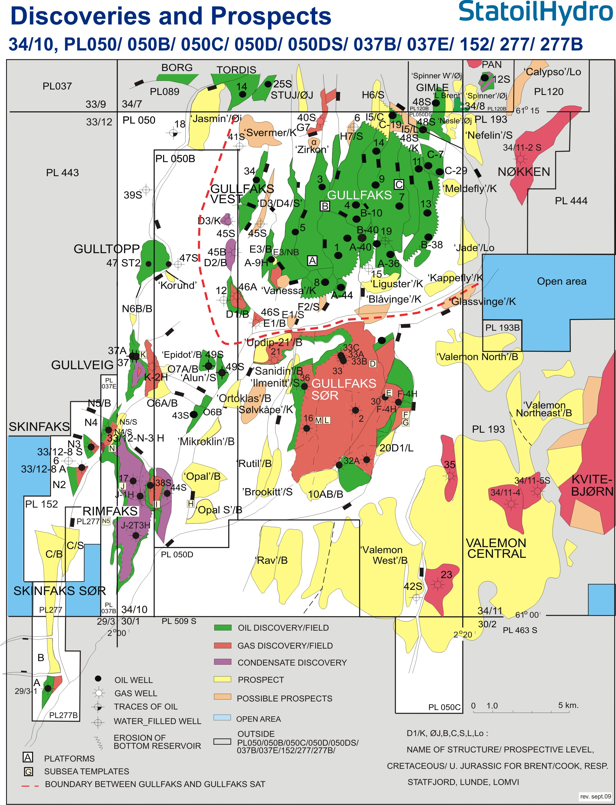
Figure 1. Fields and discoveries in the Gullfaks area.

- Visit to Statoil in Bergen on March 3

Prior to the visit, all students should have finished part A of the challenge and have reviewed relevant information inpreparation for part B. Reports from earlier Gullfaks villages may be relevant (see especially Ref. 2). All groups should submit a written document to Statoil that lists the question they want to have resolved in order to finalize part B. Soon after the visit in Bergen and no later than 10 March at 15:00, each group should submit a brief report to Statoil containing:

- A very short summary of the visit and main observations.
- The final description of part B of the assignment.

- Statoil’s role

All required information will be provided by Statoil from the presentations, from the Gullfaks Reservoir Management Plan (Ref. 1) and the visit to Statoil. In addition each group will have a contact person in Statoil that can be consulted as a supplement to the team at NTNU. If necessary, a representative from

Statoil may participate on one of the village-days to answer questions and address issues that need more explanation.

The challenges provided by Statoil shall be the basis for a technical report from each group. Statoil will participate at student presentations of the final results and provide input to the evaluations of the student reports.

- Milestones

Milestones for GullfaksVillage 2010 are:

Milestone | Task
20 January | Statoil will presents current challenges at Gullfaks | Presentations in Auditorium
24 February | Part A of project complete | Submitted to NTNU
3 March | Visit to Statoil | Presentations in Bergen
10 March | Report from visit to Bergen.  Finalise assignment part B. | Submitted to Statoil
21 April | Student presentation of the results and posters | Presentations in Auditorium
April 28 | Deadline for final report | Submitted to NTNU

- GullfaksVillage 2010 challenge

All the groups should solve part A of the challenge. Under part B there are six different challenges – one for each group.

Part A (Should be solved by all groups) (Weight 30%)

The GullfaksVillage 2010 has a focus on IOR in the Statfjord Fm. of the Gullfaks Sør field. Gullfaks Sør Statfjord Fm. is shown on Figure 2 and it is a developed by the E, F and G subsea templates tied back to the Gullfaks A platform. Information about the field will be presented by Statoil and can also be found in the RSP07 (Ref. 1). Where there is not enough information, the group should clearly describe the assumptions made. Such assumptions should preferably be reviewed with either the advisors at NTNU or Statoil.

The main purpose of Part A is to demonstrate an understanding of the challenges related to IOR from a subsea development like Gullfaks Sør. The students should to the extent possible use real data from the Gullfaks Sør Statfjord Fm.

Part A shall be answered based on an Eclipse reservoir simulation model provided by Statoil. This model is an updated version of the model used previously by one group in GullfaksVillage 2008 (Ref. 2):

- The history matched Gullfaks Sør Statfjord Fm. model is provided with Statoil’s history matched Reference case for the field. All students should be familiar with this model and each group should run the model, and plot and review relevant reservoir results.

- A new reservoir simulation run shall be made by adding four new oil producers and two new gas injectors to the model. Three of the producers are Multi-Lateral (MLT) wells. The coordinates for the wells will be provided by Statoil. This case should be termed the Extended case and it shall be compared with the Reference case.

- Make an economic evaluation if the additional oil recovery from the Extended case can be part of a reserve potential for a new drilling platform at Gullfaks Sør, or if a subsea alternative provides a better solution. Cost data and other economic assumptions will be provided by Statoil.

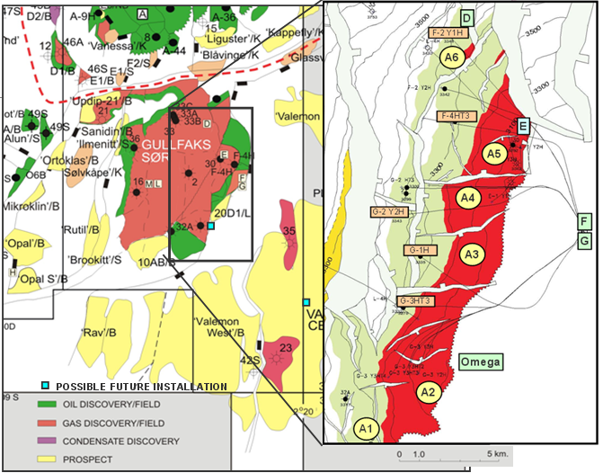
Figure 2: The Gullfaks Sør Field consists of the Brent Group and the Statfjord Fm. A detailed depth map of the Top Statfjord Fm is shown inset to the right. Segment identifiers in yellow while completed production wells are labelled in brown.

Part B (one challenge for each group) (Weight 70%)

Challenge 1. Geological and geophysical uncertainties – Statoil advisor: Esther Matland

A significant geological uncertainty in the Gullfaks Sør Statfjord Fm. is the continuity between sand bodies.

  - Discuss geological uncertainties that could result in poor continuity in a fluvial reservoir as we have at Gullfaks Sør Statfjord.
  - The group shall make a simulation run where the transmissibility across all faults are set to zero. Compare this case with the Extended case and describe how the result affects the uncertainties of the possible field development.
  - Increase the number of wells to increase the oil recovery. Make a recommendation of how many wells are required to get to the same recovery as in the Extended case.

Challenge 2. Drilling of wells through depleted Brent Group – Statoil advisor: Johan Eck-Olsen

For the new wells to reach Gullfaks Sør Statfjord Fm. they have to be drilled through the Brent Group where the pressure is depleted more than 100 bar. This zone must be managed during drilling either by casing programme, Managed Pressure Drilling (MPD) or Underbalanced Drilling (UBD).

- Explain the expressions casing programme, MPD and UBD.
- Based on a pore pressure prognosis provided by Statoil, the group shall calculate the window available for drilling. Make a recommendation whether MPD or UBD is required to be able to drill the wells, or if it is possible to design a casing program that will handle the challenges.
- Make a recommendation about which measures Statoil need to take in order to be able to drill these wells to Gullfaks Sør Statfjord.

Challenge 3. Improved oil recovery with smart wells – Statoil advisor: Knut Müller

Gullfaks Sør Statfjord has used smart wells (Ref. 3), but has mixed experiences. It could however be possible to increase the oil recovery by using smart wells and/or Inflow Control Devices (ICD).

- Explain smart wells and ICD.
- Use the Gullfaks Sør Statfjord model with a five branch well with ICD in Gullfaks Sør Statfjord.
- Make a recommendation if smart wells/ICD is a measure that Statoil should implement at Gullfaks Sør Statfjord.
- Positive and negative comments about smart wells and ICD.

Challenge 4. Improved oil recovery with WI – Statoil advisor: Eli Iren Gule

It could be possible to increase the recovery factor at Gullfaks Sør Statfjord by water injection (WI) or WAG (Water alternating Gas).

- Explain the physics behind WI and WAG and make a brief overview of experiences we have had with these techniques at the Gullfaks main field.
- Use the Gullfaks Sør Statfjord model and add for different combinations of oil-, WI- and WAG-wells to see what gives the highest recovery of oil.
- Make a recommendation if WI/WAG is a measure that Statoil should implement at Gullfaks Sør Statfjord.

Challenge 5. Production challenges by water in wells and flow lines – Statoil advisor: Ole Jørgen Birkenes

Water has a higher density than oil and gas, and increased water production will therefore lead to reduced wellhead pressure and problems co-producing the wellstream through the sub-sea flowline system:

- Make calculations that show how pressure and temperatures are influenced by increased water production in the wells.
- Discuss actions that may be implemented to maintain oil and gas production in a situation with increasing water-cut. Calculate the limits of how much water could be produced.
- Make a recommendation about actions that Statoil should implement in order to maximize the production with increasing water-cut.

Challenge 6. Environmental challenges by adding chemicals to the WI – Statoil advisor: Petter Eltvik

Adding a chemical called “BrigthWater” to the injection water may increase oil recovery by improved volumetric sweep (Ref. 4 and 5). However, the chemical is classified as red according to SFT’s regulations.

- Review SFTs list of harmful chemicals and make a recommendation if “BrightWater” can be used at Gullfaks Sør.
- Use the WI-model developed by Group 4 and find a way to model ”Bright Water”. Discuss possible improvements necessary in Eclipse to fully account for the properties of this chemical..
- Make a recommendation regarding use of chemical additives to increase the recovery at the Gullfaks Sør Statfjord Fm. considering the environmental challengenges.

- References
- Reservoir Management Plan for Gullfaks, GF RESU-HF-07 00122. November 2007
- Ny plattform på Gullfaks Sør. Fagrapport Gruppe 2. Gullfakslandsbyen 2008.
- Bruk av multilaterale brønner på Gullfaks Sør. Fagrapport Gruppe 2. Gullfakslandsbyen 2006.
- Kan bruk av tensider og polymer øke utvinningen av olje fra Gullfaksfeltet. Fagrapport Gruppe 5. Gullfakslandsbyen 2007.
- Økt oljeutvinning ved hjelp av polymer- og tensidflømming. Fagrapport Gruppe 1. Gullfakslandsbyen 2008.

