**Solution 8 Stepwise compression**

**a) Temperature**

Optimum intermediate stage pressure follows from (8-10): pi = 22.6 bar.

Temperatures:  after eq. (8-2)

Intermediate: 

Cooling to 10 C

Outlet second stage: 

**b) Thermodynamic effect**

We can include the z-factors, without too much work (Script 1, given below)

Estimates :

z-factor inlet 1st stage: z1 = 0.979 outlet: zi = 0.979

  z-factor inlet 2nd stage: ziu = 0.951 outlet: z2 = 0.950

  Thermodynamic power after eq. (8-5)

1st stage: 6.69 Mw 2nd stage: 9.58 Mw

Total: 16.3 Mw

**c) Effect of intermediate stage pressure**

This corresponds to task b above, and can easily be calculated by modifying Script 1 so that calculations are made for different pressures at the intermediate stage. Results plotted

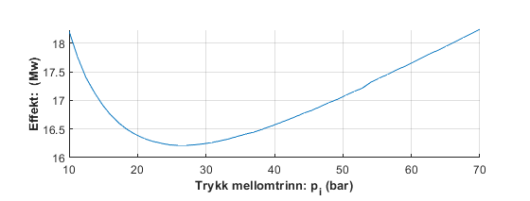

**Figure 1: Thermodynamic effekt**

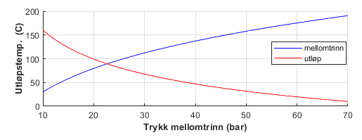

**Figure 2: Outlet temperatur for different intermediate stage pressure**

**Script 1**

clear

clf

disp(' ----------------------------Loysing 2-trinns kompresjon-----------------------------------')

m=50; % gasstrøm

R=8314;

k=1.28;

p1=10e5;

p2=70e5;

M=16.83;

Ma=28.97;

T1=30+273;

gg=M/Ma;

Tiu=273+10; % Innløpstempertur 2. trinn

pi=(Tiu/T1)^(0.5*k/(k-1))*(p2*p1)^0.5;

disp([' Optimalt mellomtrinns-trykk: ',num2str(pi*1e-5),' bar'])

%

% ---------------- 1. trinn ----------------

Ti=T1*(pi/p1)^((k-1)/k); % Utløpstemperatur

[ z1 ] = zfakgg( p1,T1,gg ,0.9);

[ zi ] = zfakgg( pi,Ti,gg ,z1);

disp([' z-faktor innløp 1. trinn: z1= ',num2str(z1), ' utløp: zi= ',num2str(zi)])

w1=m*R*T1/(M*z1)*(k/(k-1))*((pi/p1)^((k-1)/k)-1)*(z1+zi)/2;

%

% --------------- 2.trinn ---------------------------

T2=Tiu*(p2/pi)^((k-1)/k); % utløpstemperatur

[ ziu ] = zfakgg( pi,Tiu,gg ,0.9);

[ z2 ] = zfakgg( p2,T2,gg ,ziu);

disp([' z-faktor innløp 2. trinn: ziu= ',num2str(ziu),' utløp: z2= ',num2str(z2)])

w2=m*R*T1/(M*ziu)*(k/(k-1))*((p2/pi)^((k-1)/k)-1)*(ziu+z2)/2;

disp([' Utløpstemperatur 1. trinn: ',num2str(Ti-273),' C 2. trinn: ',num2str(T2-273),' C'])

disp([' Termodynamisk effekt 1. trinn: ',num2str(w1*1e-6),' Mw 2. trinn: ',num2str(w2*1e-6),...

' Mw Totalt: ',num2str((w1+w2)*1e-6),' Mw'])