Solution 6

1. **Numerical solution, verification**

Heat transfer by: . Energy conservation eq (4-11), assuming no work dw=0 gives temperature change along pipeline (For liquids: )



The analytical solution neglects friction. Thus, setting: f=0 be equivalent to prediction by



The script performs numerical integration along the pipeline should. The figure below shows close comparison for flow rate 15000 m3/d

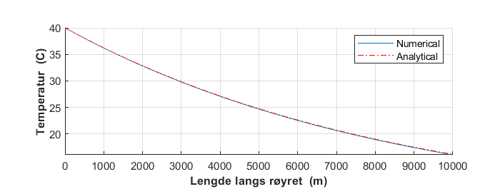

1. **Temperature along the pipeline, including friction heating**

Pipe wall roughness: 0.045 mm was used ( assuming commercial steel) and the friction factor estimated by Hålands equation. Implemented in the script. The numerical predictions are compared to the analytical, the latter neglects friction heation

Illustrated below: little friction heating for rate: 5000 m3/d, 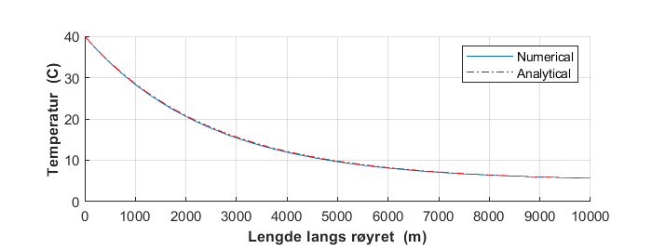

but significant for 15000 m3/d

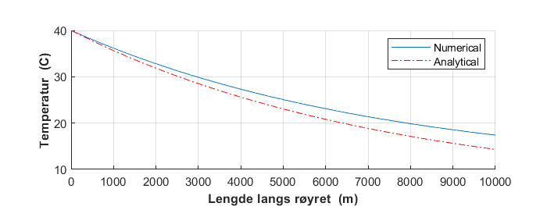

**Script for temperature predictions**

clear

clf

disp('------------------------Temperatur----------')

rho=800; % oljetetthet

qo=5000/86400; % oljerate

qo=15000/86400; % oljerate

m=rho*qo; % massestrøm

ts=0.5/100; % stålvegg

tb=4/100; % betongkappe

ri= 0.1; % indre radius

rib=ri+ts; % indre radius betongkappe

re=rib+tb; % ytre radius betongkappe

D=2*re; % ytre diameter

Di=2*ri; % indre

L=10000; % lengde

Ta=5;

Tth=40;

pth=50e5;

U=43;

cp=2.13*1000;

v=qo/(pi*D^2/4);

vis=5e-3;

Re=rho*v*D/vis;

rough=0.045e-3;

a=-1.8*log10((rough/Di /3.7)^1.1+6.9/Re);

f=(1/a)^2;

% f=0.00; if friction is neglected

disp(['Oljerate :qo=',num2str(qo*86400),' m^3/d Massestrøm :',num2str(m),' kg/s '])

disp(['Strømningsfart :v=',num2str(v),' m/s Friksjonsfaktor: f=',num2str(f)])

% ----------------- numerical integration----------------------

x=linspace(0,L);

T(1)=Tth;

p(1)=pth;

for i=2:length(x)

p(i)=p(i-1)-0.5*f*rho/Di*v^2*(x(i)-x(i-1));

T(i)=T(i-1)-U*pi*D/(cp*m)*(T(i-1)-Ta)*(x(i)-x(i-1))+f*v^2/(2*cp*Di)*(x(i)-x(i-1));

end

for i=1:length(x)

Tana(i)=Ta+(Tth-Ta)*exp(-U*pi*D/(cp*m)*x(i));

end

subplot(2,1,1)

hold on

plot(x,T)

plot(x,Tana,'r-.')

hold off

%legend('Inclucing friction heatibg', 'Without friction heating')

legend('Numerical', 'Analytical')

xlabel('\bfLengde langs røyret (m)')

ylabel('\bfTemperatur (C)')

grid

subplot(2,1,2)

plot(x,p*1e-5)

xlabel('\bfLengde langs røyret (m)')

ylabel('\bfTrykk (bar)')

grid

1. **Flow capacity**

Pressure loss along pipe is expressed



Temperature effects on fluid properties have neglected, thus neglecting coupling of pressure loss to heat. The script below is made by removing all temperature parts of that above. It predicts outlet pressure for different rates illustrated below.

The minimum outlet pressure: 20 bar is reached at rate about 7800 m3/d, which then becomes the flow capacity

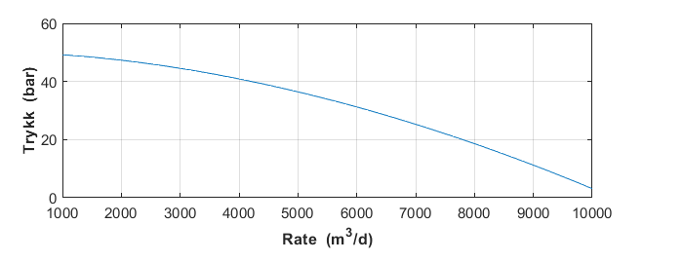

**Script**

clear

clf

disp('------------------------Strømningskapsitet----------')

rho=800; % oljetetthet

ts=0.5/100; % stålvegg

ri= 0.1; % indre radius

Di=2*ri; % indre diameter

L=10000; % lengde

pth=50e5;

vis=5e-3;

rough=0.045e-3;

% ----------------- numerical integration----------------------

p(1)=pth;

qo=linspace(1000,10000)/86400;

v=qo/(pi*Di^2/4);

Re=rho*v*Di/vis;

x=linspace(0,L,20);

for n=1:length(qo)

a=-1.8*log10((rough/3.7*Di)^1.1+6.9/Re(n));

f=(1/a)^2;

for i=2:length(x)

p(i)=p(i-1)-0.5*f*rho/Di*v(n)^2*(x(i)-x(i-1));

end

pq(n)=p(length(x));

end

subplot(2,1,2)

plot(qo*86400,pq*1e-5)

xlabel('\bfRate (m^3/d)')

ylabel('\bfTrykk (bar)')

grid