Solution proposal Exercise 3
Task 1
In the compendium is shown that to obtain equal pressure drop in gas- and liquid channels, the following must be fulfilled:
(2-11)
Shear tensions, wetted surfaces and liquid- and gas-filled areas can all be related to flow rates and opening angle: φ .
F(φ ) is calculated by: funF, script attached. The angle that come closest to: F=0 is used, done by script Oving 3, attached. (This is a crude approach, more robust than gradient searches.)

- Liquid layer heigh : horizontal pipe
The figure below illustrates: F as function of opening angle, showing that F=0 is fulfilled for opening angle a bit above 50º.
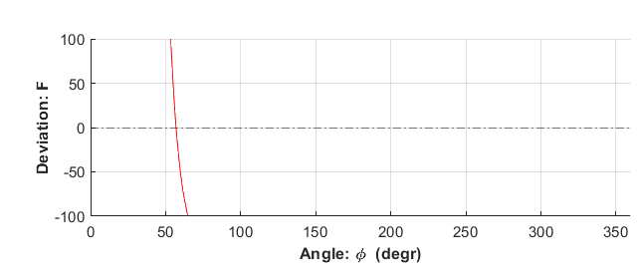

Print-out from the script:
Angle estimate: 56.9369 (degr) Remaining error: F=0.68365(Pa/m)
Liquid level height: hl: 0.024184 (m)
The figure below(made by the script) illustrates liquid level for assumed stratified flow.
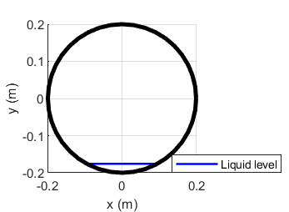

- Liquid layer heigh : upward sloping pipe
The figure below shows that F=0 is fulfilled for opening angle a bit above 200º.
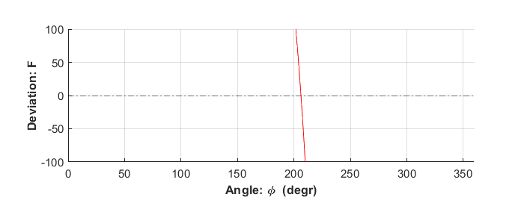
Print-out from the script:
Angle estimate: 206.1261 (degr) Remaining error: F=2.7804(Pa/m)
Liquid level height: hl: 0.2452 (m)

The figure below illustrates liquid level calculated.
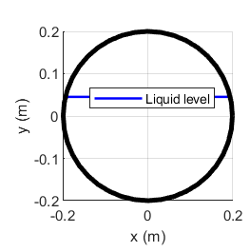
Scripts Task 1
% Exercise 3
clear
clf
r=0.2;
A=pi*r^2;
vsg=3;
lam=0.01;
vsl=vsg*lam/(1-lam);
rhl=900;
rhg=100;
slope=0; % pipe slope
g=9.81;
gx=g*sind(slope);
% calculate F
minang=0;
maxang=360;
nr=1000;
oangle=linspace(minang,maxang,nr)*pi/180; % opening angle range: [ minang,maxang]
for i=1:nr
[Sg(i),Sl(i),Si(i),taug(i),taul(i),taui(i),yl(i),hl(i),F(i)] = funF(oangle(i),r,rhg,rhl,vsg,vsl,gx);
Fo(i)=0;
end
% pick index "m" making F closest to zero
[Fm,m]=min(abs(F));
[Sgm,Slm,Sim,taugm,taulm,tauim,ylm,hlm,Fm] = funF(oangle(m),r,rhg,rhl,vsg,vsl,gx);
oam=oangle(m);
disp(['Angle estimate: ',num2str(oangle(m)*180/pi),' (degr) Remaining error: F=',num2str(Fm),'(Pa/m)'])
disp([' Liquid level height: hl: ',num2str(hl(m)), ' (m)'])
subplot(2,1,1)
hold on
plot(oangle*180/pi,F,'r-')
plot(oangle*180/pi,Fo,'k-.')
hold off
axis([minang,maxang,-100,100]);
grid
xlabel('\bf Angle: \phi (degr) ')
ylabel('\bf Deviation: F ')

% Illustration
t=0:pi/20:2*pi;
subplot(2,1,2)
hold on
plot([-Sim/2,Sim/2],[-r+hlm,-r+hlm],'b-','LineWidth',1.5)
plot(r*cos(t),r*sin(t),'k-','LineWidth',3)
hold off
axis square
legend('Liquid level')
xlabel('x (m)')
ylabel('y (m)')
grid

function [Sg,Sl,Si,taug,taul,taui,yl,hl,F] = funF(oangle,r,rhg,rhl,vsg,vsl,gx)
%
fg=0.02;
fi=0.04;
fl=0.012;

% oangle: opening angle
hl=r-r*cos(oangle/2);
Si=2*r*sin(oangle/2);
Sl=oangle*r;
Sg=r*(2*pi-oangle);
yl=1/pi*(oangle/2-cos(oangle/2)*sin(oangle/2));
yg=1-yl;
vg=vsg/yg;
vl=vsl/yl;
taui=1/8*fi*rhg*(vg-vl)*abs(vg-vl);
taug=1/8*fg*rhg*vg^2;
taul=1/8*fl*rhl*vl^2;
F=(rhl-rhg)*gx+(taul*Sl-taui*Si)/(yl*pi*r^2)-(taug*Sg+taui*Si)/(yg*pi*r^2);
end

Task 2
Pressure gradient in the gas channel was expressed
(2-12)
(Pressure loss in the liquid channel will be the same, assumed for the calculation of : F=0)

Acceleration due to gas expansion when pressure drops will be small and has here been neglected, assuming constant superficial velocities. This simplifies the gradient

The variables needed have already been computed. So pressure drop calculation may made by adding the following lines to the script “Exercise 3” above.
% Pressure loss
L=15000; % length of pipe section
disp(['Length : ',num2str(L),' m Slope:',num2str(slope),' degr'])
Ag=(1-ylm)*pi*r^2;
dpdx=rhg*gx+(taugm*Sgm+tauim*Sim)/Ag; % gradient
disp(['Gradient: ',num2str(dpdx),' Pa/m'])
disp(['Pressure drop: ',num2str(dpdx*L*1e-5),' bar'])

- Pressure drop along the horizontal section
Print-out:
Length : 15000 m Slope:0 degr
Gradient: 23.0934 Pa/m
Pressure drop: 3.464 bar

- Pressure drop the upward sloping section
Print-out:
Length : 5000 m Slope:5 degr
Gradient: 598.6193 Pa/m
Pressure drop: 29.931 bar

- Discussion
For the horizontal section, low liquid level is estimated. The assumption of stratified flow do not appear unreasonable. Thus, the pressure loss prediction seems not to violate basic assumption. (Stability predictions may be made and friction factor estimates may be considered with sound suspicion)
For the upwardly slowing section, high liquid level was estimated. This reduces the gas filled area causing higher gas velocity and lower liquid velocity. It seems doubtful that stratified flow is maintained. (Stability predictions will probably verify this). Thus, pressure loss prediction assuming stratified flow should not be trusted if the flow is not stratified.

