Solution 1.1

From attached Script

**a) --------------- Pumping A-B -----------------**

Speed: v = 9.2 m / s Friction factor f = 0.015

Required inlet pressure: pA = 43 bar

**b) -------------- Free back flow -----------------**

Outlet pressure: pA = -19 bar

Negative outlet pressure indicates that backflow as assumed is not possible.

Free backflow is possible, but at significantly less than 25,000 m3 / d

**c) Improvements**

The friction pressure loss is very large: 20 bar. This is due to high speed: 9 m / s which can also lead to faster corrosion of the pipe wall. Doubling of pipe diameter will reduce speed by factor 4, to about 2.3 m / s and friction loss by about factor 16, from 20 to around: 1.5 bar. Thus considerable potential for improvement

**Script**

clear

disp('---------------------Øving 1---------------')

% gitte data

pB=2e5;

d=0.2;

q=25000/86400;

v=q/(pi*d^2/4);

rho=1000;

vis=1e-3;

Re=rho*v*d/vis;

g=9.81;

eps=0.046/1000;

h=100;

L=1000;

% ----------------------------------------------

% Haalands formel

a=-1.8*log10((eps/3.7/d)^1.11+6.9/Re);

f=1/a^2;

%

disp(' ')

disp('a) --------------- Pumping A-B -----------------')

delp=rho*g*h+0.5*f*rho/d*v^2*L;

pA=pB+delp;

disp(['Fart: v= ',num2str(v),' m/s Friksjonsfaktor f= ',num2str(f)])

disp(['Nødvendig innløpstrykk: pA= ',num2str(pA*1e-5),' bar '])

%

disp(' ')

disp('b) --------------- Fri strømning tilbake -----------------')

pA=pB+rho*g*h-0.5*f*rho/d*v^2*L;

disp(['Utløpstrykk: pA= ',num2str(pA*1e-5),' bar '])

Solution 1.2

**a) Heat transfer coefficient**

Thermal conductivity for pipe walls and concrete can be found online

Steel: <https://www.engineeringtoolbox.com/thermal-conductivity-d_429.html>

k = 43 w / (mK)

For concrete: <https://en.wikipedia.org/wiki/List_of_thermal_conductivities>

\\home.ansatt.ntnu.no\asheim\Desktop\Skjermbilde.GIF

The variation is probably due to both material variation and water content. Dry concrete will reasonably insulate better than moist. Here will be used: k = 2- 2.5 w / (mK).

Fourier's law integrated through steel wall, : 

and through cement jacket, : 

🡪

Heat flow expressed by eq.(2-2): … where:

Combined to express heat transfer coefficient due to thermal conduction through pipe wall



Since the conductivity of steel is relatively large and the wall thin, it is tempting to neglect this.



**b) Temperature Profile**

Formula: 

Heat capacity for paraffin, stated in the compendium: cp = 2.13 kJ / (kgK). Calculated profile (script given below).

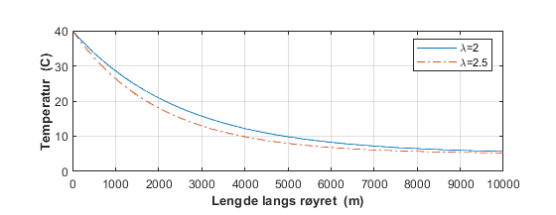

We see that the temperature in the fluid after 10,000 m becomes approximately equal to the outside temperature. It does not matter if the thermal conductivity is 2.0, or 2.5