**Solutions Exercise 10.2**

**Task 1**

Changes in concentration are now measured in the tank, no delay.



By integration



1. **Dynamic response**

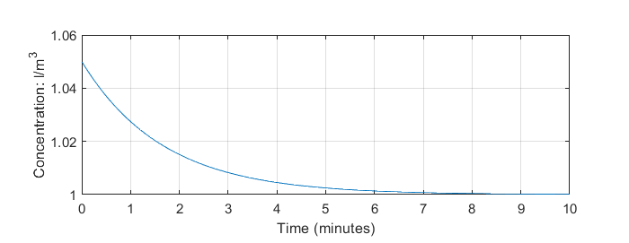

1. **With reduced flow rate**

No changes

**Script**

disp('Quiz 10.2 Task 1 : Concentration control')

clf

clear

V=1; % tank volume (m3)

cset=1; % concentration goal l/m3

c0=1.05*cset; % concentration rise, 5%

t=linspace(0,10)*60;

alf=0.01; % P- regulation coefficient

c=cset+(c0-cset)*exp(alf/V*t);

subplot (2,1,1)

plot(t/60,c)

grid

xlabel('Time (minutes)')

ylabel('Concentration: l/m^3')

**Solution task 2**

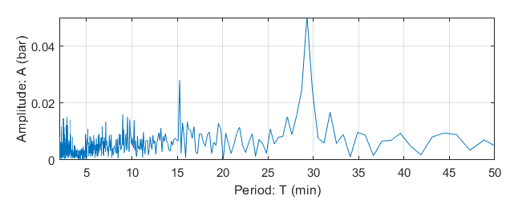

**FSpectrum for January 2016 (1465 data points)**

**Script**

clear

clf

delT = 60; % logging interval(s)

Fs = 1/delT; % logging frequency

fny=0.5*Fs;

load DataJan2016.txt

data=DataJan2016;

ant=size(data);

nt=ant(1);

pth=data(1:nt,3);

disp(['No. of data points in file: ',num2str(nt)])

% Valgt tidsinterval

t=(0:nt-1)*delT; % Time span

disp(['No. of data points used: ',num2str(nt)])

% plot input sample

subplot(2,1,1)

plot(t(1:200)/60,pth(1:200),'r.')

grid

xlabel('Time (min)')

ylabel('Tubing head: (bar)')

%

Y = fft(pth);

P2 = abs(Y/nt);

ampl = P2(1:nt/2+1);

na=length(ampl);

ampl(2:na-1) = 2*ampl(2:na-1);

f = Fs*(0:(nt/2))/nt;

% Plot period spectrun

Tny=2*delT; % shortest noticable period

subplot(2,1,2)

Tf=f.^-1;

plot(Tf/60,ampl)

axis([Tny/60,50,0,0.05])

xlabel('Period: T (min)')

ylabel('Amplitude: A (bar)')

grid