Solution proposal : Training exercise 10.1.

Task 1
The task is similar to previous investigation of tubing head pressure variations and is solved by simple modifications to the script then used. A such modified script is listed below. It provides

- Bottom well
Mean pressure: 123.9252bar Standard deviation: 0.062376

- Estimated distribution of downhole pressure measurement.
Estimated cumulative distribution
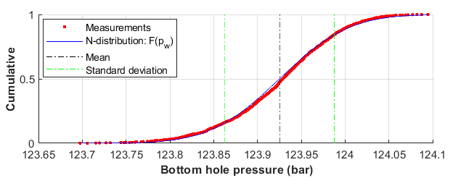
Variation of downhole pressure measurement seems to follow the normal distribution

- Downhole pressure-, compared to tubing head pressure variation:
Estimates at tubing head: 28.6415bar Standard deviation: 0.12389
Estimated cumulative tubing head pressure distribution:
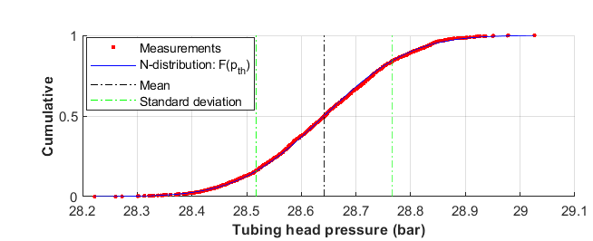

Observations: Downhole and tubing head pressure measurement seem both to follow normal distributions.
The downhole mean pressure is much larger, as would also be predicted steady-state pipe flow calculation.
The standard deviation is 50% smaller downhole than at the tubing head. This is not is not predicted by steady-state pipe flow calculation.

Script 1a
disp('Plot: tubing head pressure')
clear
clf
delt=1; % time between measurements (minutes)
load DataJan2016.txt
data=DataJan2016;
ant=size(data); ntot=ant(1); % antall målepunkter
% Time-interval
n1=1; n2=100;
pth=data(n1:n2,3);
t1=delt*n1;
t2=delt*n2;
tp=delt*n1:delt:delt*n2; % time logged
ntp=length(tp);
stdtp(1:ntp)=mean(pth)+std(pth);
stdtm(1:ntp)=mean(pth)-std(pth);
meant(1:ntp)=mean(pth);
disp([' Midlet utløpstrykk: ',num2str(mean(pth)),'(Sm^3/d) Standardavvik: ',num2str(std(pth)) ])
subplot(2,1,1)
hold on
plot(tp,pth,'r.')
plot(tp,meant,'k-')
plot(tp,stdtp,'b-.')
plot(tp,stdtm,'b-.')
hold off
legend('Measurements','Mean value','Standard deviation')
grid
xlabel('\bf Time (minutes)')
ylabel('\bf p_{th} (bar)')
% Downhole
pw=data(n1:n2,5);
stdtp(1:ntp)=mean(pw)+std(pw);
stdtm(1:ntp)=mean(pw)-std(pw);
meant(1:ntp)=mean(pw);
disp([' Midlet nedihullstrykk: ',num2str(mean(pw)),'(Sm^3/d) Standardavvik: ',num2str(std(pw)) ])
subplot(2,1,2)
hold on
plot(tp,pw,'r.')
plot(tp,meant,'k-')
plot(tp,stdtp,'b-.')
plot(tp,stdtm,'b-.')
hold off
legend('Measurements','Mean value','Standard deviation')
grid
xlabel('\bf Time (minutes)')
ylabel('\bf p_{w} (bar)')

Script 1b
disp(' Normal distribution, comparison')
clear
clf
delt=1.;
load DataJan2016.txt
data=DataJan2016;
ant=size(data);
disp(['No. of data points in file: ',num2str(ant(1))])
% Tidsinterval
n1=1;
n2=ant;
pth=data(n1:n2,3);
pw=data(n1:n2,5);
tp=delt*n1:delt:delt*n2;
ntp=length(tp);
disp(['No. of data points ',num2str(ntp)])

%--------------------tubing head -------------------
disp(' Tubing head ')
meanpth=mean(pth);
stdpth=std(pth);
disp(['Mean pressure: ',num2str(meanpth),'bar Standard deviation: ',num2str(stdpth) ])
% ----------------------- Cummulative distribution -----------------------
pths=sort(pth);
Femp=1:1:ntp;
Femp=Femp/ntp;
% normalfordeling
Fn = normcdf(pths,meanpth,stdpth);
subplot(2,1,1)
hold on
plot(pths,Femp,'r.')
plot(pths,Fn,'b')
plot([meanpth,meanpth],[0,1],'k-.')
plot([meanpth+stdpth,meanpth+stdpth],[0,1],'g-.')
plot([meanpth-stdpth,meanpth-stdpth],[0,1],'g-.')
hold off
legend('Measurements','N-distribution: F(p_{th})','Mean','Standard deviation')
xlabel('\bfTubing head pressure (bar)')
ylabel('\bfCumulative')
grid
%
% - bottom well
disp(' Bottom well ')
meanpw=mean(pw);
stdpw=std(pw);
disp(['Mean pressure: ',num2str(meanpw),'bar Standard deviation: ',num2str(stdpw)])
pws=sort(pw);
Femp=1:1:ntp;
Femp=Femp/ntp;
% normalfordeling
Fn = normcdf(pws,meanpw,stdpw);
subplot(2,1,2)
hold on
plot(pws,Femp,'r.')
plot(pws,Fn,'b')
plot([meanpw,meanpw],[0,1],'k-.')
plot([meanpw+stdpw,meanpw+stdpw],[0,1],'g-.')
plot([meanpw-stdpw,meanpw-stdpw],[0,1],'g-.')
hold off
legend('Measurements','N-distribution: F(p_{w})','Mean','Standard deviation')
xlabel('\bf Bottom hole pressure (bar)')
ylabel('\bfCumulative')
grid

Task 2
From the data file, mean tubing head pressure, and rates of gas, oil and water can be calculated. Solubility and volume factors can be calculated from the black-oil model and mean velocity and fractions estimated. I got the following
- Flow velocity at tubing head: 5.06 m/s
- Gas, oil and water fractions: y_{g}=0.84, y_{w}=0.11, y_{o}=0.05
- Gas-continuous. Velocity so the fluids are probably fairly well mixed

Script

fprintf('\n Training exercise 10.2 Task 2 \n\n ')
clear
p0 = 1.01e5;
T0 = 273+15;
% -------- fluider -------
go=0.92;
gg=0.61;
gw=1.06;
Bw=1;
% tubing
d=4.778*0.0254;
At=pi*d^2/4;

% Measurements
delt=1;
load DataJan2016.txt
data=DataJan2016;
ant=size(data); ntot=ant(1); % antall målepunkter
index=1:1:ntot; % numerering
tidtot=delt*ntot;
% Tidsrom
n1=1;
n2=ant;
disp(['No. of measurements: ',num2str(ntot)])
pth=(data(n1:n2,3)+1)*1e5; % topptrykk
Tth=data(n1:n2,4)+273;
qo=data(n1:n2,11)/86400; % MFM oljerate
qw=data(n1:n2,12)/86400; % MFM vannrate
qg=data(n1:n2,13)/86400; % MFM gassrate
%
qom=mean(qo);
qwm=mean(qw);
qgm=mean(qg);
pthm=mean(pth);
Fw=qwm/qom;
Rt=qgm/qom;
Tthm=mean(Tth);
disp(['Tubing head pressure: ',num2str(pthm*1e-5),' (bar) '])
disp(['Tubing head temperture: ',num2str(Tthm-273),' (C)' ])
disp(['Gas rate: ',num2str(86400*qgm*1e-5),'*10^5 (Sm^3/d) ' ])
disp(['Oil rate: ',num2str(qom*86400),' (Sm^3/d)' ])
disp(['Water rate: ',num2str(qwm*86400),' (Sm^3/d) ' ])
disp(['Producingg as/oil-ratio: Rt= ',num2str(Rt)])
%[ z ] = zfakgg( pthm,Tthm,gg,z);
z=0.9;
Bg =1.01e5/pthm*Tthm/(273+15)*z;
Rs =0.0059*gg*10^(2.14/go-0.00198*Tthm)*(0.797*10^-5*pthm+1.4)^1.205;
Bo =0.9759+0.000952*((gg/go)^0.5*Rs+0.401*Tthm-103)^1.2;
Qo=Bo*qom;
Qw=Bw*qwm;
Qg=(qgm-qom*Rs)*Bg;
yo=Qo/(Qw+Qo+Qg);
yw=Qw/(Qw+Qo+Qg);
yg=Qg/(Qw+Qo+Qg);
vm=(Qo+Qg)/At;
disp(['Oil fraction: yo= ',num2str(yo)])
disp(['Water fraction: yw= ',num2str(yw)])
disp(['Gas fraction: yg= ',num2str(yg)])
disp(['Superficial velocity: vm= ',num2str(vm),' m/s'])

