**Exercise 7 Pumps and pumping**

**Task 7.1 Centrifugal pump in the system**

We consider a pump with characteristics

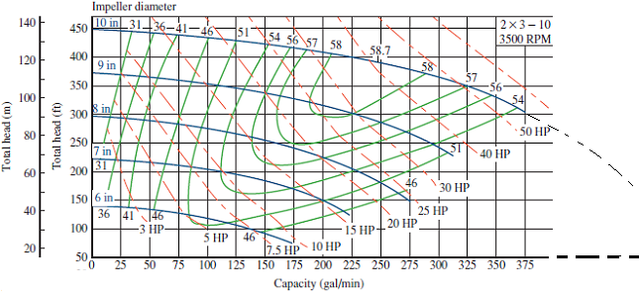

a) Express the pump characteristic for impeller diameter 10 inches by a 2nd degree polynomial: . (It may be done by the matlab function: polyfit (x, y, 2))

b) Water should be pumped from A to B. Pipe diameter 200 mm selected. The inlet pressure of the pump at A is 1 bar above atmospheric. Predict the flow rate.

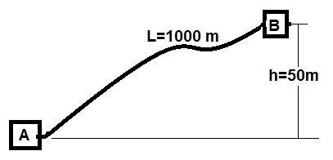

**Task 7.2 Frequency**

The pump characteristic above was given for 3500 RPM. This will be achieved by to a 2-pole motor and electric frequency, f = 60Hz as in the USA . Estimate the characteristic when the pump is driven by 2-pole motor at frequency: f = 50Hz