Task 1 Valve closing
The system below was introduced in exercise 1. Inner pipe diameter is 200 mm. Free backflow from B to A has been estimated: 15,000 m³/d
During free backflow the outlet valve at A is closed. The closing takes 5 seconds and reduces the flow rate evenly, from full to null
a) Estimate the pressure upstream of the outlet valve when the closing has just begun
b) Estimate the pressure just before the valve is fully closed
c) Calculate pressure change at A while closing the valve
d) Explain the results to someone who has a math-allergy

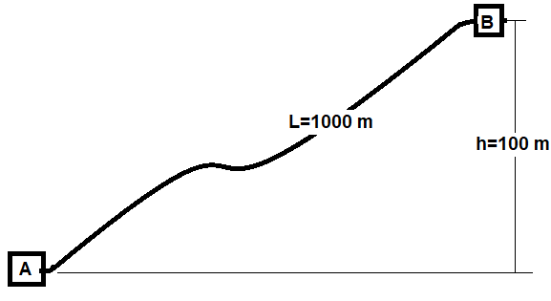

Task 2 Flow in oil well
Data
- Oil production 1194 Sm³ / d
- Producing gas/oil ratio 250 (Sm³ / Sm³ )
- specific gravity, gas 0.7
- specific gravity, oil 0.84
- Measured tubing length 3000 m
- vertically depth 2500 m
- inner diameter 10 cm

At downhole conditions:
- Pressure 307 bar
Temperature 90 ° C
- gas solubility R_{s} 212 Sm3 / Sm3
- volume factor, oil, B_{o} 1.65 m3 / Sm3
- volume factor, gas, B_{g} 0.0038 m3 / Sm3
- viscosity, gas-saturated oil 0.5 cP
- viscosity, gas 0.0012 cP
- z-factor, gas 0.92

a) Will the flow downhole be 1-phase: oil with dissolved gas, or 2-phase: oil and free gas
b) Estimate the downhole average density of the fluid mixture
c) Estimate downhole superficial velocities
d) Estimate the downhole pressure gradient, assuming friction factor: f=0.02

Task 2 Flow in oil well
Data provided
- Oil production 1194 Sm³ / d
- gas content in reservoir oil 110 (-)
- injection of gas 2.5.105 Sm³ / d
- specific gravity, gas 0.7
- specific gravity, oil 0.84
- Measured tubing length 3000 m
- vertically depth 2500 m
- inner diameter 10 cm

At downhole conditions:
- Pressure 307 bar
Temperature 90 ° C
- viscosity, gas-saturated oil 0.5 cP
- viscosity, gas 0.0012 cP
- z-factor, gas 0.92

a) Will the flow downhole be 1-phase: oil with dissolved gas, or 2-phase: oil and free gas
b) Estimate superficial velocity
c) Estimate the downhole average density of the fluid mixture

