Training exercise 10.2.

Task 1
Figure 11 in the compendium A sketched a concentration control process. It was shown to be subject to oscillations.
The figure below sketch a modified process
Tank volume: 1 m³
Pipe length L=300 m
The design rate makes pipe flow velocity v=3 m/s.

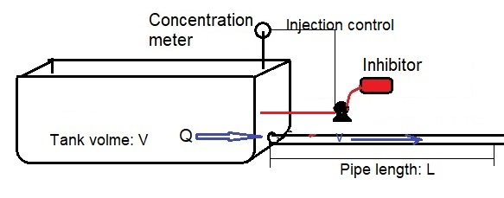

- Predict dynamic response to 5% concentration change.
- Predict dynamic response to 5% concentration change, if the flow is reduced 50%

Task 2
- Calculate the oscillation spectrum for well head pressure variation during the whole month of January 2016
- Do the spectrum indicate oscillations?

