Task 1.1
Water 25 000 m³/d should be pumped from A to B. It is suggested internal pipe diameter 200 mm. Required outlet pressure at B is 2 bar (above atmospheric)
a) How much inlet pressure is needed at pump station A?
b) If the water flows back from B to A, without pumping, what will the outlet pressure be?
c) Consider the system. Suggest changes if the calculations appear to give cause for this
Questions a) and b) correspond to task 1 in the compendium, but we will now include friction losses

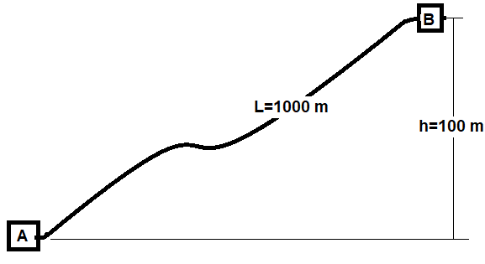

Task 2.2
The figure below illustrates cross section of transport pipes between wells completed on the seabed and processing platform.
Inner pipe diameter: 0.2 m
Tubing wall: 0.5 cm
Cement jacket around the pipe: 4cm
Pipe length: 10,000m
Oil rate: 5000 m³ / d
Oil density: 800 kg / m³
Temperature at the well: 40 C

a) Estimate the : U for heat transfer between the pipe and the sea outside.
b) Estimate temperature along the pipe

