**8 Gas compressors**

**8.1 Design**

Gas compressors pump gas. Viscosity is much less for gases than for liquids. This makes sealing more demanding. With compression, the temperature rises. This places extra demands on design and materials.

Still, most gas compressors are designed much like pumps. Figure 8.1 illustrates a piston compressor. This is similar to a 2-stage volumetric pump, but since the gas is compressed, the cylinder volume for the 2nd stage is smaller than for the first.

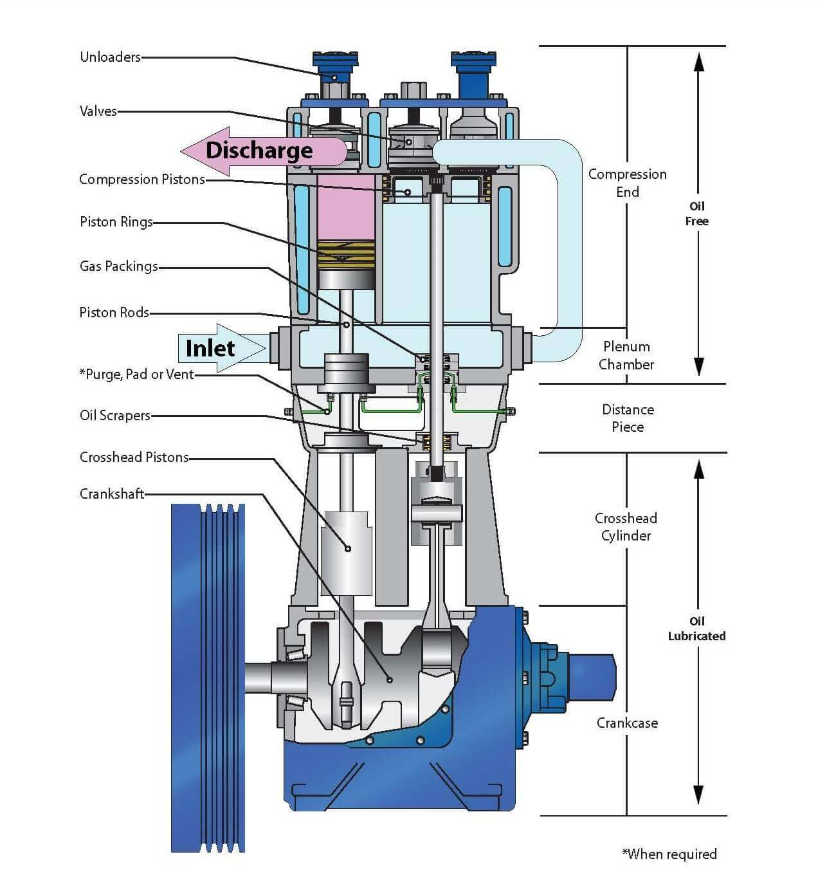

**Figur 8.1: 2-stage piston compressor (Hycom)**

Figure 8.2 illustrates a simple centrifugal compressor. It is based on acceleration / de-acceleration, with no seals between the stages.

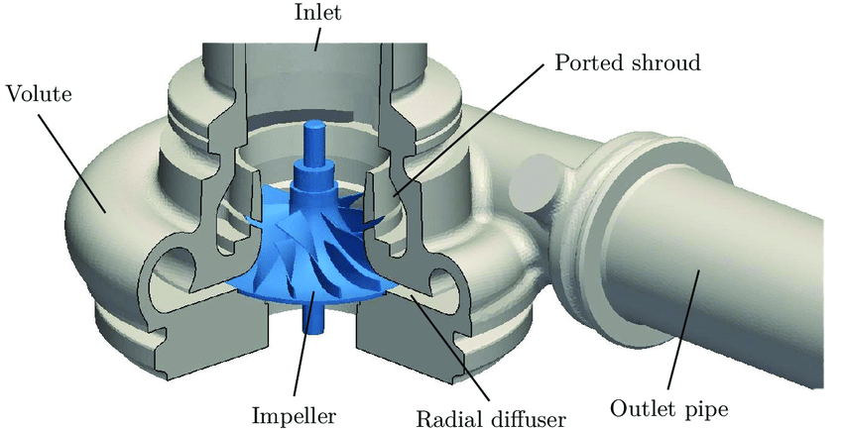

**Figure 8.2 Single stage centrifugal compressor**

The compressor illustrated below has 8 stages. The size of the impeller and ducts therefore becomes smaller for each stage, to accommodate reduced gas volume as pressure increases

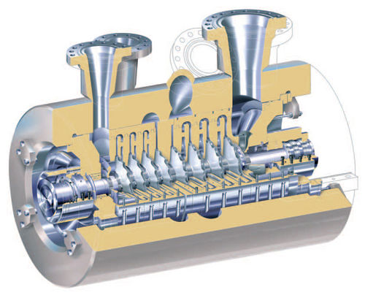

**Figure 8.3: 8-stage centrifugal compressor (Rolls Royce)**

In jet engines, compressed air enters the combustion chamber. Axial compressors is mostly used, although radial compressors were used in some early British jet fighter and in the iconic MiG-15. Figure 8.4 shows a turbo-fan engine with a fan for the external air flow and both axial and centrifugal compressors for air to the combustion chamber

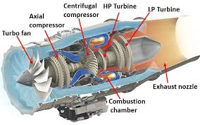

**Figure 8.4 Turbo fan jet engine with axial compressor**

**8.2 Power**

**8.2.1 Ideal**

A compressor is a pump that pumps gas. With gas volume expressed by the isentropic equation: , compressor power is derived by integration of the pump power relation : dw=Qdp

 (8-1)

The isentropic equation of provides outlet temperature related to the compression ratio.

 (8-2)

Alternatively, we may consider the energy balance. Here neglecting friction and heat transfer. This implies constant entropy, so the approach is similar to that above

**Quiz 8.1**

Gas is compressed from 30 to 70 bar

Given

Mass flow: 50 kg / s

Inlet temperature: 30C

Molecular Weight: 16.83

Adiabatic exponent: 1.28

a) Estimate outlet temperature

b) Estimate power needed

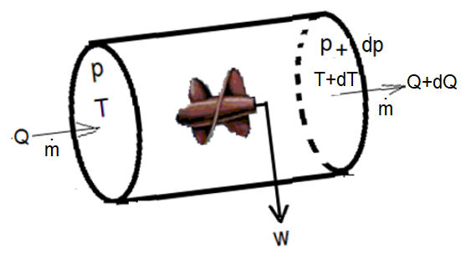

**Figure 8.5 Energy balance compressor**

The corresponding energy balance becomes

 (8-3)

Enthalpy, defined : , and the molecular energy ideally only depending only on pressure:  . For ideal gas (pV=nRT), it follows from (8-3) that compressor work corresponds to enthalpy change:

 (8-4)

Enthalpy has 2 degrees of freedom, like pressure, volume and other thermodynamic, intensive variable. Thus, if 2 other variables are specified, the enthalpy follows. Thus, enthalpy by be expressed as function of pressure and entropy: H(p,S) as in the Mollier diagram. Figur 5 shows the Mollier-diagram prepared for gas from the FRIGG field.

The solid line corresponds to isentropic compression from 30 bar and 30 C, to 70 bar. This corresponds to isentropic work: w=H2-H1=217.5-185=32.5 cal/g=136kJ/kg (1cal = 4.184J). The outlet temperature: T2=96C.

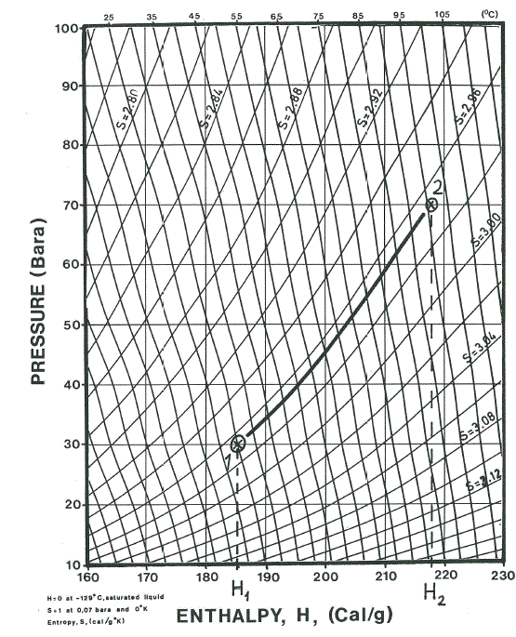

**Figure 6 Mollier diagram (Bergan /1981/)**

**8.2.2 Non-ideal effects**

In reality, gas behavior may deviate from ideal and there will be friction losses. Including the extended equation of state:  in (8-1), real power requirement may be expressed

 (8-5)

Friction makes temperature rise more than predicted assuming constant entropy. Since temperature rise often is a limiting factor, this is not insignificant. From (8-4) follows that additional work relates to additional enthalpy:  . The figure below illustrates this for enthalpy addition 6 cal/g, corresponding to compression efficiency:. As observed, this corresponds to outlet temperature: 104 C, a rise from the isentropic prediction: 95 C

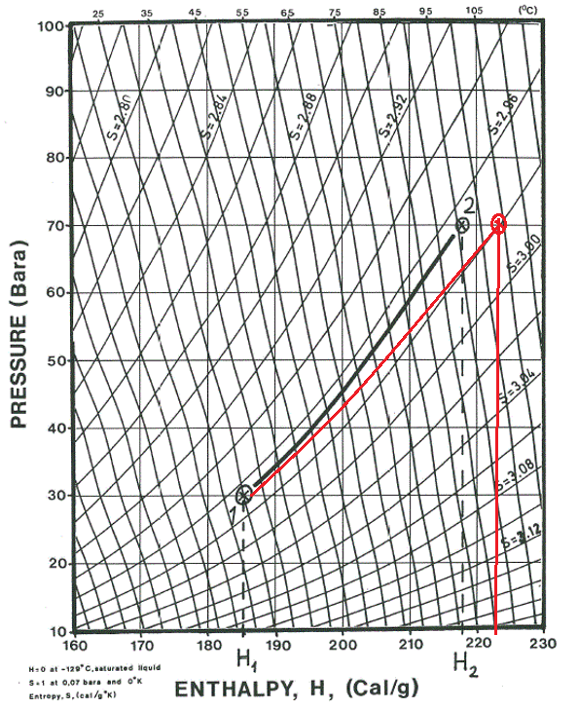

**Figure 7: Non ideal compression**.

This temperature rise correction enthalpy-rise approach is also analytically applicable. From (8-1) and (8-2) follows additional enthalpy rise due to friction: . Since enthalpy rise at constant pressure is expressed: , the additional temperature rise due to friction can be estimated

 (8-6)

**Quiz 8.2**

Frigg gas should is compressed from 30 to 70 bar.

Given

  Mass flow: 50 kg / s

Inlet temperature: 30C

Molecular Weight: 16.83

Inlet temperature: 30C

Compressor efficiency: 0.9

Using the Mollier diagram given

a) Estimate the outlet temperature

b) Estimate power needed

**Quiz 8.3**

Frigg gas is compressed from 30 to 70 bar, as considered above. Given

Molecular Weight: 16.83

Adiabatic exponent: 1.28

Specific heat capacity: cp=2.20 kJ/(kgK)

Compressor efficiency: 0.9

Using the analytic relations

a) Estimate outlet temperature

b) Estimate power needed

**8.3 Compressor performance**

**8.3.1 Polytrophic head**

Compression work: w is provides by the machine by rotation and flow. Polytrophic head is defined as compression work per mass unit, |w/kg/s| = |J/kg| and provides a measure of compressor performance

 (8-7)

Equation (8-5) relates polytrophic head to gas properties and compression ratio

 (8-8)

The manufacturer provides polytrophic head, figure 8. The surge limit indicates flow instability at low flow rate. This may cause vibration with catastrophic result.

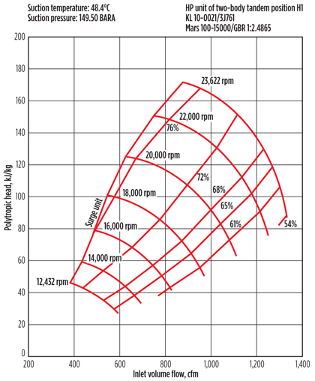

**Figure 8 Polytrophic head**

Compressor performance is sometimes expressed by pressure ratio:. This can be calculated from: , using (8-7). Thus, polytrophic head and pressure ratio provides the same information.

**Quiz 8.4**

Polytrophic head for compressors was defined: 

1. Use this definition to express polytrophic head for pumps.
2. Compare the result to the definition of hydraulic head: 

**Quiz 8.5**

The figure below provides performance curved for a dynamic pump

1. Predict maximum head if it is used to pump air, atmospheric conditions
2. Predict corresponding pressure rise

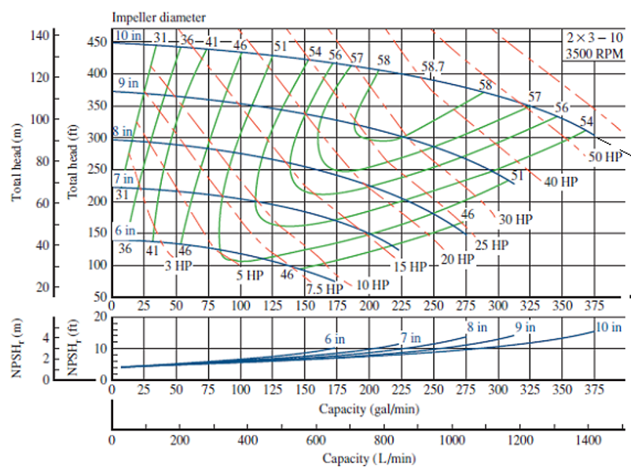

**Quiz 8.6:**

1. We want pressure rise 1 bar. Using affinity laws, estimate rotation velocity
2. Estimate flow velocity of gas leaving the impeller
3. Should we trust the estimate?

**8.4 Stepwise compression**

The figure illustrates compression in 2 steps, with cooling between. This reduces the gas temperature in the compressor and also the power demand.

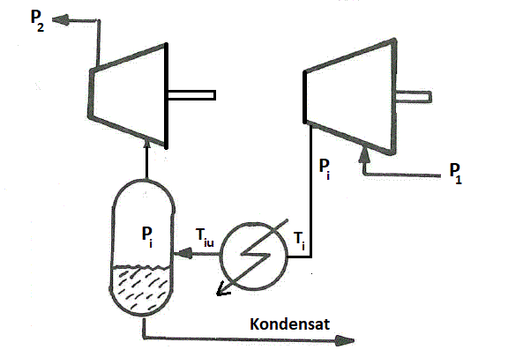

**Figure 9 Two-stage compression**

Thermodynamic effect for 2-stage compression as illustrated above follows from (8-2)

 (8-9)

The intermedia pressure: pi requiring least work corresponds to : . This provides

 (8-10)

With intermediate cooling down to the inlet temperature: Tiu = T1, the stage ratio becomes.

 (8-11)

**8.5 Integrated process**

The figure below illustrates the process at Statfjord A, Hancock / 1983 /. All produced gas is re-injected and oil loaded onto tankers and transported further at atmospheric pressure. Such transport requieres low vapor pressure . The oil is therefore stabilized at 0.7 bar and 77 ° C.

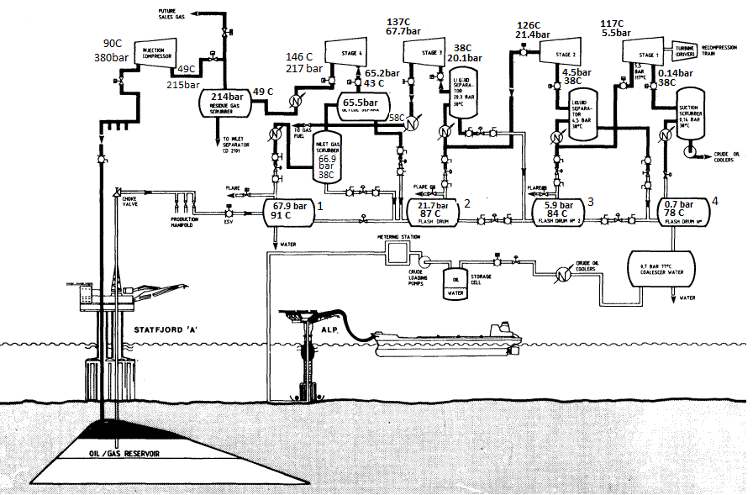

**Figure 9: Process Statfjord A**

The figure shows how gas from 4 separators is collected and compressed to 380 bar. The inlet pressure for each of the 4 compressors corresponds to the outlet pressure of the associated separator. Gas from the 4th separator is then compressed from 0.7 to 217 bar, over 4 stages with cooling between each stage. Gas from the 1st separator is compressed from 67.9 to 217 bar, over 1 stage. Separation and compression are thus integrated so that the separators and compressors 1, 2, 3, 4 must be controlled together

The injection compressor raises the outlet pressure from stage 4 (217 bar) to the pressure needed for injection: 360-380 bar. This can be varied without affecting the separation process.

For all compressors, the inlet currents are cooled down to about 40 C. The compression ratio for stage 2, 3 and 4 is approximately: r = 3.5, that is, in accordance with the optimal step ratio. Step 1 differs somewhat.

 Thus, it may appear that optimum stage ratio between the compressors also determines the separator stages. However, there will also be a similar ratio between the separator pressures to limit the sizes and utilize the gas pressure energy optimally.

**Referanser**

Bergan, T. : Frigg Compressors-Thermodynamic Models

Hovedoppgave, IPT, NTH 1981

Hancock, W.P.: «Development of a Reliable Gas Injection Operation for the North Seas’s Largest Capacity Production Platform, Statfjord A” JPT, Nov. 1983, p.1983