**7 Pumps and pumping**

**7.1 Different constructions**

**7.1.1 Volumetric**

|  |  |  |
| --- | --- | --- |
| https://upload.wikimedia.org/wikipedia/commons/thumb/3/3c/Old_hand_water_pump.jpg/220px-Old_hand_water_pump.jpg  **Water pump** | DeRe  **Mine de-watering** | Bilderesultat for downhole pumps oil and gas  **Oil well lifting** |

**Figure 1 Piston lift**

**7.1.2 Centrifugal dynamic pumps**

Dynamic pumps use de-accelertion to convert velocity energy to pressure, as predicted by Bernoullis equation. In centrifugal pumps, rotating impellers (“fan”) provide velocity. No seals are used in the fluid channels. Thus, fluid may back-flow if the impellers do not provide sufficient head

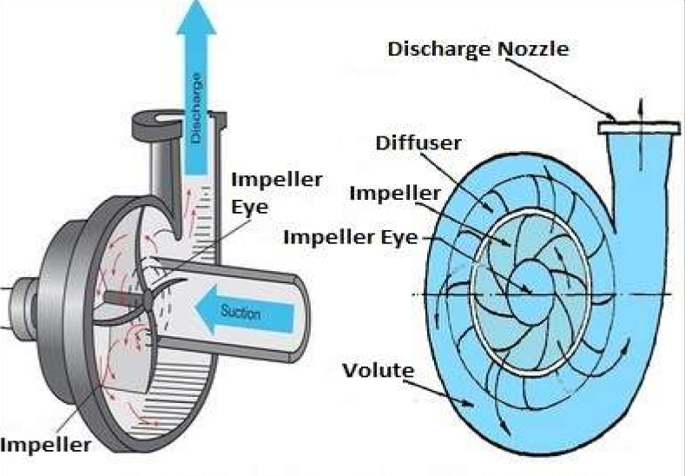

**Figure 2 : Centrifugal pump, principle**

|  |  |  |
| --- | --- | --- |
| **Centrifugal pump /Allweiler/** | \\home.ansatt.ntnu.no\asheim\Documents\102999-3339617.jpg  **Three-stage submersible pump /Directindustry.com/** | Bilderesultater for downhole centrifugal pump |

**Figure 3 Centrifugal pump, constructions**

**7.1.3 Jet pumps**

Jet pumps are also dynamic: Choking of high-pressure power fluid provides velocity energy that can be converted to pressure. In effect, the pump mixes a power fluid stream and a lower-pressure pumped stream, providing a co-mingled stream at intermediate pressure

|  |  |
| --- | --- |
| **Raising low-pressure process stream**  \\home.ansatt.ntnu.no\asheim\Desktop\Skjermbilde.PNG | https://j-jtech.com/wp-content/uploads/2014/05/jj-tech-artificial-lift-jet-pump-horizontal-completion-sump.jpg |

**Figure 4: Jet pumps**

**7.2 Power consumption**

The energy balance for open systems was illustrated by fig 6.2. If we neglect friction and heat transfer (q=0) through the pump and consider incompressible fluid (dQ=0), which implies constant temperature (dT=0), energy transfer by the pump is illustrated

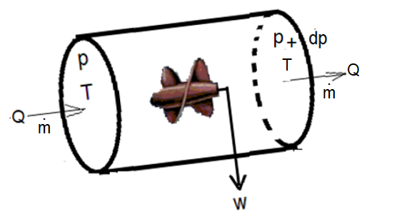

**Figure 5 Energy balance**

Equation (6-5) provides the corresponding energy balance. By our assumptions:. If internal friction is included by an efficiency factor: , the power requirement becomes

 (1)

The efficiency factor measures transfer of mechanical energy to heat, mainly by internal turbulence. Thus, some temperature rise should be expected and may be predicted

**7.3 Centrifugal pump**

**7.3.1 Impeller**

Figure 8 illustrates flow of fluids through a rotating impeller. The time to perform one rotation (rotation period) is denoted: T. Thus, its frequency (1/s) is: f=1/T. The corresponding angular frequency (radians/s):  is often used.

When the impeller rotates, it transfer velocity to the fluid. The tangential velocity depends on rotation speed (frequency) and distance from center.

 (2)

Since the tangential velocity increases with radial distance, the fluid flowing through the impeller is subjected to tangential acceleration (Coriolis acceleration) as illustrated below

|  |  |
| --- | --- |
| **\\home.ansatt.ntnu.no\asheim\Desktop\Skjermbilde.PNG** | **\\home.ansatt.ntnu.no\asheim\Desktop\Skjermbilde.PNG** |
| 1. Without rotation | 1. With rotation |

**Figure 6: Flow through impeller**

Coriolis acceleration is what causes wind and water currents to turn. It can be shown that its oscillation frequency is twice the system rotation frequency /Cushman-Roisin 1994/. The figure below illustrates ocean current measurements in the Baltic sea. The observed period is :****, about half of the earth rotation period: 24 hours.

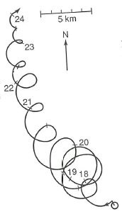

**Figure 7: Current measurements in the Baltic Sea (numbers represents days in a month)**

Figure 8 bellow illustrates flow through an impeller, designed to avoid excessive turbulence.

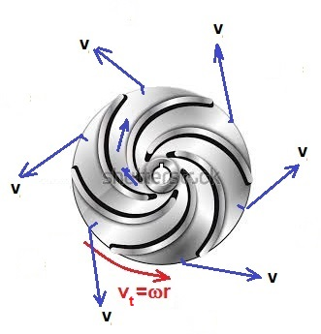

**Figure 8: Impeller flow**

|  |  |  |
| --- | --- | --- |
| Open\\home.ansatt.ntnu.no\asheim\Documents\bilde.jpg | Closed\\home.ansatt.ntnu.no\asheim\Documents\last ned.jpg | Axial flow\\home.ansatt.ntnu.no\asheim\Documents\last ned2.jpg |

**Figure 9: Impeller designs**

**7.3.2 Diffuser**

|  |  |
| --- | --- |
| \\home.ansatt.ntnu.no\asheim\Desktop\Skjermbilde.PNG | Flow through diffuser channel  \\home.ansatt.ntnu.no\asheim\Desktop\Skjermbilde.PNG |

**Figure 10 Diffuser**

Pressure rise through diffuser, by Bernoullis law:  . The velocity out of the impeller: v, should ideally be close the tangential velocity: . Thus, the pressure rise should be proportional to impeller size- and frequency- squared. This provide basis for the affinity rules to be treated later

**7.4 Pump performance**

**7.4.1 Hydraulic head**

 (3)

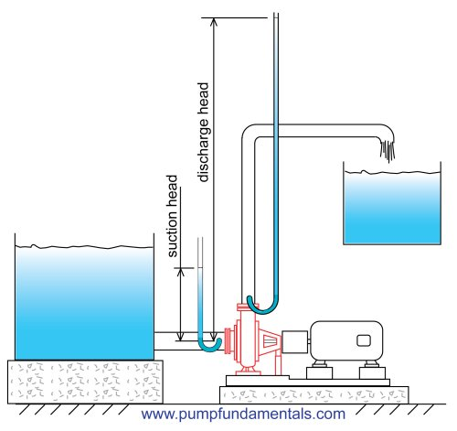

**Figure 11: Head**

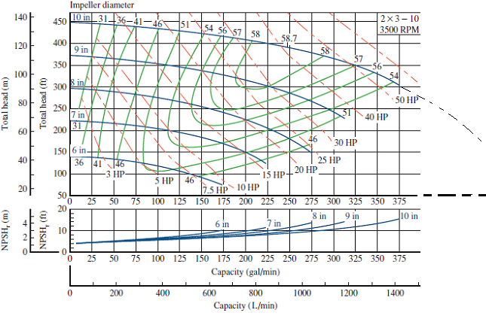

**Figure 12: Pump performance curves /Chegg: Applied Fluid Mechanics/**

**Quiz 1**

The performance curves above refer to 3500 RPM.

* What frequency does this corresponds to?
* What are the implications if we are to use this pump?

**7.4.2 Cavitation**

Pressure drops through the impeller, before rising through the diffusor. Below the vapor pressure, small bubbles may form and implode. This involves local pressure peaks and cavitation, as illustrated below

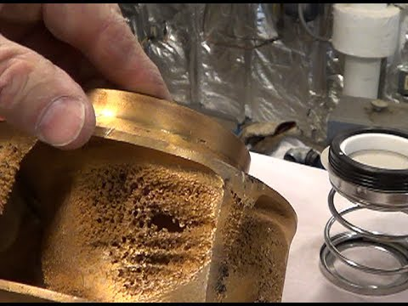

**Figure 13 Cavitation**

To avoid cavitation, the inlet pressure must be high enough to drops be vapor pressure. In figure 12 this provided as requiered: Net Positive Suction Head (NPSHr), for water. At room conditions, water vapor pressure is very low, such that NPSHr can interpreted directly as minimum water level above the pump intake, illustrated in figure 11.

**Quiz 2**

Figure 12 provides NPSHr for our pump,

* Estimate inlet pressure required to avoid cavitation when pumping 300 liter/minute of water at temperature 100 C

**Quiz 3**

* Estimate the lifting head provided by a 10 inch impeller, rotating at RPM 3500
* Relate this estimate to the pump performance provided by figure 12

**7.4.3 Affinity laws**

Figure 12 above suggests that the fluid leaves the impeller at velocities governed by the tangential velocity at the outer radius of the impeller: . The flow rate may be expected proportional to this velocity, thus

 (4)

Through the diffuser, the velocity energy is converted to pressure: . By Bernoulli’s law, pressure rise becomes proportional to density, and squared frequency and impeller diameter: and head:  proportional to squared frequency and diameter

 (5)

The power requirement is expressed: . Equations (4) and (5) provides the proportionality relation

 (6)

The equations above enables extrapolation from head relations provided:  to performance under different operation conditions.

**7.5 System performance**

**7.5.1 Prediction of flow rate**

Consider pump and pipe as illustrated below

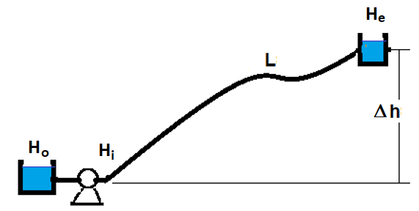

**Figure 14**

For pressure drop along pipe : 

The inlet pipe inlet head needed for flow Q is expressed

 (7)

head at outlet: He

For hydraulic head: Ho at the pump inlet, the pump provides outlet head

 (8)

And this must correspond to the head required by the pipe (7) . Figure 17 illustrates this, providing graphical solution for flow rate

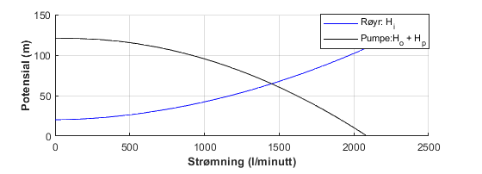

**Figure 15: System performance**

**7.6 Flow control**

**7.6.1 Throttling**

|  |  |
| --- | --- |
| **\\home.ansatt.ntnu.no\asheim\Desktop\Skjermbilde.PNG** |  |

**Figure 16: Throttling control**

Throttling reduces the outlet pressure delivered by the pump. Assuming choke valve performance:  , the resulting head becomes

 (9)

Work provided by the pump and work delivered to the pipe relate to flow and pressure drop, or head: . The figure below shows that for the case considered, throttling control makes the pump do about 3 times the work needed

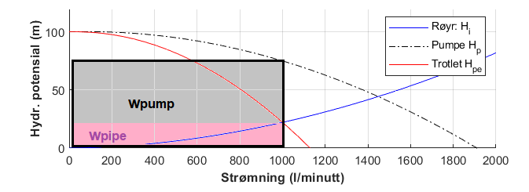

**Figure 17: System performance with pump controlled by throttling**

**7.6.2Bypassing**

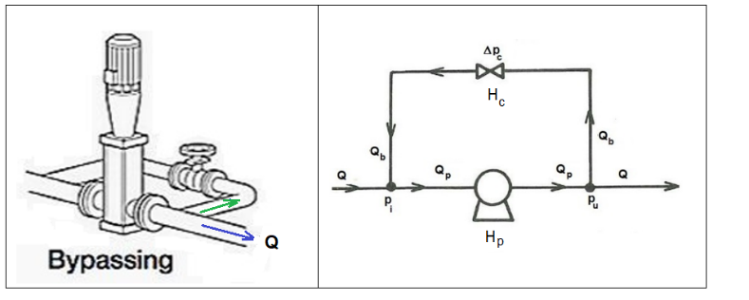

**Figure 18: Bypass-control**

Kirchoffs laws

* Equal flows (currents) in and out of junctions: 
* Potential (voltage) balance around loops: 

Pump potential

* by second-order polynomial : 

Potential drop across the bypass valve

* choke flow relation:

Combined, the flow rate through the pump relates to the outflow rate



Thus, the pump potential relates to the outflow rate: , derived above. The figure below illustrates this

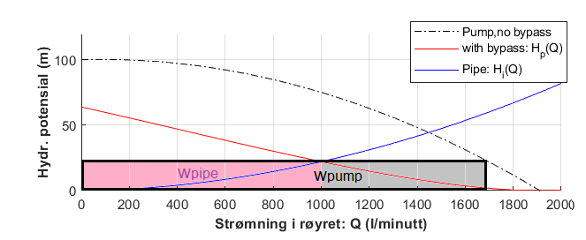

**Figure 19: Pump potential with bypass control**

**Quiz 4**

Consider pump performance provided by figure 12:

* Estimate the performance for 2 pumps in series, one with 10 inch impeller, one with 8
* Estimate the performance for 2 pumps in parallel, one with 10 inch impeller, one with 8
* Any recommendations based on these estimates?

**7.6.3 Frequency control**

Modern electronics makes it attractive to control the frequency and thus the rotation speed of the pump motor (variable speed drive)

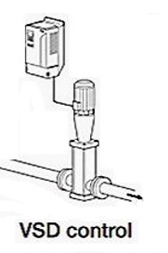

**Figure 20: Variable speed drive**

Performance curves like provide head: H1 for given rate Q1 when the pump impeller rotates at frequency: 1 . Head, rate, and effect if the frequency is changed to:  follow from the affinity laws







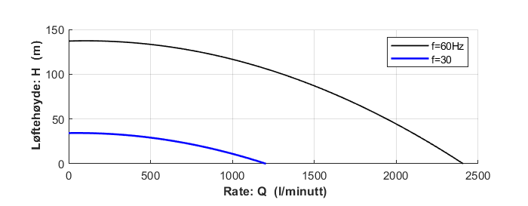

**Figure 21 : Predicted by 50% frequency reduction**

**7.8 Ejector pumps**

**7.8.1 Performance prediction**

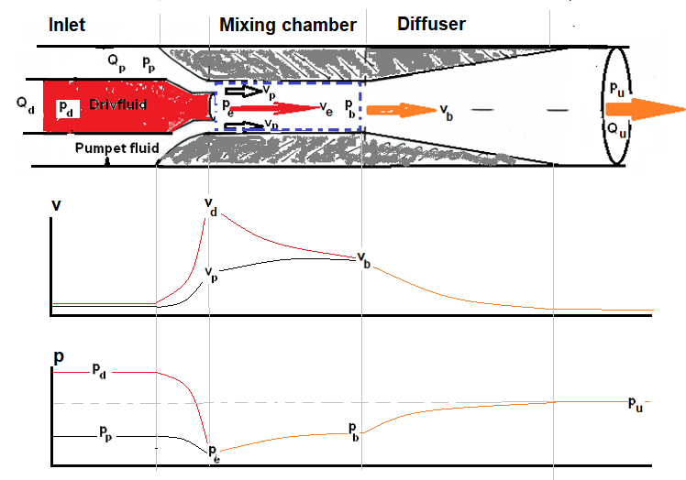

**Figure 22: Jet pump, velocity and pressure**

Choke outlet

The inlet flows are accelerated by reduced flow areas. Neglecting upstream velocities, the power fluid pressure at choke outlet pressure is expressed

 (10)

At the choke outlet the power fluid meets the pumped fluid and their pressures must be equal

 (11)

Mixing chamber

The drive- and pumped fluids flow in at different velocities, while mixing makes the outflow homogenous. By momentum balance: , where outlet mass flow equals the sum of inlet flows: . Solving the momentum balance, the pressure drop along the mixing chamber becomes

 (12)

For incompressible fluids: . Thus, the outlet velocity : 

Diffuser

The diffuser de-accelerates the flow out of the mixing chamber, transforming velocity energy into pressure. By Bernoulli law, neglecting downstream velocity



**7.8.2 Performance relations**

Heads

Combining the relations above, the lifting head :  can be expressed

 (13)

with corresponding head loss of the drive fluid: 

 (14)

Theoretical efficiency

The jet pump provides energy to the pumped stream:, while the drive fluid loses energy rate: . Thus, the ideal efficiency factor: *p/Ee* , is expressed

 (15)

The ideal (“thermodynamic”) efficiency of piston- and rotating pumps is: , while non-ideal effects commonly make it drop to 0.6-0.7. Thus, the jet pump efficiencies considerably below theoretical should be expected

**Example calculation**

Drive fluid choke diameter: 1 cm. Diameter mixing chamber: 3 cm. Inlet area pumped fluid:  Density for drive- and pumped fluid assumed equal: 1000kg/m3. Drive fluid rate: 3 l/s.

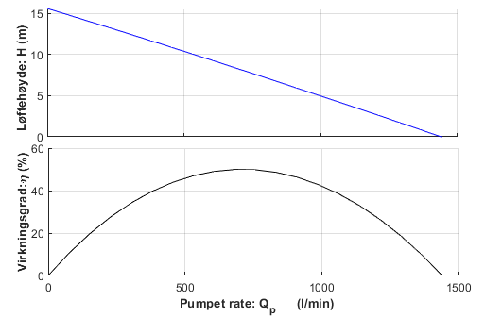

**Figure 23 Performance predicted for constant drive fluid rate**

**References**

1994 Cushman-Roisin, B.: Introduction to Geophysical Fluid Dynamics

Prentice Hall, NJ, 1994

2015 Khalifa, Peeran, Koleshwar: Successful Utilization of Surface Jet Pumps at Gas-Oil Separation Plant, 2015, SPE-177403-MS