6 Energy

Energy is the quantitative property that must be transferred to an object in order to perform work on, or to raise its temperature. Energy is a conserved quantity: can be converted in form, but not created or destroyed. Thus, it provides the 3rd fundamental conservation relation; the 2 first being balances of mass and force.

Energy balance enables us to predict temperature in flowing fluids. For liquids, expansion cooling and friction heating are normally be negligible. If so, is sufficient to account for cooling by heat conduction to surroundings.

Gases expands when pressure drops. This couples the force balance describing pressure drop and the energy balance describing work and heat content. Under some simplifications, this leads to the isentropic model and analytic solutions for gas flow through valves and restrictions

**6.1 Energy balance open systems**

The first law of thermodynamics states that energy may change form, but not disappear. This is traditionally illustrated by a Sterling Engine; where a gas-filled cylinder is heated and does mechanical work by expanding against a piston. Thereby heat energy is converted to work. Conversely, if gas expands without heat being supplied, the temperature will drop

 (6-1)

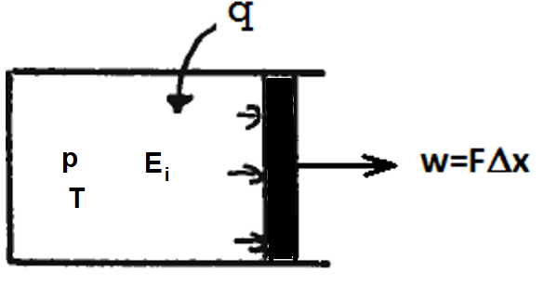

**Figure 1: Energy balance for closed system**

q: heat supplied from outside | J |, or |J/s|  
w: work performed | J |, or |J/s|

For flowing fluids there is no piston and changes in pressure, height and velocity also affect energy content. An “open system” illustration then below seems appropriate

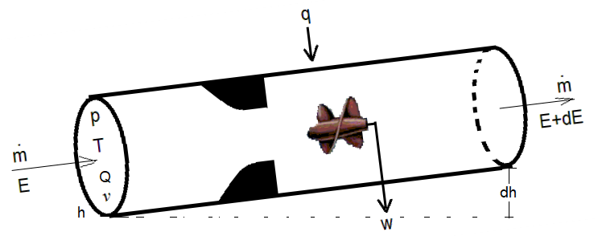

**Figure 2 Energy balance for an open system**

**6.2 Conservation relations**

Internal energy

Speed and vibration of the molecules depends primarily on temperature. The relationship is tentatively illustrated below. Rather than the function: *Ei(p,T,..)*, linear thermodynamics considers the slope ,  called heat capacity at constant volume.

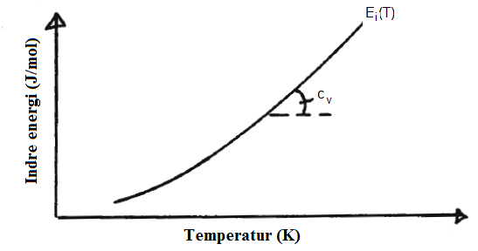

**Figure 3 Internal energy as function of temperature**

As long as interactions between molecules can be neglected, the molecular energy depends on temperature alone, so that: . Thus, change is approximated:

 (6-2)

Equation (8-11) assumes heat capacity per mass unit |J/kg|, favoured in flow engineering

(Chemical engineering favours mole flow, mole relates to mass by: n=m/M)

The site: <https://www.engineeringtoolbox.com/specific-heat-capacity-gases-d_159.html> lists thermal properties for a number of gases. Heat capacity of some liquids can be found in:

<http://www.engineeringtoolbox.com/specific-heat-fluids-d_151.html>

Mechanical energy

Bernoulli’s equation relates pressure in a flowing fluid to height and velocity. Expressed in energy units, with Q denoting volume flow

 (6-3)

Expansion   
When fluid expands, it performs mechanical work.

 (6-4)

This may transferred out of the system by a moving piston, or a rotating expander. The internal energy then decreases and the temperature falls.

If the pressure is reduced by turbulent losses, similar work is performed, but the corresponding energy (6-4) remains in the system

Energy conservation for open system

Adding internal (6-2), mechanical (6-3) and expansion (6-4) energies provides the energy conservation equation for open systems

 (6-5)

The first 2 terms of (6-5) represents change in “heat content” (enthalpy) by molecular energy plus expansion. The enthalpy is defined: H=Ei+pV. Thus (6-5) can be expressed:  , with: . The general gas equation: H=Ei+nRT enables simple estimation of: cp for gases. Most liquids that do no expand much with pressure, so: 

Heat transfer from surroundings

Transfer by conduction depends on the difference between inside and outside temperatures, as expressed by (1-10). An electric element may ideally provide constant heat flow: q.



**6.3 Isentropic model**

If friction, heat transfer, work, height- and velocity change are neglected: f=0, dq=0, dw=0, dv=0 and dh=0, (6-5) simplifies : 

The general equation of state  provides:. Using this to eliminate temperature:  and integration gives the isentropic process equation, often called: “isentropic equation of state”

 (6-6)

adiabatic exponent 

Combining eq. (6-6) and the general equation of state relates temperature to pressure

 (6-7)

Similarly, density changes can be expressed

 (6-8)

With initial density : 

The isentropic equation assumes no work and neglects friction and heat transfer. It state is developed combining energy balance and the general gas equation and is thus relevant for gas flows that expands.

If pressure drops little relative to the inlet pressure, the gas expansion is small and often neglected. Gas is thereby approximated assuming constant-volume; as for liquid.

**6.4 Flowing fluids**

**6.4.1 Pipe flow**

The pipe flow equation (1-3), re-written below, expresses force balance. It has the unit: (Pa=N/m2) and enables us to calculate pressure loss

 (6-9)

Multiplying by flow rate (m3/s), it measures energy transfer (Nm/s=J/s), within the pipe

 (6-10)

Subtracting (6-4) from (6-5), energy conservation for pipe flow is simpler expressed

 (6-11)

Equation (6-11) enables us to calculate how flow affects the temperature within the pipe. Fluid expansion: pdQ contributes as external work: w. Friction contributes similarly to external heating: q.

Temperature change affects viscosity, density and may cause condensation/vaporization. This couples the energy- and flow equations. If the coupling is strong, eqs. (6-9) and (6-11) should be solved simultaneously.

**6.4.2 Gas flow through restrictions**

For reversible processes involving ideal gas, general energy conservation equation was simplified, leading to the isentropic relations (6-6)-(6-8).

Bernoullis equation for compressible fluid becomes: . For density variation (6-8) , integrating from upstream pressure: *pi* and velocity:*vi*~0, to outlet: *pc ,vc* , gives

 (6-12)

Mass flow is expressed: . With eq. (6-12), it leads to “Thornhill-Craver’s equation”

 (6-13)

The blue, dotted line in the figure below shows prediction for constant upstream pressure. The red line shows incompressible flow, almost coinciding with (6-13) for pressure drop <5%. (pc / pi> 0.95)

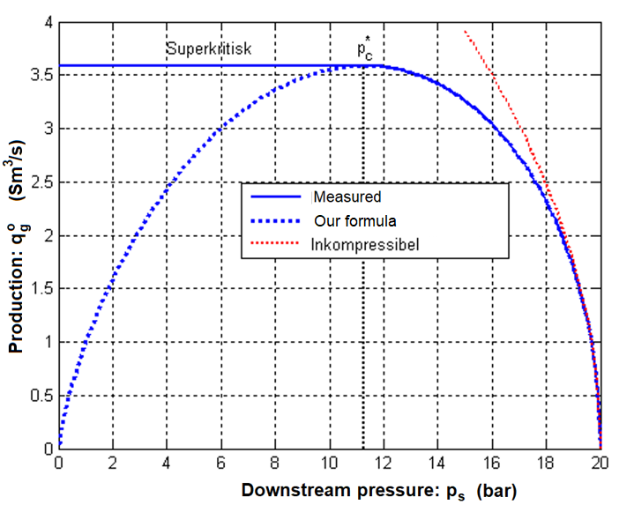

**Figure 5 Mass flow through orifice, calculated by different approximations**

When downstream pressure decreases, increasing rate is predicted until a maximum is reached, thereafter decreasing. By differentiation, the pressure ratio corresponding to maximum rate is expressed

 (6-14)

Critical pressure drop (6-14) corresponds to sonic velocity :  at the choke outlet. 

At higher pressure, critical pressure and sonic velocity are maintained at the outlet. After the outlet, a pressure shock will form.

If the cross-section is gradually increased after the outlet, supersonic flow may establish. The shock will then establish further down-stream, where the velocity drops to sub-sonic.

**6.5 Non-isentropic processes**

A relevant case is the choking discussed in chapter 1.3, illustrated below . The flow involves no transfer of heat and work, thus adiabatic. Friction will be low till the choke outlet. Thus, isentropy may be assumed and temperature estimated by (6-8). After the outlet, the jet hits slower fluid, causing intense turbulence and friction. This transfers velocity energy to heat, rising the temperature

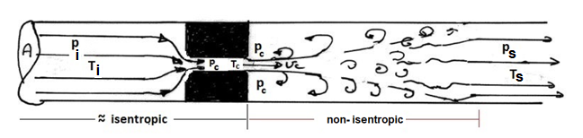

**Figure 4 : Flow through chokes**

The flow out of the orifice causes turbulence and dissipation of most of the kinetic energy. Thus, the isentropic assumption is no longer valid.

The general energy equation (6-5) applies. Here: no external work, heat transfer to surroundings and wall friction may be neglected. Using the general gas equation, (6-5) simplifies



Thus, energy change between upstream and downstream, being nil without transfer to surroundings, is expressed:



The velocities will only contribute significantly to the energy balance if they approach critical ( ).Usually, they are much smaller, so that is insignificant. Neglecting velocity change: dT=0. Thus: Ts=Ti, temperature is not changed by choking (adiabatic expansion). At higher pressure, gas behavior deviates from ideal and temperature may drop, or rise. This is called Joule-Thompson expansion and can be derived by extended equations of state.