Classroom exercise 2.
Task 2.1 Stratified flow
Gamma densitometers work by measuring the absorption of penetrating gamma rays. Since oil and gas absorbs differently, this enables measurement of their relative amounts.
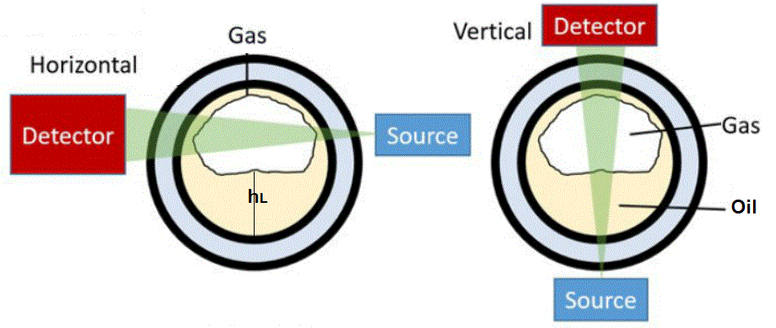
Figure: Gamma densitometer
The pipe inner diameter is 200 mm. Horizontal ray (figure left) measures 3% oil content, while vertical ray (figure right) measures 20%. This may be interpreted as stratified flow regime, may be as illustrated
- Estimate height of the liquid layer: h_{L}
- Estimate liquid holdup: y_{L}=A_{L}/A

