**2 Multi phase flow**

**2.1 Flow regimes**

In wells, oil often flow together with gas, water and solid particles. Figure 2.1 illustrates the typical flow patterns. Simplified sets are 3 main patterns of vertical flow:

- Continuous fluid, with gas bubbles / solid particles   
- Continuous gas, with drops of liquid / solid particles and liquid film along the walls   
- Alternating liquid plugs and gas accumulations

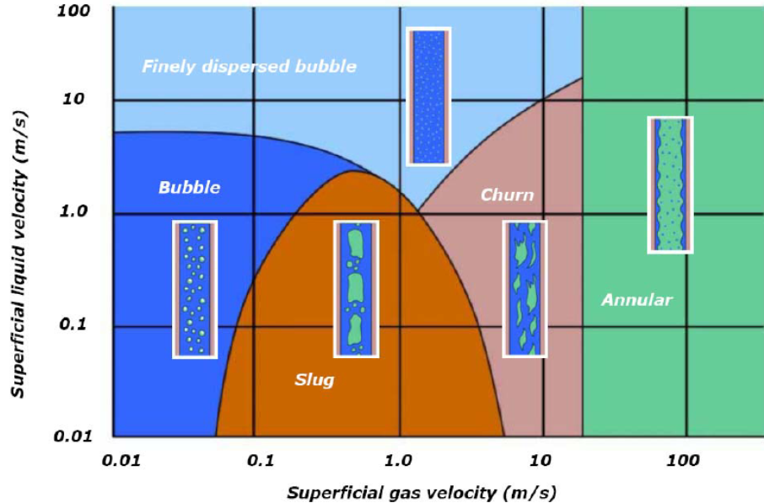

**Figure 2.1 Flow regimes, vertical flow of liquid and gas**

Subsea fields are often developed with wellhead clusters connected to central processing plants figure 2.2 illustrates the Tanpen area. From well heads to processing plant, un-processed fluid mixtures flow over considerable distances, in large-diameter pipes.

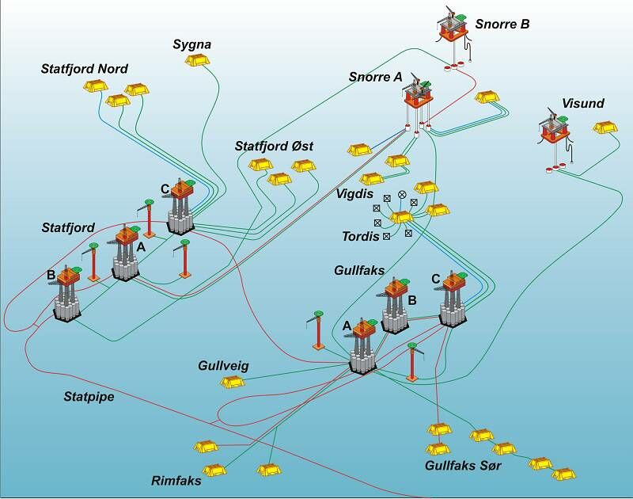

**Figure 2.2 Tampen area**

In horizontal flow at low velocity, there with a tendency to stratification because of density difference. Figure 2.3 illustrates horizontal regimes

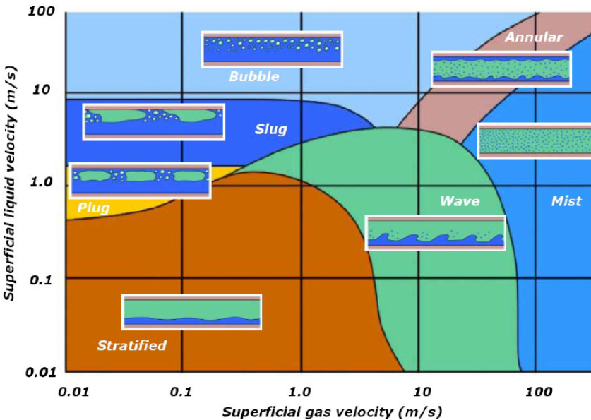   
  
**Figure 2.3 Flow regimes, horizontal flow of liquid and gas**

Most wells and pipelines are neither horizontal, nor vertical. The inclination also affects the flow. Fluid properties like densities, viscosities and surface tension varies with pressure and temperature and affect the flow regimes. Thus, illustrations like above are not predicative.

***2.2 Flow***

**2.2.1 Velocities and holdup**

Usually, the lighter and less viscous gas phase flows faster than liquid. This results in relative accumulation of liquid. In oil-patch jargon, the resulting in-situ liquid fraction is called “liquid holdup”.

Liquid fraction in a pipe may be measured by emptying the liquid by pigging. Liquid fraction is equivalent to the fluid volume, divided by the volume of the pipe segment

Locally it may by measuring the electrical impedance. Liquid and gas have different impedance. Such measurements therefore indicate fractions of gas and liquid.

Since the ability to absorb the gamma rays is also different for liquid and gas, gamma absorption can also be used for measuring in situ fractions.   
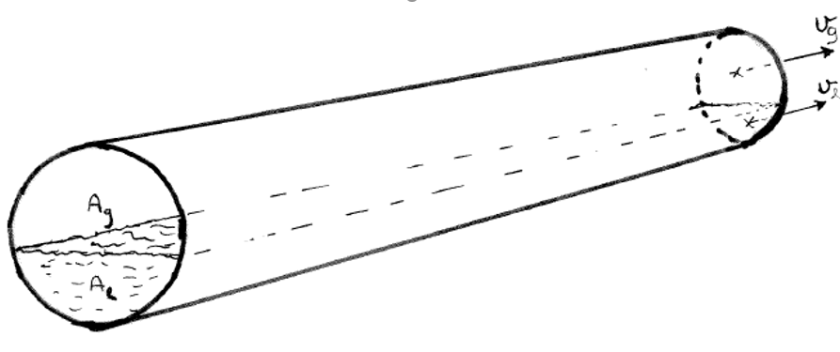

**Figure 2.4: Fluid velocities and in-situ fractions**

Flow velocities relates to superficial velocity and fraction

 (2-1)

 (2-2)

*yg* : gas fraction   
*yl* : liquid fraction (liquid holdup)

Average density of fluid mixture in a pipe segment links to fluid densities and fractions

 (2-3)

**2.2.2 Slip**   
Gas has less density and viscosity than the liquid and will usually flow faster. Zuber & Findlay /1965 / proposed to link gas velocity to total superficial velocity

 (2-4)

*Co*: distribution parameter: 1.0 <*Co* <1.2

*vo* : rise of gas bubbles, relative to liquid

By combining (2-1) and (2-4), we can express the liquid fraction directly

 (2-5)

Z & F model has been widely used, but is misleading in many cases. Asheim /1986 / relates gas velocity directly to the velocity surrounding liquids

 (2-6)

By combining the relationship between velocity and superficial velocity to the drop relationship (2-6), the liquid fraction is expressed as

 (2-7)

Relationship (2-7) is more complicated than (2-5), but avoids most shortcomings of the Z & F model.

If the gas flows up and the liquid down, equation (2-7) gives one, two, or no solutions. One solution predicts stable counter current flow. No solutions imply that counter-flow at the given rates is impossible. Two solutions imply transition between continuous liquid and continuous gas. One of these solutions will then usually be unstable, such that the flow regimes will change

***2.2.3*  Force balance for separate gas and liquid channels**To start, we may assume that the phase flows in stratified channels, as outlined in Figure 2.3 below. The gas flow equation becomes

 (2-8)

*Ag*: gas-filled cross-sectional area

*Sgw*: contact length (perimeter), gas against pipe wall

*gw*: shear stress, between gas and pipe wall

*Si*: contact length between gas and liquid

*i*: shear stress, between gas and liquid

The flow equation for the liquid channel becomes

 (2-9)

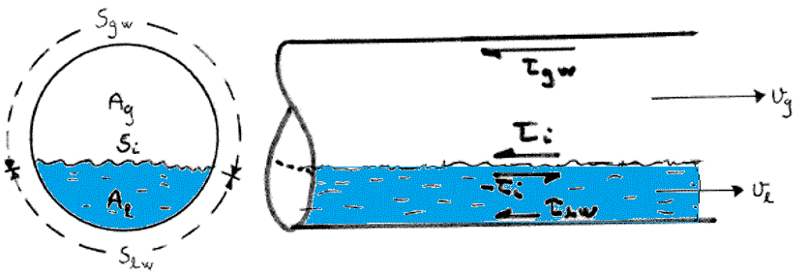

**Figure 2.5 Segregated flow**

In the equations above, friction resistances are estimated by shear stresses: force / contact-area. Shear stress can be correlated against speed and density: , usually by Fanning’s friction factor: fF. For calculation of pressure drop in pipes, the Darcy-Weisbach friction factor is more commonly used. This is by definition 4 times greater than Fanning’s: f = 4fF. Otherwise, they are equivalent, can be estimated by the same correlations, and pressure loss can also be calculated based on shear stress.

For horisontal pipes, flow with small velocity will be stratified. Taitel & Dukler /1976 / predicted velocity and fractions of stratified flow and used as stability analysis to assess whether the stratified solutions were physically realistic, or whether the gas and liquid would be divided in any way in the pipe.

2.2.4 Stratified flow

The pressures in gas and liquid channels must be the same. Eliminating pressure gradients provides the flow channel relationship

 (2-10)

Thus, the gas- and liquid filled areas: Ag, Al, wetted perimeters: Slw, Sgw , Si and liquid holdup: yl and shear tensions:  must be such that the equation above |Pa/m| is fulfilled.

For stratified flow, the channel cross section is illustrated below. The “piece-of-cake” cut by the angle:  has the area: . The figure to the right emphasizes the “piece-of-cake” above the liquid layer.

|  |  |
| --- | --- |
| \\home.ansatt.ntnu.no\asheim\Desktop\Skjermbilde.GIF | \\home.ansatt.ntnu.no\asheim\Desktop\hydrocarbones_temperature_vapor_pressures.png |

**Figure 2.6 Stratified flow**

Simple geometry then relates the other distribution parameters to:  (radians)













With shear stresses against pipe wall





The interfase shear is preferably predicted from the gas channel, since the gas flow is almost always turbulent. In downward sloping pipe, liquid may flow fastest and exert a drag on the gas. This is accounted for by the absolute-value product:



We seek the angle  such that the pressure balance is fulfilled

 (2-11)

Common results of level predicitions

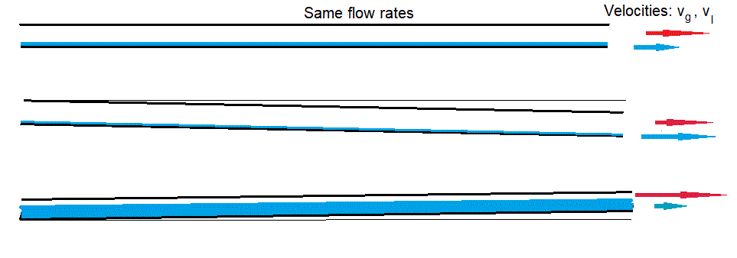

**Figure 2.7 Liquid level predicted for different pipe inclinations**

Pressure prediction

 (2-12)

**2.2.5 Stability of stratified flow**

At very low velocity, the gas/liquid interface may be smooth. At higher velocity, capillary waves will disturb the interface, but not necessarily grow. The Kelvin-Helmholtz criterion considers the dynamic stability of interface perturbations, e.g. sinusoidals.

The current analyses below consider a local change of liquid level, illustrated below. This is simpler than sinusoidal perturbation and the results easier to apply

**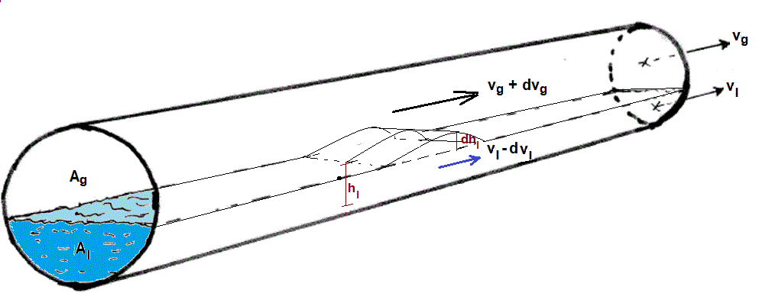**

**Figure 2.8 Dynamic stability consideration**

The local elevation reduces the gas flow channel. If the elevation moves with liquid velocity, the relative gas velocity above becomes:  , causing dynamic pressure drop: (Bernoullis law). This is opposed by static pressure drop due to increased liquid level:. If the static pressure change exceeds the dynamic, the elevation will decrease.

Thus, the dynamic stability criterion becomes

 (2-13)

Using the stratified flow geometry relations, the term  can be derived analytically

The derivation of goes:

, ,

Providing

 (2-14)

**2.2.6 Slug sustainability**

According to the criteria above (2-13)-(2-14), an unstable elevation may rise to the top, blocking the gas channel as illustrated below. Thereafter, the slug may grow, or decay

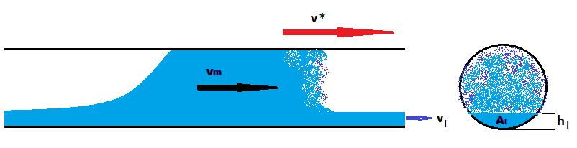

**Figure 2.9 Liquid slug**

The slug will pick up and slower moving liquid velocity ahead of it, thus creating a hydraulic jump. Figure 2.10 below shows an analogous case with a tidal wave moving up a river.

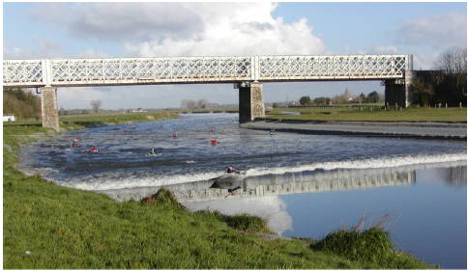

**Figure 2.10 Tidal wave in the river Selune, Chanson /2009/**

Hydraulic jumps may be mathematically be treated as “shocks”, discontinuities. The shock velocity: v\* must be such that the mass balance is maintained across it. Considering the control volume, figure 2.11, the mass picked up ahead:  must equal the mass left behind . Thus, the slug front velocity

 (2-15)

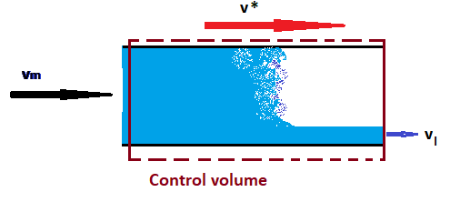

**Figure 2.11 Control volume, moving at slug front velocity**

At the rear end, liquid will sink back, causing the gas/liquid interface to penetrate into the slug as illustrated below. If the penetration velocity is denoted: vZ , the rear end slug velocity becomes

 (2-16)

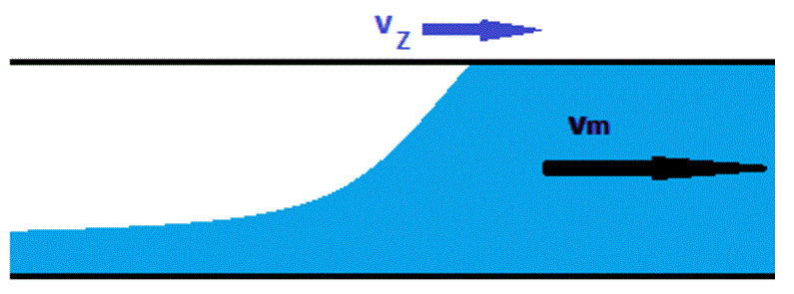

**Figure 2.12 Rear end of moving slug**

The difference between front and rear velocity: (2-15)-(2-16) provides the sustainability criterion

 (2-17)

Thus, if (2-17) is fulfilled, the slug will grow, the growth velocity being: v\*-ve. This predicts slug length growing linearly along the pipe, as long as the sustainability criterion is fulfilled, and decreasing linearly when it is not.

Zukoski /1966/ investigated gas penetration into liquid filled pipe. Figure 2.13 illustrates this for different inclinations.

|  |  |
| --- | --- |
| \\home.ansatt.ntnu.no\asheim\Desktop\Skjermbilde.GIF | \\home.ansatt.ntnu.no\asheim\Desktop\Skjermbilde.GIF |

Figure 2.13 Rise of large gas bubble through liquid

Zukoski expresses the bubble front velocity

 (2-17)

where:

** : inclination angle (vertical=90o)

 : surface-tension parameter 

The figure below provides the correlation: Cz(**). For vertical pipe and low , as for large pipe and large density difference: CZ =0.491. This corresponds to the analytical solution by Dumitrecsu/1944/ and experimental by Taylor/1950/, for vertical pipes.

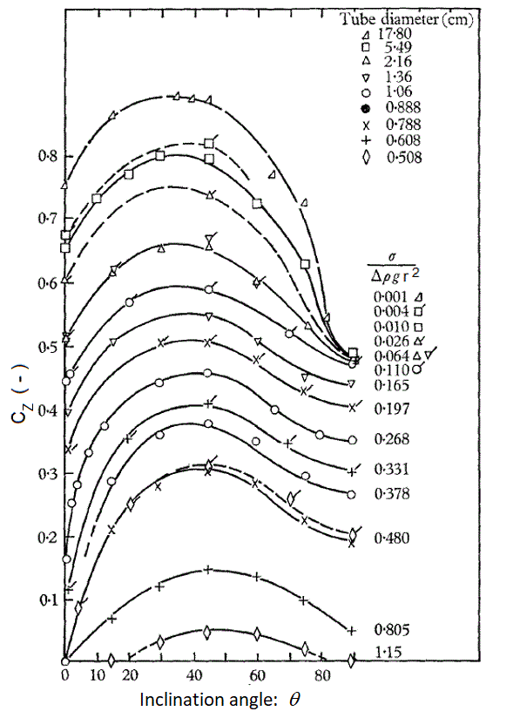

**Figure 2.14 : Correlation for dimensionless penetration velocity Cz(**).**

**2.2.7 Mixed flow with slippage**

If gas and liquid flow together, we need a flow equation for mixture. We find it by putting: *Ag/A = yg , Al/A = yl* into (2-) and (2-), and adding them. This eliminates the interphasial shear. The mixed flow equation becomes

 (2-)

The last part in (2-) contains shear stresses and wetted perimeters. If we presume that perimeter is proportional with fractions (*Sgw=ygS=ygd*), and represent the velocity by (2-), (2-), we can develop shear contribution as



When gas and liquid flow in the same direction, we can ignore the absolute values. It is useful to relate shear to rate and flux density (2-), (2-). If we also assume equal friction factors for liquid and gas : *fg = fl =fo*, we get

 (2-)

Often the shear contribution (2-) expressed as for flow of homogeneous mixture

 (2-)

Here *fTP* is thetwo phase friction factor, estimated from the correlation for single-phase flow, with a correction factor for the drop:

 (2-)

The comparable single phase friction factor *fo* is estimated by standard single-phase correlation (for example : *fo=0.16/Rem0.172*) with Reynolds Number for the homogeneous mixture, usually defined as

 (2-)

From (2-28), (2-29) follows the slip correction factor then becomes

 (2-)

With this theoreteical basis, we can express and calculate the pressure gradient

 (2-)

The theory above involved many assumptions and approaches. Published models for steady-state two phase flow may deviations somewhat from the basis outlined above.

.   
  
1943 Dumitrescu, DT: "Strömung an einer Luftblase in senkrecthen Rohr"   
    Z. angew. Math. Mech., 1343, vol. 23, no. 3, pp 133-143   
  
1950 Davis, R.M., Taylor, G.I.:   
"The Mechanics of Large Bubbles Rising Trough   
Extended Liquids and Through Liquids in tubes " 

1962 Nicklin, DJ, Wilkes, JO, Davidson, JF: "Two Phase Flow in Vertical tubes"   
Trans. Instn. Chem. Engrs. Vol 40, 1962, pp 61-68.

1963 Duns, H., Jr. and Ros, N. C. J.:

Vertical Flow of Gas and Liquid Mixtures in Wells,

*Proc. Sixth World Pet. Congress,* Frankfurt (Jun. 19-26, 1963) Section II, Paper 22-PD6.  
  
1965 Zuber, N. & Finlay, J.:   
"Average volumetric concentration in two-phase flow systems"   
         Trans ASME, J. Heat Transfer. C87, 453-468   
  
1966 Zukoski, EE: "Influence of viscosity, surface tension and inclination   
Wednesday angle motion of long bubbles in closed tubes "   
Journet. of Fluid Mechanics 1996, vol. 25, p. 4, pp 821-837.   
  
1974 Ashford, FE: "An Evaluation of Critical Multi-Phase Flow Performance   
Through Well Head Chokers "   
JPT, Aug. 1974, p. 843.   
  
1976 Taitel, Y., Dukla, A.E. : "A Model for predicting Flow Regime Transitions   
in Horizontal and Near Horizontal Gas-Liquid Flow "   
AICHE Journet., Vol 22, No. 1, Jan. 1976, pp 47-55.   
  
1976 Campbell, JM: Gas Conditioning and Processing. (Vol 1)   
Campbell Petroleum Series, 121 Collier Drive, Norman, OK   
  
1986 Asheim, H.:   
  "MONA, An Accurate Two-Phase Well Flow Model Based on Phase Slip Page"   
SPE Production Engineering, May 1986, pp 221-230

### 1989 Lunde, Olav: [Experimental study and modelling of slug stability in horizontal flow](https://bibsys-almaprimo.hosted.exlibrisgroup.com/primo-explore/fulldisplay?docid=BIBSYS_ILS71492821850002201&context=L&vid=NTNU_UB&lang=no_NO&search_scope=default_scope&adaptor=Local%20Search%20Engine&tab=default_tab&query=any,contains,olav%20lunde,AND&mode=advanced&pfilter=pfilter,exact,dissertations,AND&offset=0), Doctoral dissertation NTH

1990 Kabir, C.S. and Hasan, A.R.:   
"Performance of two-phase gas / liquid flow model in vertical wells"   
J. of Petroleum Sci. and Engr, 4, 1990, 273 

1. Sagar, R., Doty, D.R., & Schmidt, Z.: “ Predicting Temperature Profiles in a Flowing Well”, SPE PE, Nov. 1991, 441-448

1991 Basniev, K.S. & Many others:   
"Thermal Dynamic model for the provision of the flow capacity of gas wells" (in Russian)   
Gasprom 1991

1. Lea, J., Nickens, H.V., Wells, M.

Gas Well Deliquification ,Gulf Professional Publishing, 2003

2005 Shoham, O.:

Mechanistic Modelling of Gas-Liquid Two-Phase Flow in Pipes

SPE Books, 2005

2009 Aarvik A., Djuve S., Valle D.: «Steady state calculations of wellbore and wellhead temperature” Multiphase Production Technology 14, 199-214 BHR Group 2009

2009 Chanson, H.

“Current knowledge in hydraulic jumps and related phenomena.”

European J. of Mechanics B/Fluids 28, 2009, 191-210

2010 Veeken, C.A.M. and Belfroid, S.P.C.

“New Perspective on Gas-Well Liquid Loading and Unloading.”

SPE 134483, presented at Annual Tech. Meeting, 2010