**1 Stationary flow**

Bernoulli's equation is assumed to be known. This links the change of pressure to speed and height

 (1)

If fluid flows through pipes from A to B as illustrated below, we can now calculate pressures when we know the height difference and speed of inlet and outlet.

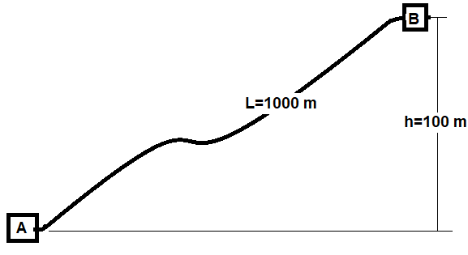

**Figure 1-1**

***Example 1***

*Water should be pumped 25,000 m3 / d from A to B. It is proposed pipe inner diameter 200 mm. Required outlet pressure at B is 2 bar (above atmospheric)*

*- How much inlet pressure is needed at pump station A?*

*- If the fluid flows back from B to A, what will the outlet pressure be?*

**Solution 1**

*Water density can be considered constant. With constant pipe diameter, the speed will then also be constant. Equation 1 can then easily be integrated*



1. If the system is not crazy-sized, it can expect velocity a few meters per second. The acceleration becomes negligible, eg at speed 3 m / s: .
2. Static pressure change : .

With outlet pressure 2 bar, inlet pressure is then required: pA = 12 bar

Friction between fluid and stationary pipe wall provides shear stress and flow resistance. The shear stress is related to contact area, speed and density; expressed by Darcy-Weisbach friction factor:

 (2)

(The shear stress on objects in flowing fluids is traditionally expressed using the Fanning friction factor. This being 4 times the Darcy-Weisbach friction factor, thus :  . )

For a circular pipe, the perimeter:  and the shear force: . The pressure gradient is this force divided by the pipe cross section: , thus



Pressure loss can then be estimated by adding the friction loss above to equation (1)

 (3)

The height contribution is here expressed by the acceleration of gravity along the pipe: .

The friction factor for pipes is often estimated with the Moody chart, Moody | 1944 |.

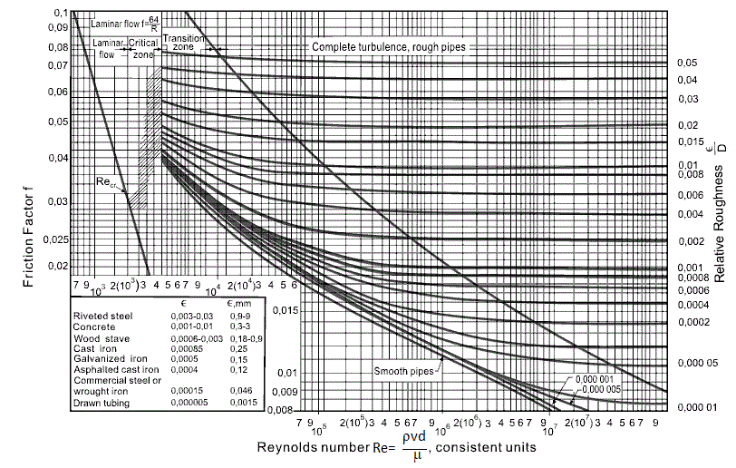

The Moody chart matches Colebrook's equation: 

Haaland's formula provides an explicit approach  (4)

**2 Transient flow**

The mass balance must be maintained, in accordance with the continuity equation

 (5)

Stationary flow means no change over time, and the continuity condition (5) gives: ; thus constant speed if the pipe diameter is constant, possibly adjusted for change in density.

Acceleration in time and space must match Newton's law: . This leads to



Easier expression i obtained by the combination of (6) and the above relationship

 (6)

**3 Flow through nozzles**

The figure illustrates flow through a nozzle. Wall friction i insignificant, because the contact surface against the wall is small. The height difference can be neglected. The fluid is considered incompressible and the area: A is the same before and after the nozzle, so the speed becomes the same.

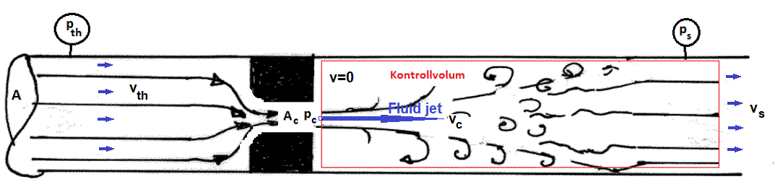

**Figure**

Pressure change to orifice outlet

For height considered constant and friction neglected, equation (4) simplifies: 

Integration:  (7)

For incompressible flow: Q: 

Total pressure loss

Impulse balance over indicated control volume: 

Mass flow: 

Neglecting expansion: ,

Pressure becomes: 

From the results above: , provides downstream pressure

 (8)

**Flow through valves**

To provide significant pressure loss: Ac<<A, 🡪 vc>>vth. From (1-8) follows:



Friksjonsfaktoren er knyttet til Reynoldstallet for blandingen

**4 Heat transfer**

Flowing fluid will have an inlet temperature. Along the pipe, this will change, due to several mechanisms, where heat transfer to the environment is usually important. The temperature affects fluid properties such as density and viscosity, thus also loss of pressure. Temperature also affects the deposition of wax, hydrates, condensation and other phenomena that may be decisive for the flow.

Figure 2.1 illustrates a cross section of a pipe surrounded by air, or water. If the temperature inside: T is greater than outside: Ta there will be a heat flow: q (w) as illustrated. This is proportional to the transition area: and the temperature difference (Newton's law), where the constant: U (w / (m2K)) is affected by thermal conductivity through the pipe wall

 (9)



**Figure 2 Heat transfer between pipe and surroundings**

The transition area relates to total length:  and the temperature varies along the pipe. The transition relationship (2-1) is also applicable to a segment, illustrated in Figure . With length dx and diameter: D, the outer area becomes:  and the transitional relationship differential

 (10)

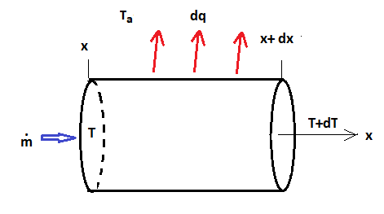

**Figure Heat transfer from a pipe segment**

How much the temperature changes due to the heat transfer depends mainly on heat capacity: of the fluids in the pipe. The heat capacity of some fluids is given by: <http://www.engineeringtoolbox.com/specific-heat-fluids-d_151.html>

For mass flow: , the relationship between heat flow and temperature change.

 (11)

Inserted in (2-2) this gives the temperature gradient:  which, integrated expresses the temperature profile along the pipe

 (12)

The heat transfer constant: U can be linked to experience with similar lines, estimated from measured inlet and outlet temperatures: Ti -T (L), or estimated for the relevant pipe line.

The heat transfer will mainly depend on the length through the pipe wall, protection / insulation and conductivity: k. Conductivity, thermal conductivity, for some materials is provided in: <https://www.engineeringtoolbox.com/thermal-conductivity-d_429.html>.

Heat conduction through solids follows Fourier's law: . In differential form, this is expressed

 (13)

For homogeneous pipe wall with inner radius: ri and outer: re, combination of () and (13) gives  (14)

**Buried pipe**

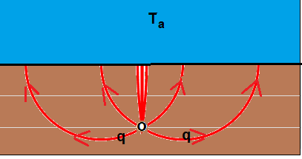

**Figure Heat transfer from buried pipe**

**5 Homogenous 2-phase flow**

**Pressure loss equation**

We express and the pressure gradient as for single phase flow

 (15)

For mixture-averaged velocity: and density: and friction factor related to the Reynolds number of the mixture.

**Mixed flow**  
Consider a pipe segment in a well where oil and gas flows.

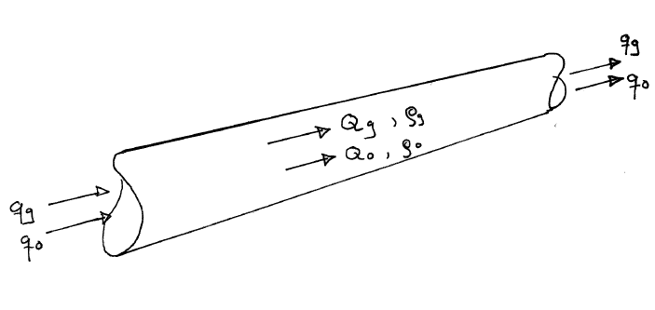

**Figure Steady-state multi-phase flow**  
  
Under stationary flow, the mass rate is constant through any cross section along the pipe. Knowing production rates at standard conditions: qg, qo, qw, we can express volume streams down in the well by using the black oil model. It is convenient to represent the volume streams by superficial velocities: flow rate/ pipe cross-section

 (16)

 (17)



**Flux fractions and flow density**

Flux fractions set flow rate for each fluid in relation to the total flow volume. Flux fractions can be linked to superficial velocity

 (18)

where





Reynolds number for the mixture flow



For perfectly homogenous flow, the friction factor may be estimated by single phase flow correlations: **. If gas and liquid flow at different velocities interphase friction will also contribute, quantified by a multiplicator: **

**References**

Moody, L.F .: "Friction Factors for Pipe Flow"

Trans. ASME, Nov. 1944, p.671