**11Heat exchanger**

**11.1 Pipe in pool**

The purpose is to heat, or cool, a fluid flow. This can be done by laying the pipe through a constant temperature pool as illustrated below

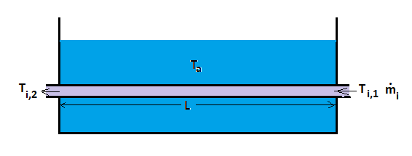

**Figure 11.1: Heat exchanger with constant outer temperature**

This event has obvious similarities to the heat transfer between pipes and surroundings; and some differences. The relationships for heat conduction (2-2) and energy balance (2-3) still apply. Reprinted

 (11-1)

 (11-2)

Combination of these led to the solution for temperature along the pipe, shown below

 (11-3)

One difference is that since the purpose is to heat, or cool, we will use thin pipe wall and material with high thermal conductivity. When the pipe wall included concrete casing and any insulation, we could neglect heat transfer between outer and inner fluids and pipe wall and any coating resistance. We can no longer do that.

Another difference is that the purpose now is not calculated temperature along the pipe, but to select pipe dimensions and outer temperature to achieve the desired outlet temperature: Ti,2. It is then appropriate to integrate (11-1) to quantify heat transfer between inlet and outlet: . This must correspond to the heat transfer between the fluid and the refrigerant, quantified by integrating (11-2): , where: means mean temperature difference between fluid and refrigerant. By setting: inlet and outlet temperatures relate to transition parameters

 , where:  (11-4)

We can find the mean temperature difference based on (11-3). The logarithm of this gives

 (11-6)

Temperature difference at inlet "hot end": 

Temperature difference at outlet "cold end": 

**Example 11.1**

Cooling water from a process plant: 10,000m3/d has temperature: 70C. This is considered used in a lobster farm, where water at 20C provides rapid growth. A lake lies between the plant and the lobster farm. We consider cooling the process water laying pipe, diameter: 0.2m through the lake. Expected summer water temperature in the lake: 10C and we have found "typical total heat transfer coefficient": U = 800w / m2K for comparable plants

- Estimate the necessary pipe length

- Consider the advantages and disadvantages of such a cooling system

- Recommendations?

.....................................................................................................................................

**Solution 11.1**

**a) Pipe length**

Temperature difference at inlet: 

Desired temperature difference at outlet: 

Effective temperature difference: 

Heat capacity for water: cp = cv = 4190 J / (kgK)

From (11-4): 

**b) Advantages / disadvantages**

If the distance is around 2km, the process water can be cooled by laying the pipe through the lake. It seems simple and cost effective.

One drawback is that if the flow rate, inlet temperature, or water temperature in the lake changes, this will affect the outlet temperature.

In temperate areas, for example, the winter temperature in fresh water may fall towards 4 C, so that: .Thus, 25% higher effective temperature difference with the resulting reduction of the outlet temperature

**11.2 Countercurrent heat exchangers**

A heat exchanger in which the refrigerant is pumped provides means for control, so that the desired outlet temperature can be achieved even if the inlet temperature and flow rate vary.

In a simple countercurrent heat exchanger as illustrated in Figure 11.2, the refrigerant heates flowing toward its outlet, but will be surrounded by increasingly hotter fluid. The outlet temperature of the refrigerant can then be higher than the outlet temperature of the fluid to be cooled: Ta2> Ti2. This is not possible if the refrigerant is stagnant or flows downstream, and makes heat exchange more efficient

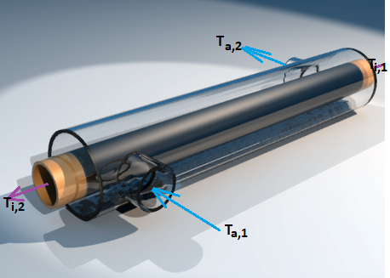

**Figure 11.2 Countercurrent heat exchanger**

(ref. <https://en.wikipedia.org/wiki/Heat_exchanger> )

  Heat transfer from fluid to flowing refrigerant can be treated analytically: <https://web.mit.edu/16.unified/www/FALL/thermodynamics/notes/node131.html> . Here we will limit ourselves to the result: that heat emitted from the fluid linked to transition numbers and area

 (11-7)

For:

 (11-8)

Temperature difference at "hot end":

Temperature difference at "cold end":

This is quite similar to that of stationary refrigerant. But the outlet temperature: Ta,2 now depends on the flows and must match the heat balances

for fluid  (11-9)

and refrigerant  (11-10)

Together, the equations (11-7) - (11-10) provide the basis for design. For example, we can now estimate the flow of refrigerant:  and area: A to achieve the desired outlet temperature of the fluid: Ti,2.

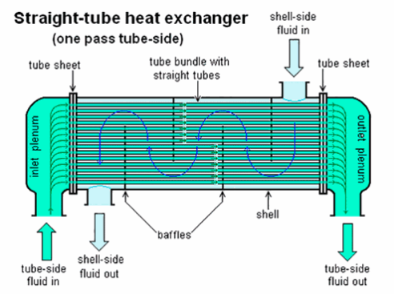

**Figure 11.3 Shell-and-tubes heat exchanger**

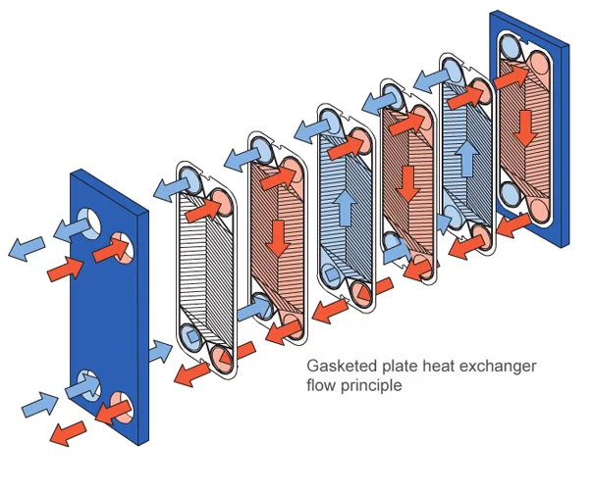

**Figure 11.4 Plate heat exchanger**

**11.3 Heat transfer numbers**

**11.1 Selection of heat transfer numbers**

Transfer numbers can be estimated, or obtained from experience data. Estimation omust be based on heat exchanger geometry and flow conditions. Experience data can be found in the literature, for example table 11.1.

**Table 11.1 Typical heat transition numbers (ref.Thermopedia.com)**

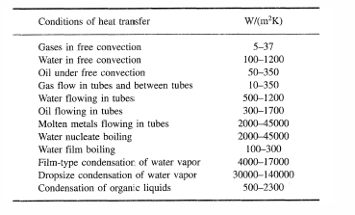

**Quiz 11.1:**

Exercise 1.2 considered oil in a pipe on the sea bottom and we estimated the heat transfer coefficient U=43. Your boss has gotten hold of Table 11.1 which suggests: U=300-1700 for oil flowing in tubes an ask “Where in h*** have you gotten your engineering degree!” How can you handle that?

**Example 11.2 Heat transport through steel pipes**

In example 11.1, we considered steel pipe: D = 0.2. Conductivity: ks = 50 w/mK for steel. If we assume steel wall thickness: t = 6mm, this provide heat transfer coefficient for the pipe



If we neglect the curvature: 

This is order-of-magnitude above experience data. So either we have calculated wrongly, thought wrongly, or the experience data is irrelevant??

**11.2 Convection by flow, forced convection**

Under laminar conditions, flow occurs in the pipe direction. Under turbulent conditions, local flow direction will vary chaotically, even if the average is stable in the pipe direction. But also under turbulent conditions, variations near the pipe wall are constrained by the pipe wall. Ludwig Prandtl suggested this quantified by the concept of "boundary layer": a layer in where special relationships apply, while the flow outside is unaffected. This provides great simplifications and has proved useful in many different contexts.

Outside the boundary layer, the turbulence will provide effective mixing and equalize temperature. In the boundary layer, the turbulence is smaller and heat transport perpendicular to the main flow direction is therefore less efficient. A resulting thermal boundary layer is illustrated below

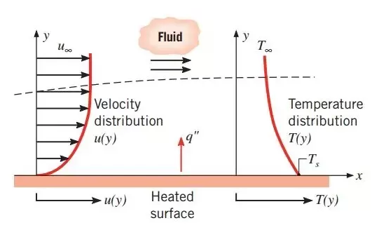

**Figure 11.5 Velocity and temperature in the boundary layer**

**Quiz 11.2:**

Investigate how heat transfer between fluid flowing in the pipe and stagnant fluid at the pipe wall affects the heat transfer coefficient estimate in exercise 1.2

Heat transport through the boundary layer links to 3 dimension-free sizes:

- Prandtl number; viscous diffusivity / thermal conductivity ratio: 

- Nusselt number; ratio of heat transfer / heat conduction: 

- Reynolds number; relationship turbulent / viscous forces: 

These are usually linked together in correlations of type: .Some such correlations, for turbulent and laminar flow, are found in:

<https://www.e3s-conferences.org/articles/e3sconf/pdf/2017/01/e3sconf_wtiue2017_02008.pdf>

For turbulent flow, Colburn's correlation is widely used, given

 (11-11)

**Example 11.3 Heat transport through thermal boundary layer and steel pipe**

a) Estimate the total transition coefficient for countercurrent heat exchanger, example 11.2

b) Assess the estimate in relation to the values given in Table 11.1

**Solution**

Thermal conductivity for water: kw = 0.606.

Heat transfer coefficient inner boundary layer:



🡪

 Heat transfer coefficient outer boundary layer:

Geometry of the cooling water channel

Assume concentric channel. The Reynolds number depends on flow rate and area.

Here assumed

- Volume flow process water: Qa = 15000, 50% greater than the flow in the pipe

- Speed: va = 1 m / s

Area: 🡪Outer diameter: 

Wetted perimeter of concentric channel: 

Hydraulic diameter: 

Reynolds number: 

Heat transfer coefficient



🡪

Total heat transfer coefficient

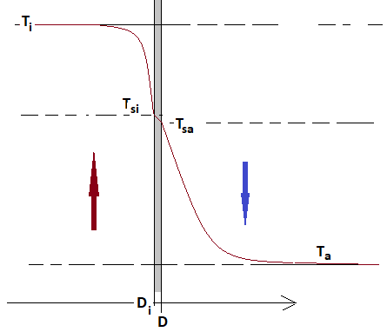

Total heat transfer : 

Transfer, inner boundary layer: 

Similar for steel and boundary layer between pipe wall and annular space

From the figure: 

Inserted :  🡪

Estimate: 